Aurelien-Geron-Hands-On-Machine-Learning-with-Scikit-Learn-Keras-and-Tensorflow-2019

<http://scikit-learn.org/>

Introduction to Machine Learning with Python

<https://jakevdp.github.io/PythonDataScienceHandbook/>

<https://docs.pola.rs/api/python/stable/reference/>

Learn Rust, SQL stored procedures, SQL other stuff, polars in R, web scraping, processes that can be automated

Wes McKinney:

* How to think about datasets
* Designing schemas
* Organising data
* Relational algebra
* File formats, Data storage, Data partitioning
  + Relationship between how data is stored/managed and how well systems like DuckDB perform
  + Relationship between execution engines and how data is stored
* Which DataFrame library to use?
  + Pandas, Polars, DuckDB, Ibis?
  + Polars vs Pandas
    - LLM’s support in pandas (stackoverflow), maybe not integrated yet in Polars?
    - Polars much faster for larger datasets, leverages multi-threading of CPU cores.
    - Polars didn’t try to mimic API of pandas, so is simpler to use atm?
  + Ibis
    - Encouraged to try out Ibis, particularly if coming from a SQL-oriented background with ability to write advanced-SQL.
    - You can write UNIT-TESTS for ibis expressions – Wes
    - Advanced query development more software-development-like
  + DuckDB
    - Some people use Ibis for some things and DuckDB for others?

**What’s the real difference between Polars and DuckDB?**

DuckDB is going to be SQL from end to end.

Polars is Dataframe centric with a SQL option.

Polars is a high-performance tool.

DuckDB is taking aim at analytics and databases.

Polars is taking aim at ETL and pipeline tools.

There is much overlap in what each tool does.

Simplicity is the name of the game for DuckDB.

Polars isn’t necessarily simple. It’s fast and complex.

# Pandas 🡪 Polars differences

<https://docs.pola.rs/user-guide/migration/pandas/>

# Ad-hoc learnings

Pl.col(..).as_expr() 🡪 converting to expression

Pl.col(..).as_expr().dt.to_string(“dateformat”) 🡪 convert to date string

Pl.col(..).name.map( func ) to change output name

Pl.col(..).name.<prefix or suffix> ( “prefix or suffix”) to change output name

Unique / Distinct Count

.n_unique() and .approx_n_unique 🡪 Python type None does count as one of the unique values

# Regular Expressions

<https://docs.python.org/3/library/re.html>

# Reading & Writing

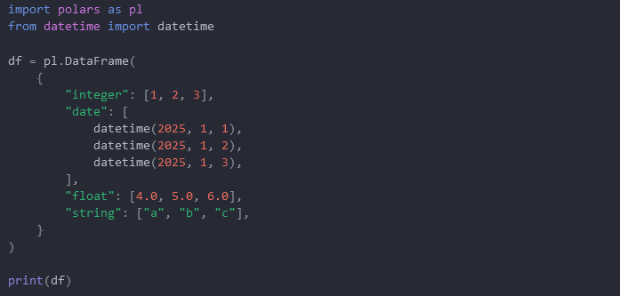

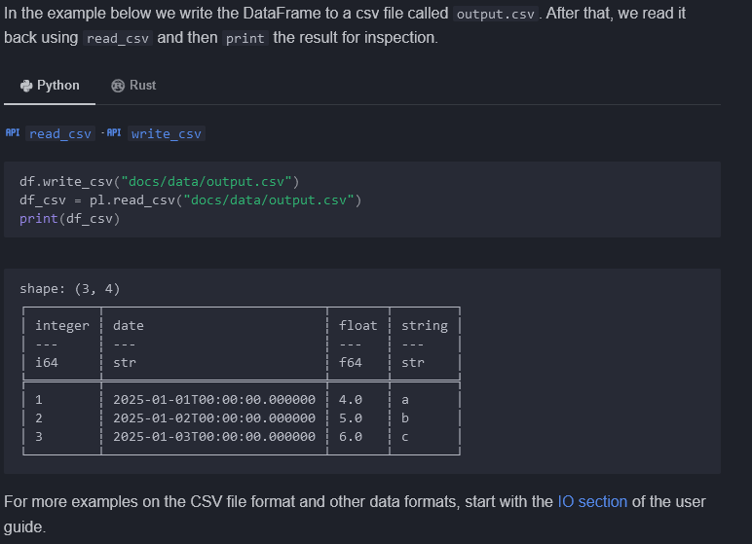

<https://docs.pola.rs/user-guide/io/>

# Expressions

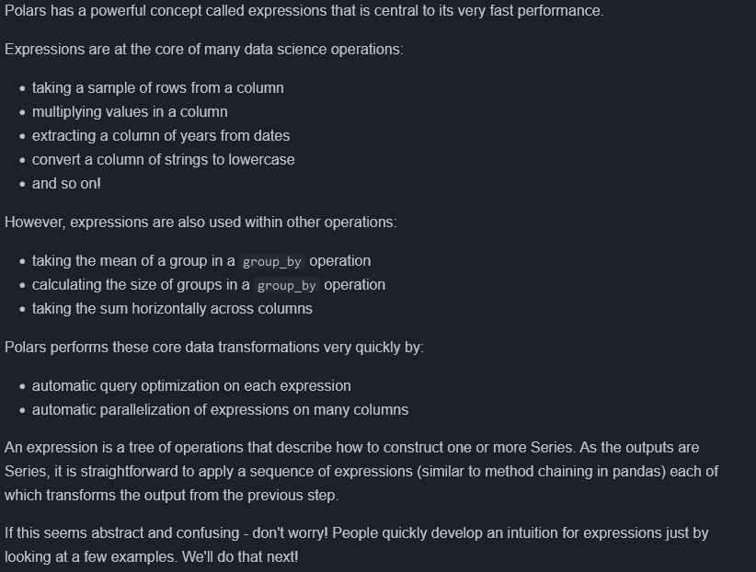

## Examples

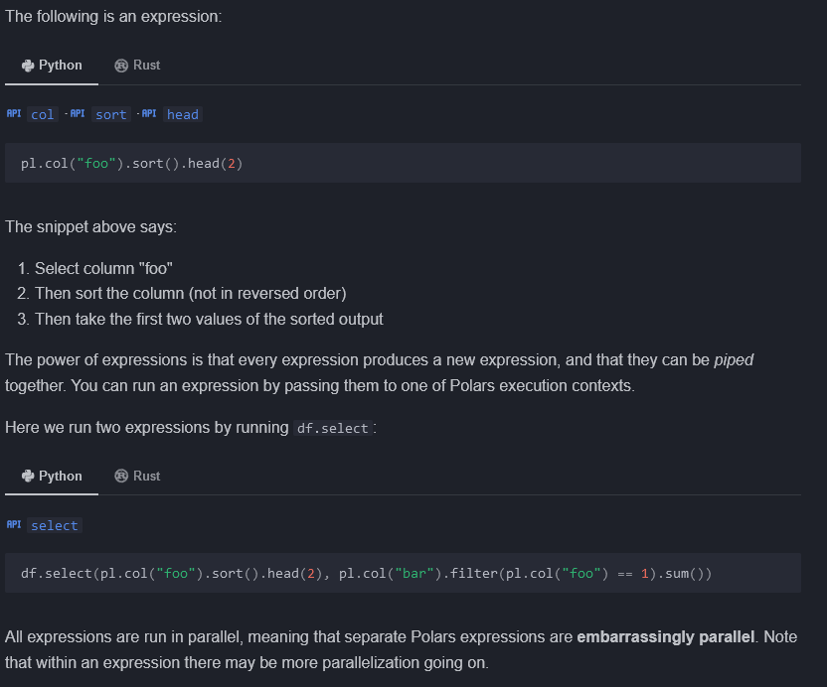

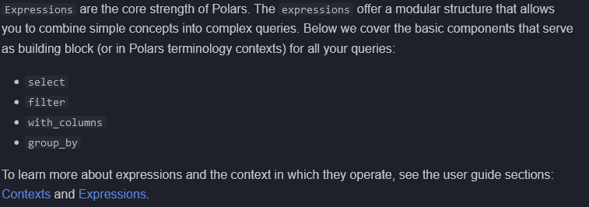

<https://docs.pola.rs/user-guide/concepts/contexts/>

<https://docs.pola.rs/user-guide/concepts/expressions/>

## Select

Pl.col(“*”) EQUIVALENT TO pl.all()

Pl.col(“*”).exclude( col1, col2, …)

Pl.col( col1, col2 , … )

df.select(pl.col("^.*(as|sa).*$")) 🡪 select columns via regular expressions, require wrap regex by ^ and $.

Df.select(pl.col( pl.dtype1, pl.dtype2, … ) ) 🡪 select columns via data types

import polars.selectors as cs

<https://docs.pola.rs/api/python/stable/reference/selectors.html>

Df.select(cs.integer(), cs.string() ) 🡪 select just integer and string columns

Df.select(cs.numeric() – cs.first()) 🡪 select numeric columns except first column

Df.select(cs.by_name(“index”) | ~cs.numeric()) 🡪 select “index” column by name and NON-numeric columns

… more

Cs.contains, cs.matches( <regex>, cs.starts_with, cs.ends_with, cs.by_index( **indices (or list))

Cs.temporal() 🡪 all temporal columns (time-related)

Expand_selector(df, cs.< > ) 🡪 view associated columns selected

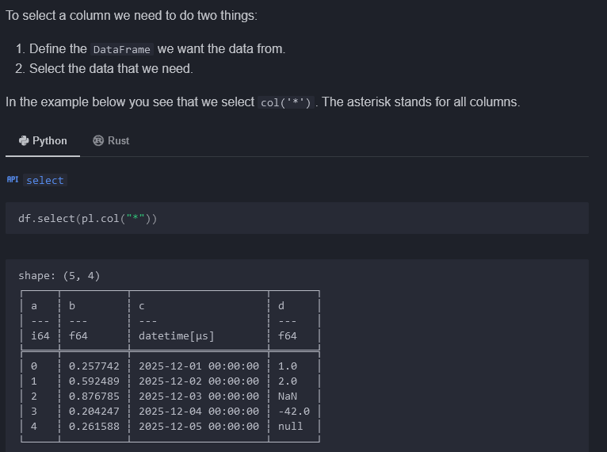

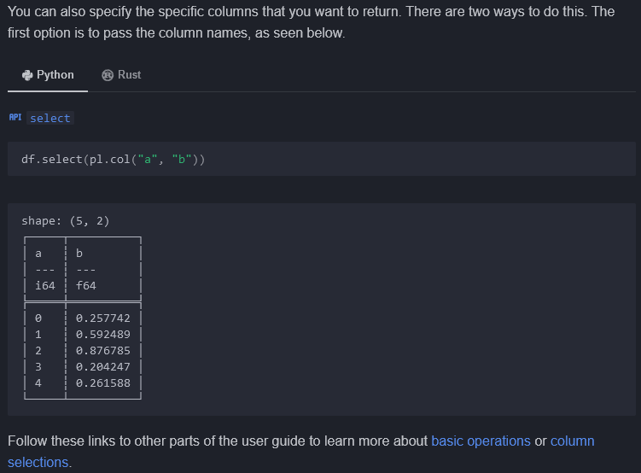

<https://docs.pola.rs/user-guide/expressions/operators/>

<https://docs.pola.rs/user-guide/expressions/column-selections/>

## Filter

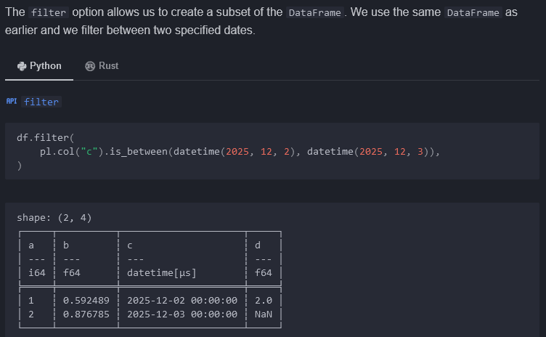

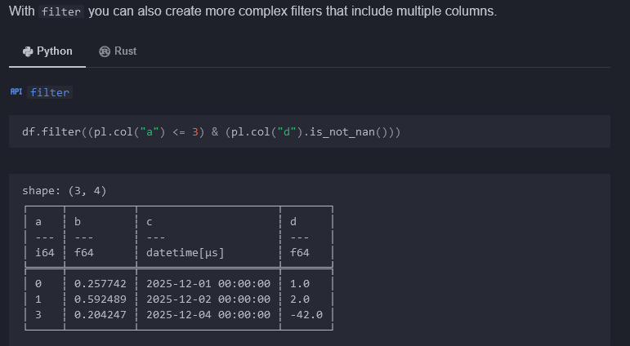

## Add columns

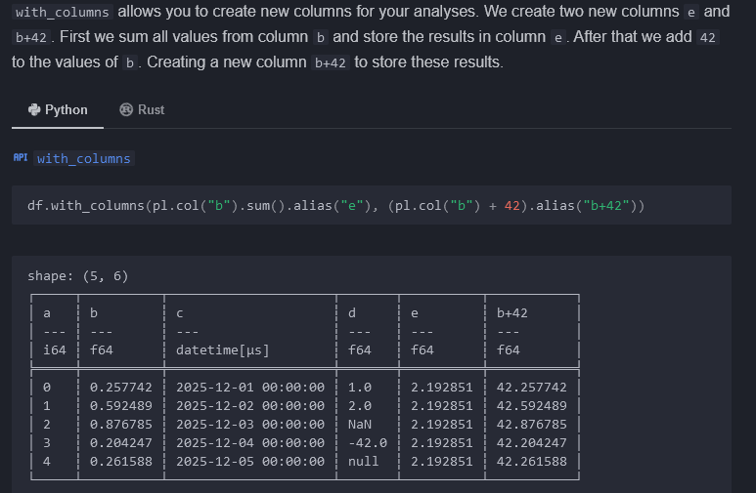

## Group by

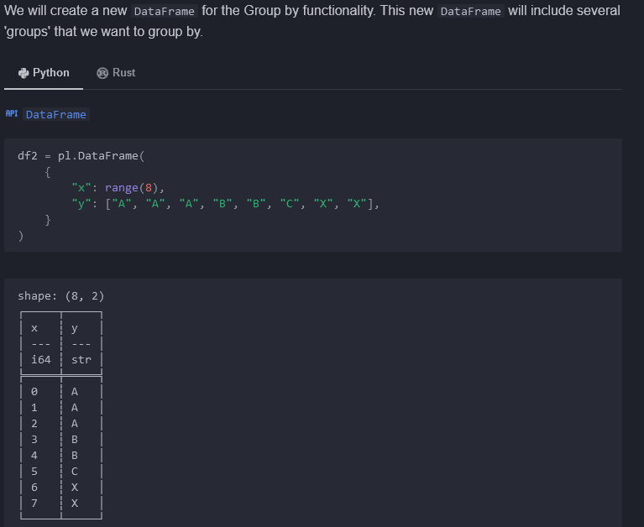

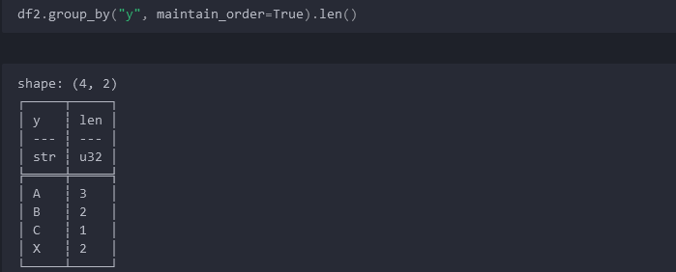

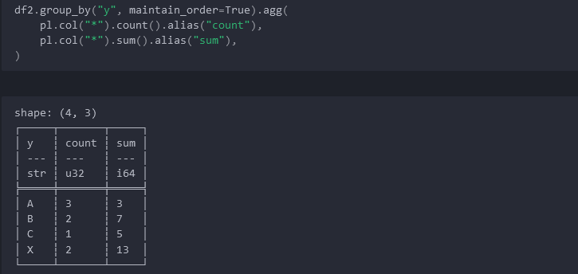

## Combination of operations

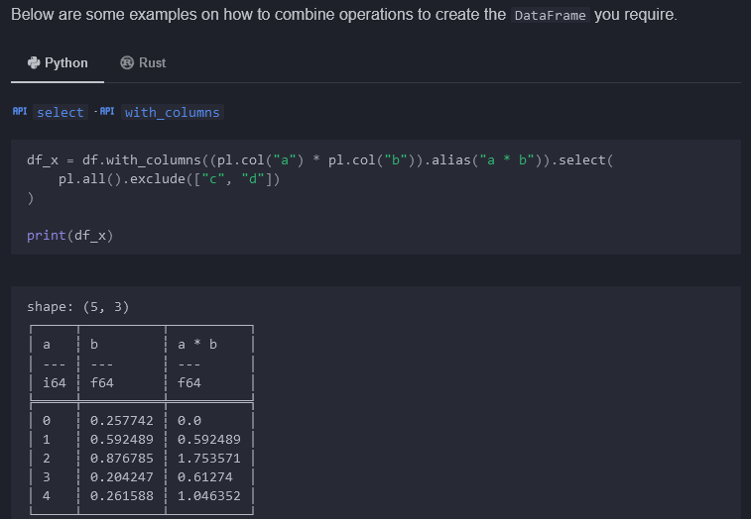

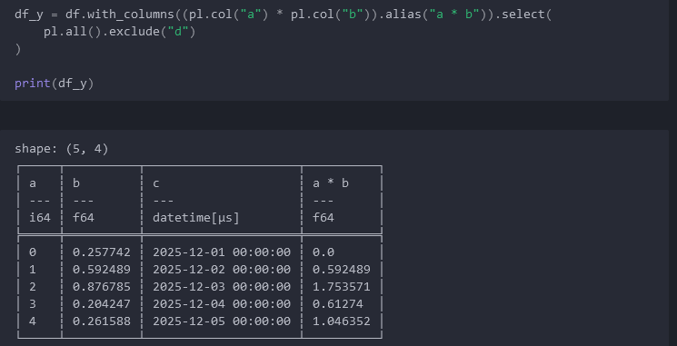

# Combining DataFrames



## Join / join_asof

<https://docs.pola.rs/api/python/stable/reference/dataframe/api/polars.DataFrame.join.html>

[https://docs.pola.rs/api/python/stable/reference/dataframe/api/polars.DataFrame.join_asof.html#](https://docs.pola.rs/api/python/stable/reference/dataframe/api/polars.DataFrame.join_asof.html)

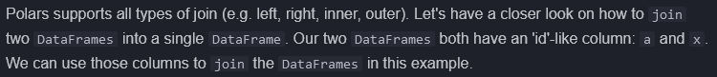

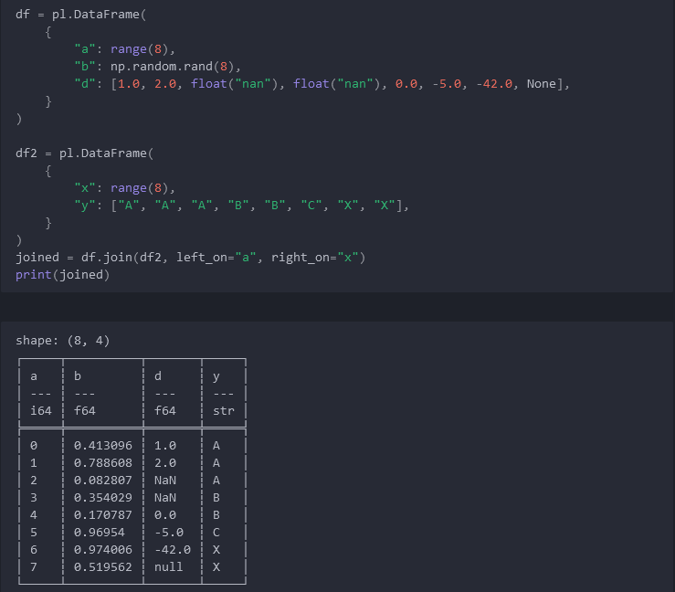



<https://docs.pola.rs/user-guide/transformations/joins/>

## Concat



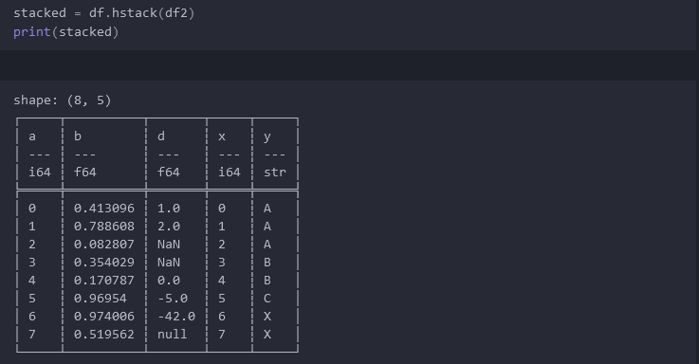

# Installation and Extras

<https://docs.pola.rs/user-guide/installation/>

# Data Types: Overview

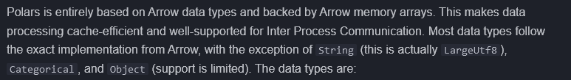

## Numeric Groups

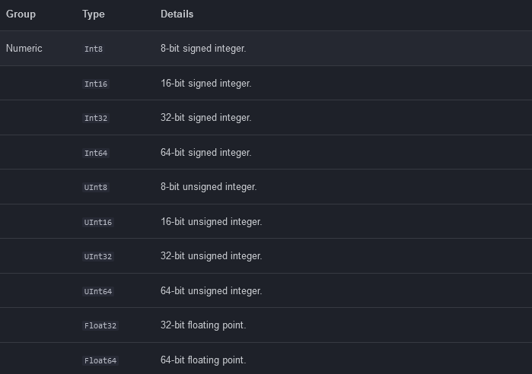

## Nested Groups

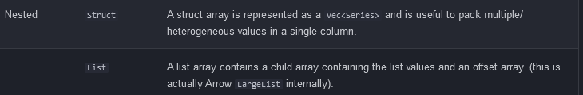

## Temporal Groups

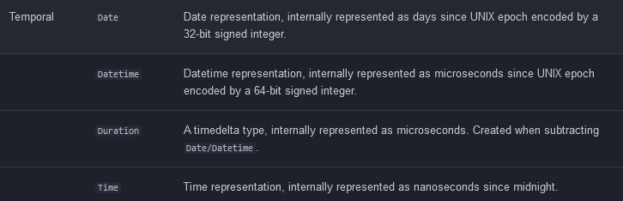

## Other Groups

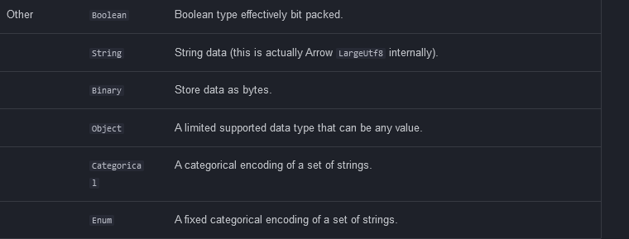

<https://arrow.apache.org/docs/format/Columnar.html>

## Floating Point

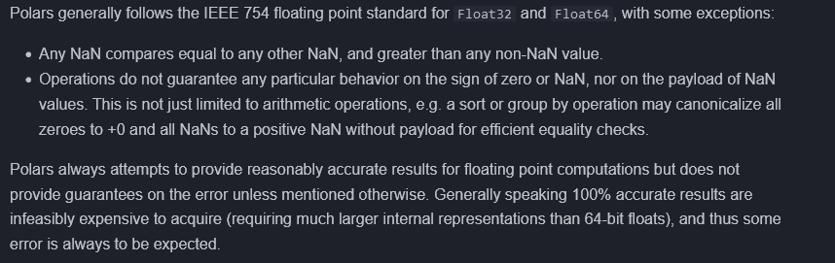

# Categorical data (and Enum)

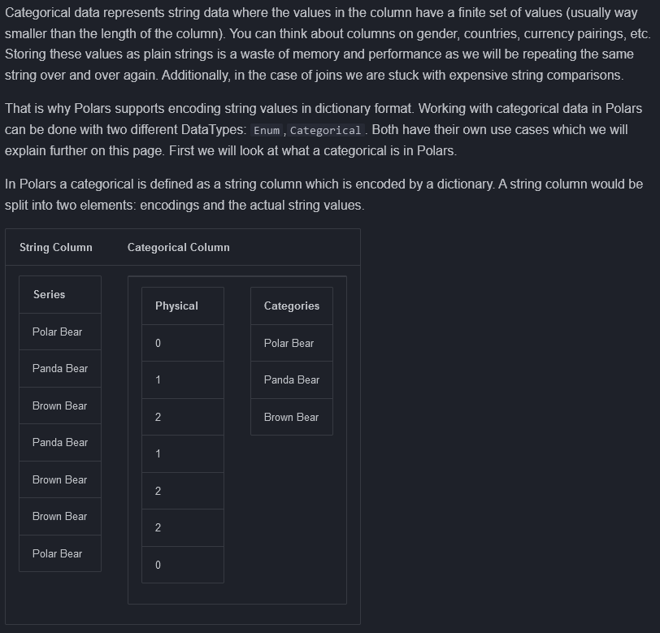

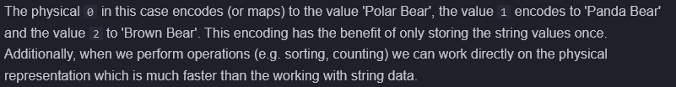

## Enum vs Categorical

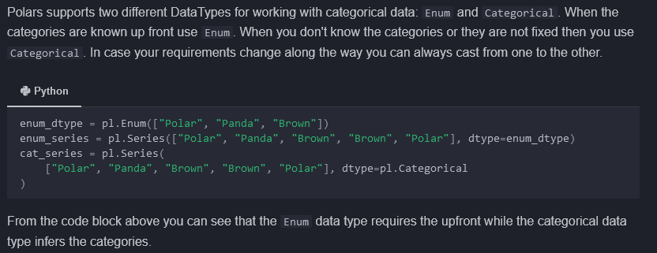

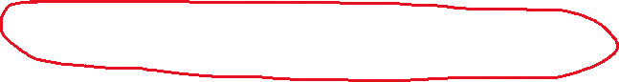

## Categorical data type

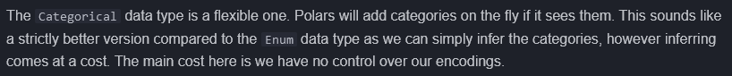

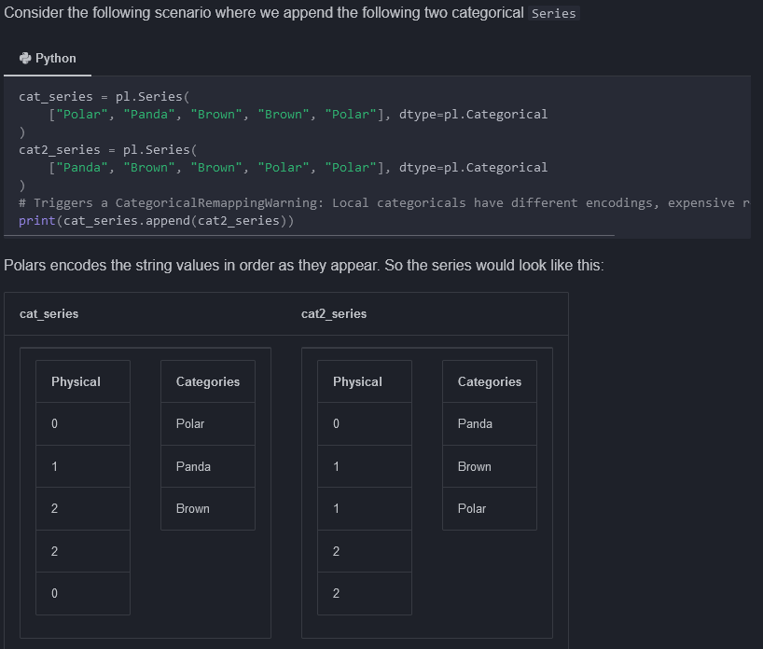

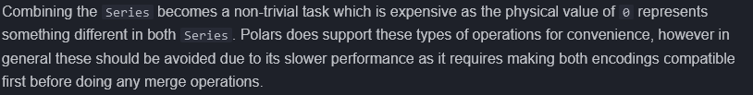

### Using the Global String Cache

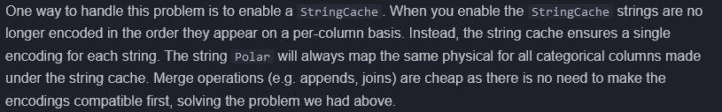

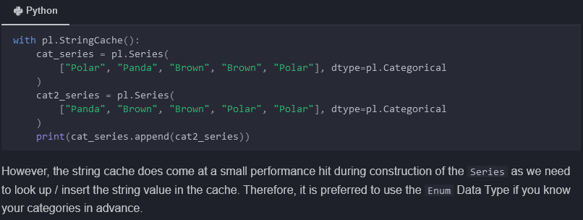

## Enum data type

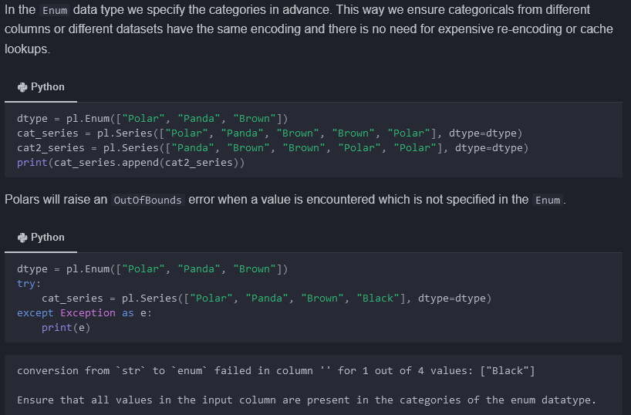

## Comparisons

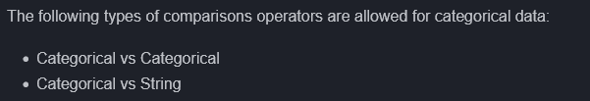

### Categorical vs Categorical

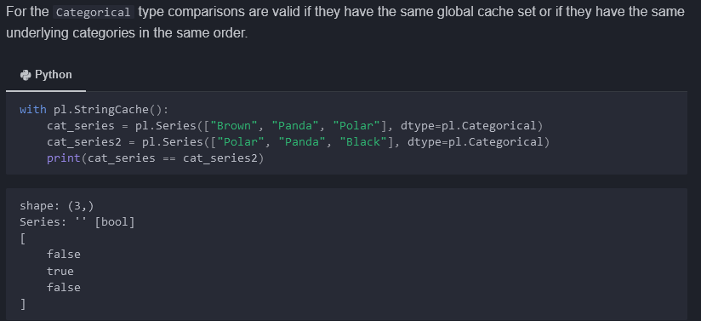

### Categorical vs String

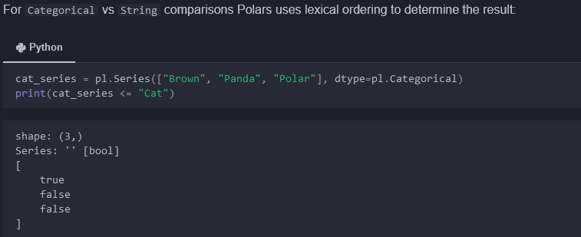

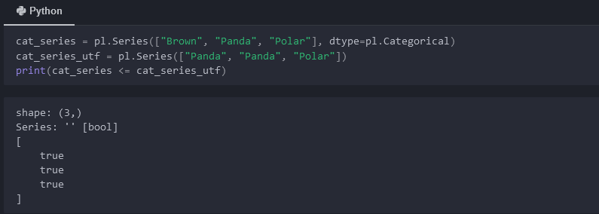

### Enum vs Enum

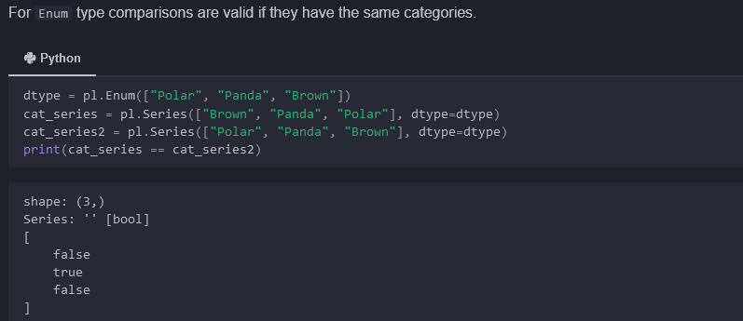

### Enum vs String



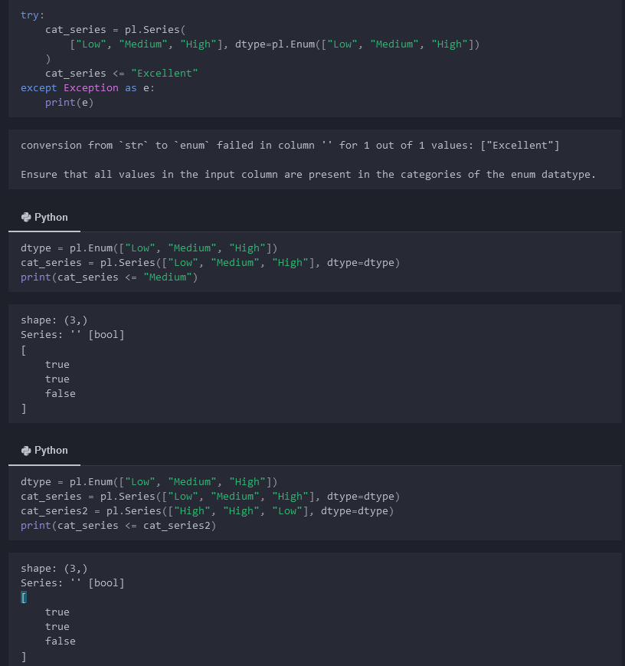

# Data structures

## Series



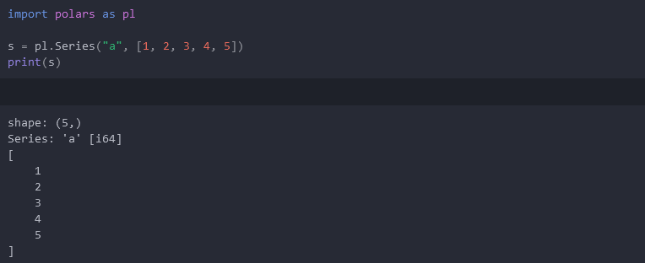

## DataFrame

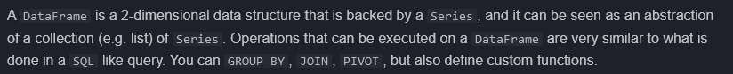

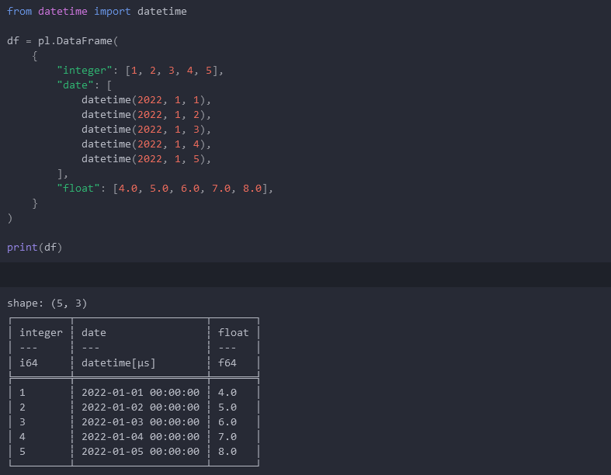

## Viewing data



Df.head( numrows )

Df.tail( numrows )

Df.sample( n ) 🡪 sample n random rows

Df.describe() 🡪 returns summary statistics for dataframe

# Contexts

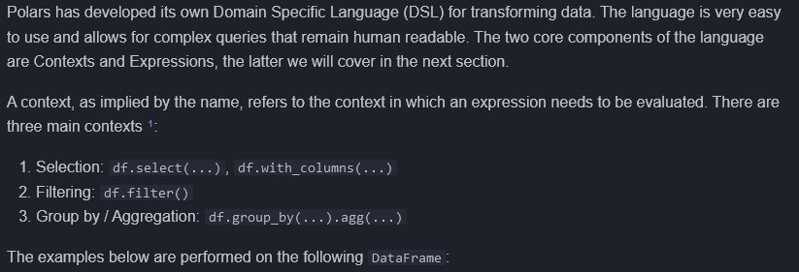

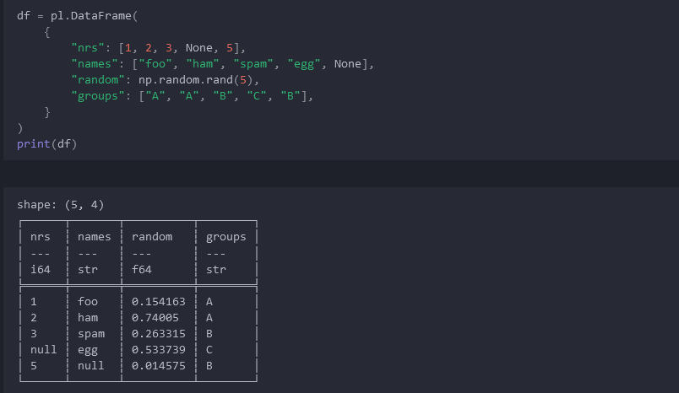

## Selection

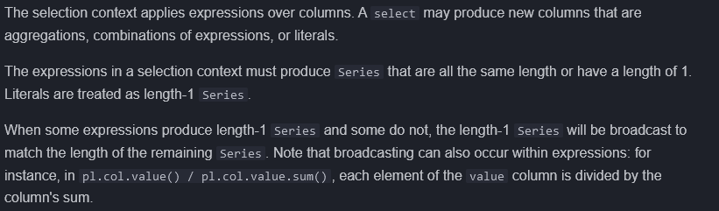

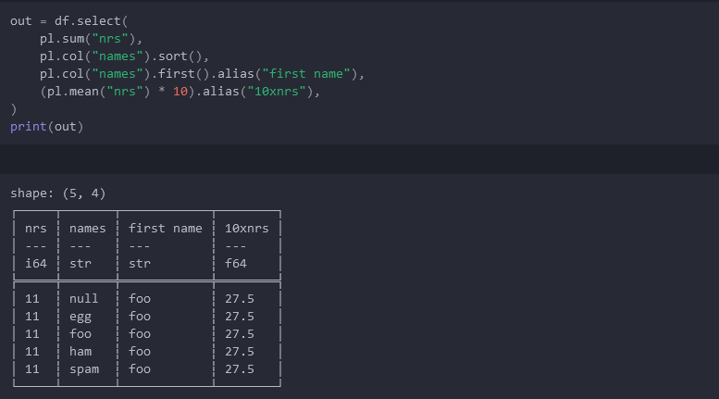



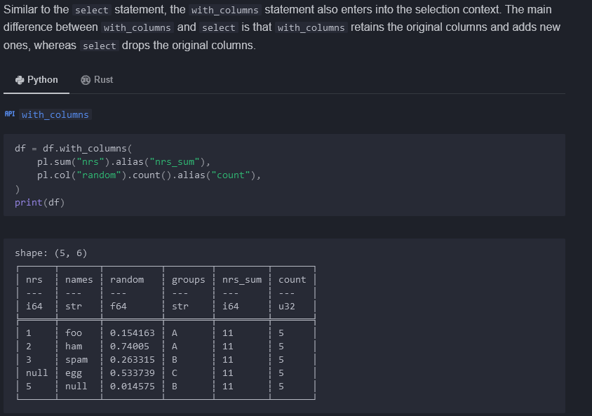

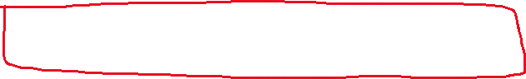

## Filtering

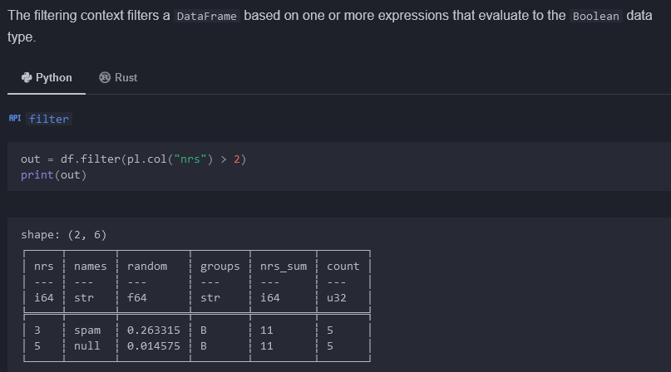

## Group by / aggregation

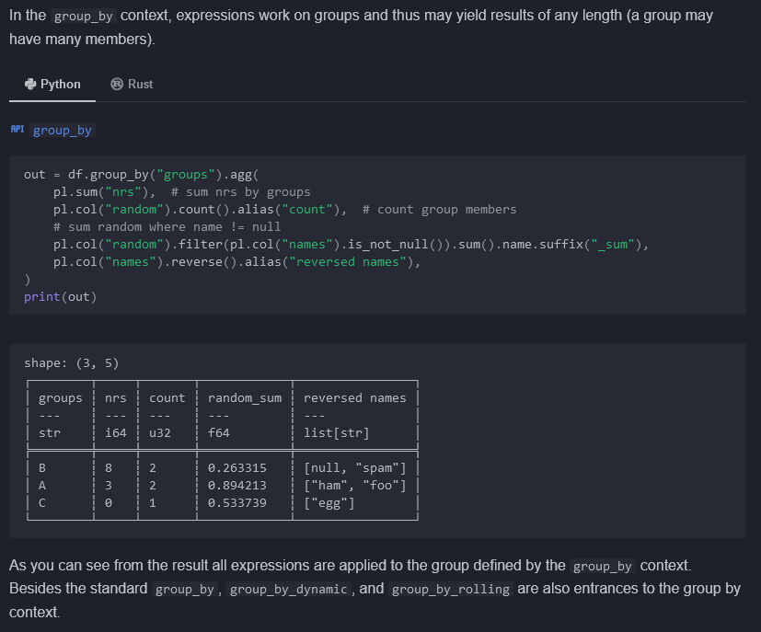

## List / SQL contexts



# Lazy / eager API

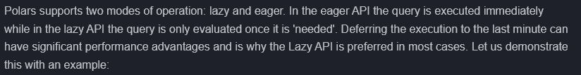

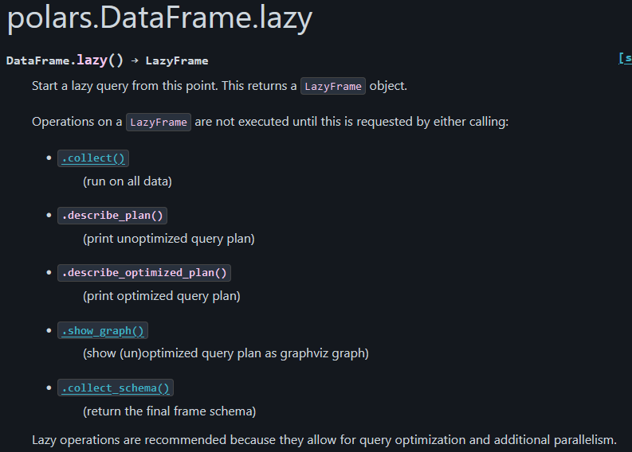

## Example

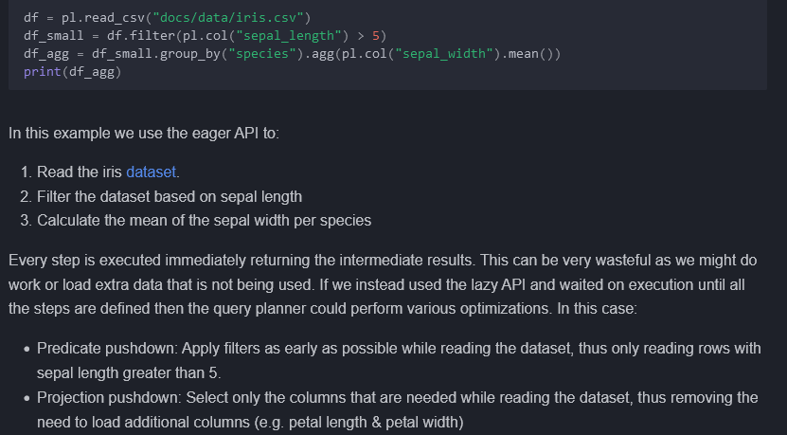

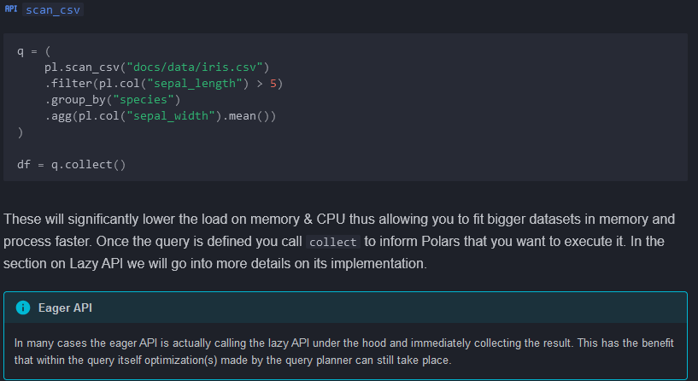



# Streaming API

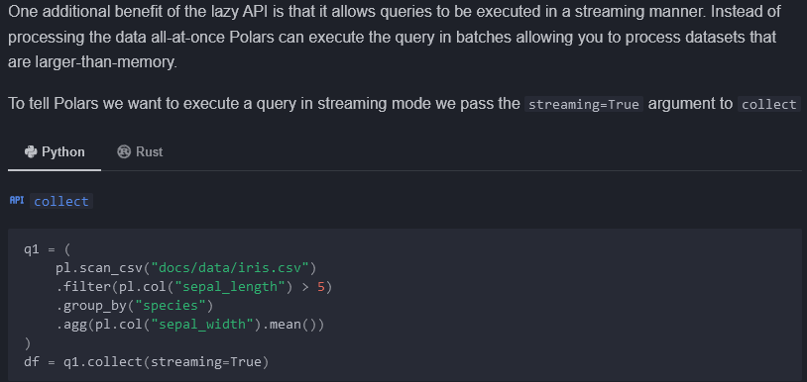

## When is streaming available?

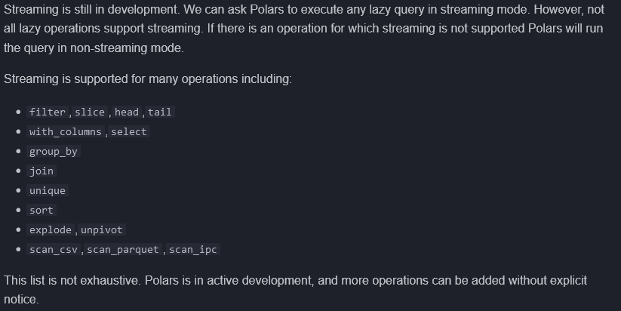

## Example with supported operations



<https://docs.pola.rs/user-guide/lazy/query-plan/>

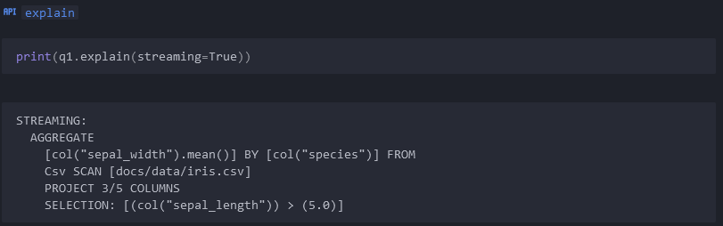

## Example with non-streaming operations

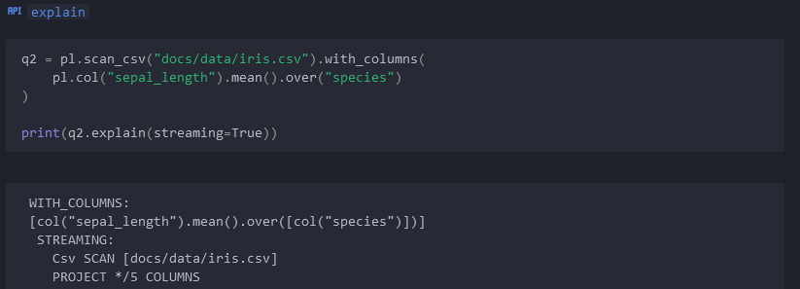

# Type Casting

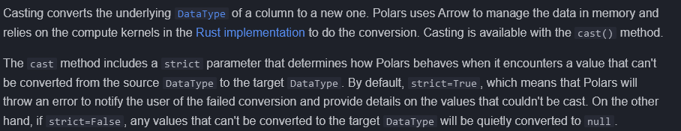

## Numerics

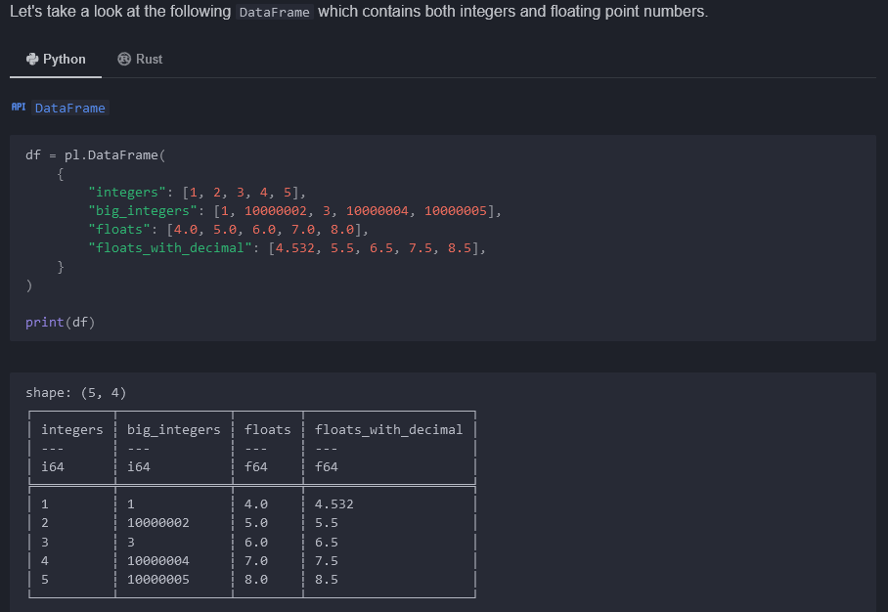

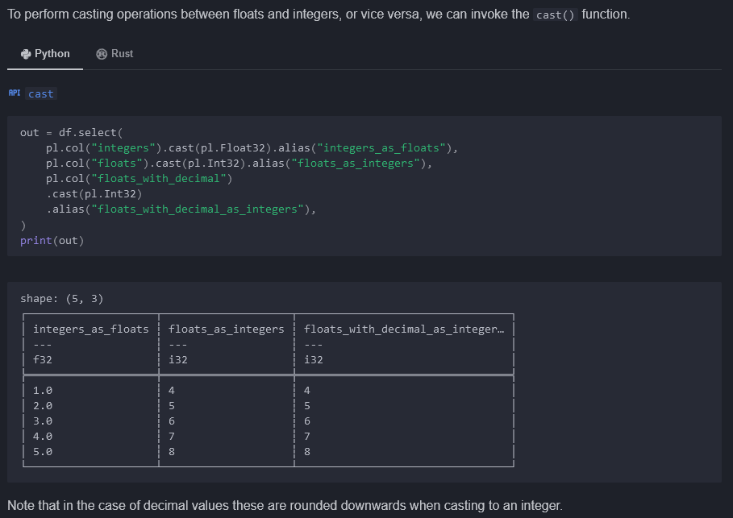

### Downcast

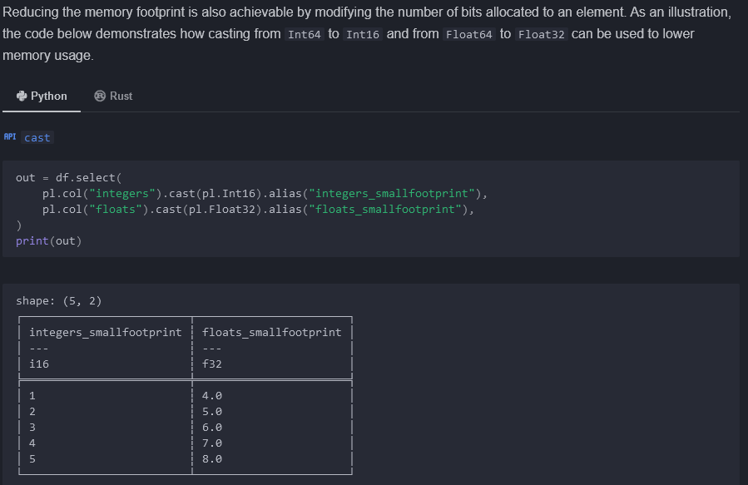

### Overflow

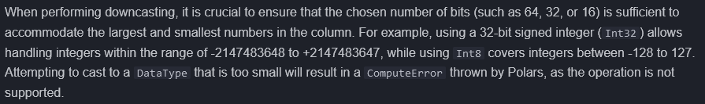

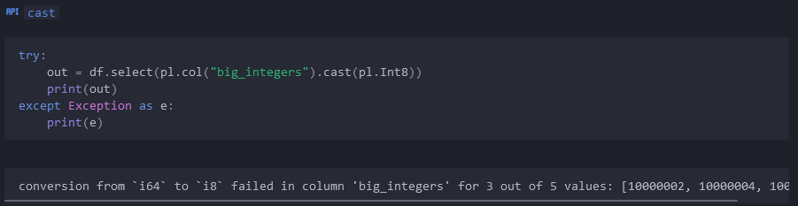

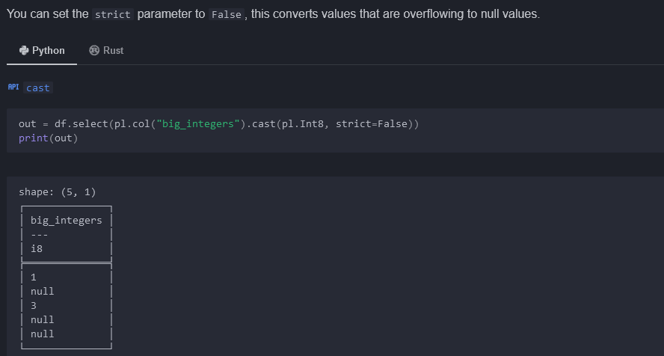

## Strings



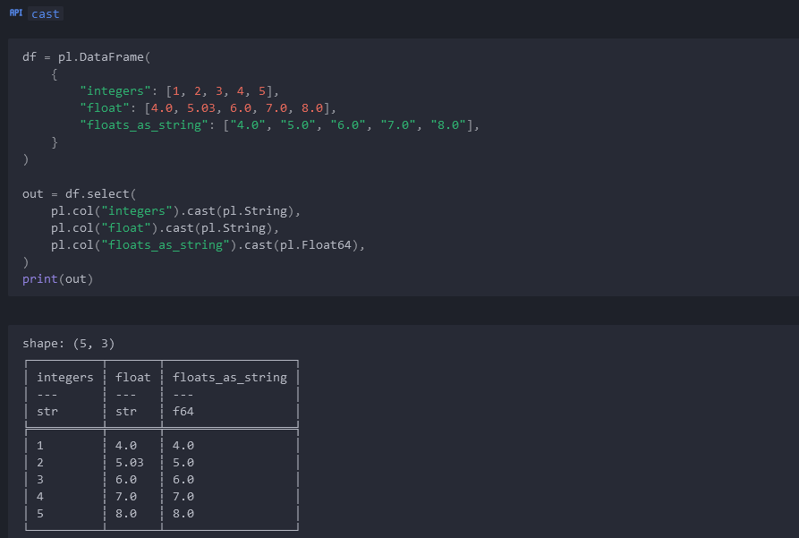

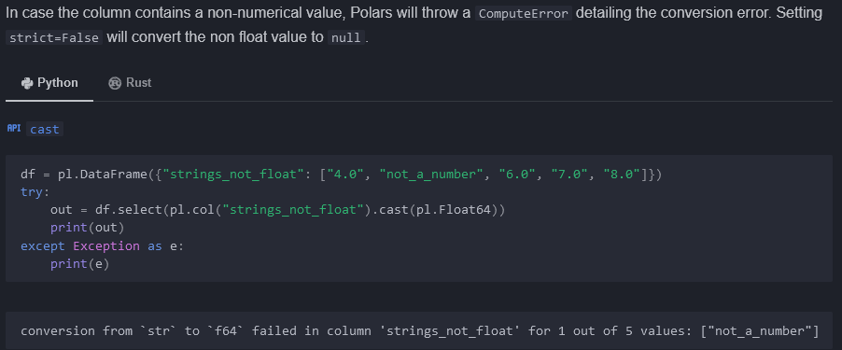

## Booleans

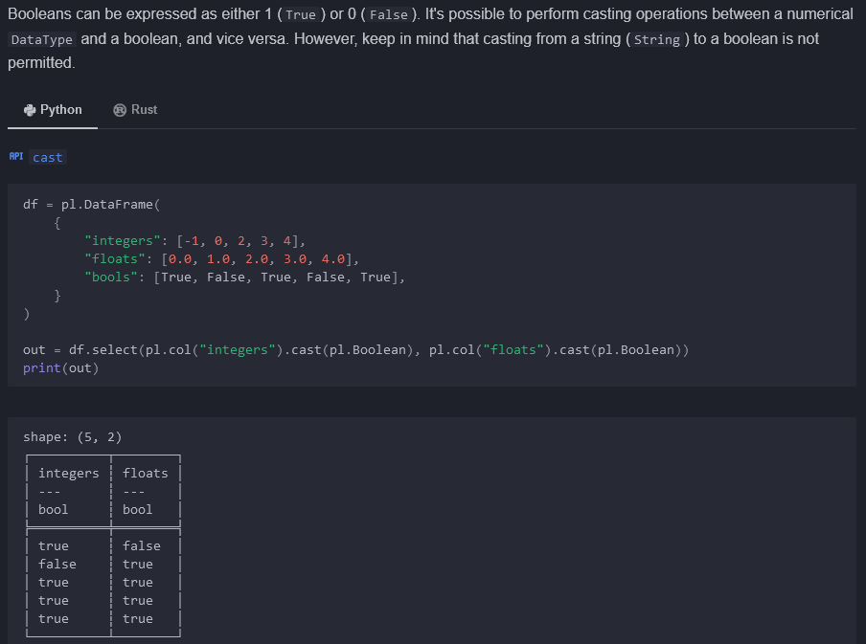

## Dates



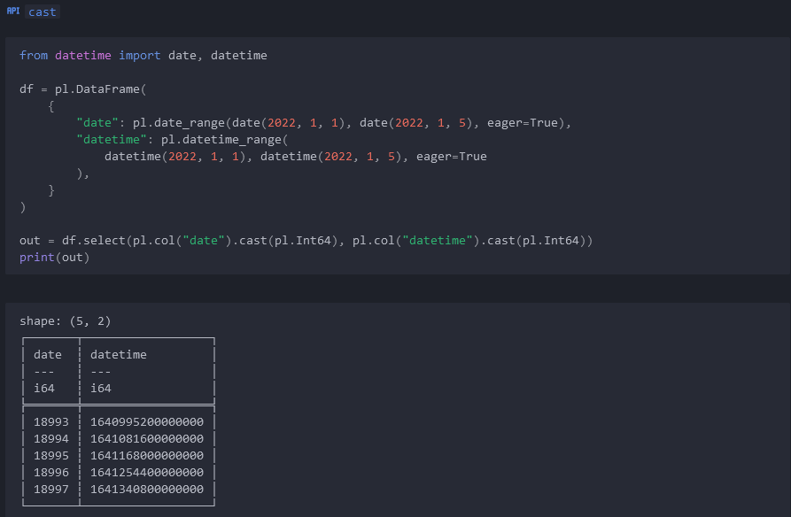

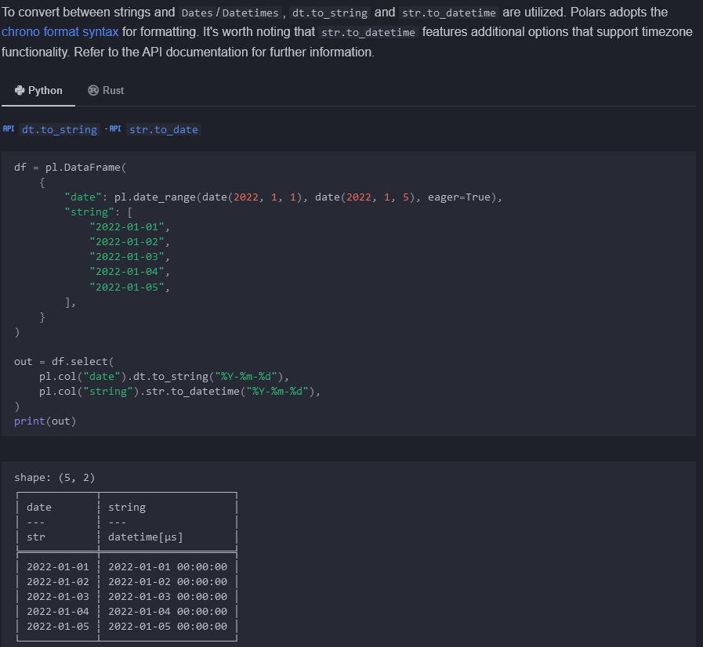

<https://docs.rs/chrono/latest/chrono/format/strftime/index.html>

# Strings

Str.len_bytes(), str.len_chars(),

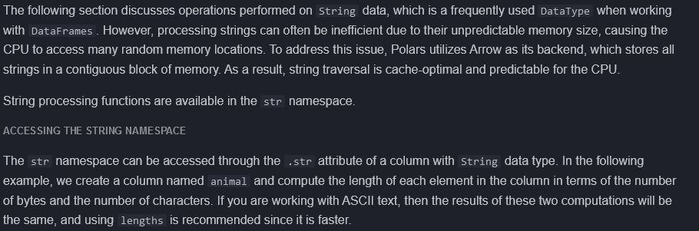

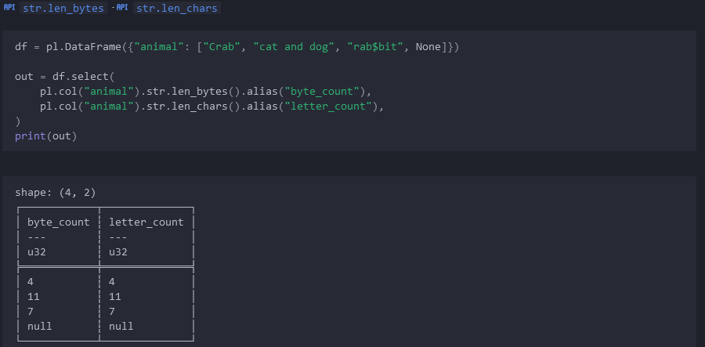

## String parsing



## Check Existence of Pattern

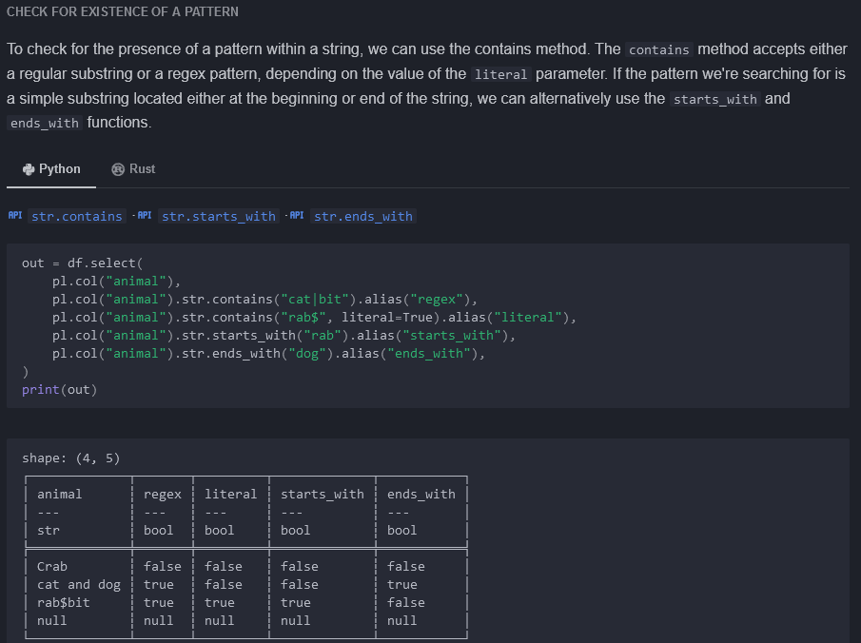

## Extract a Pattern

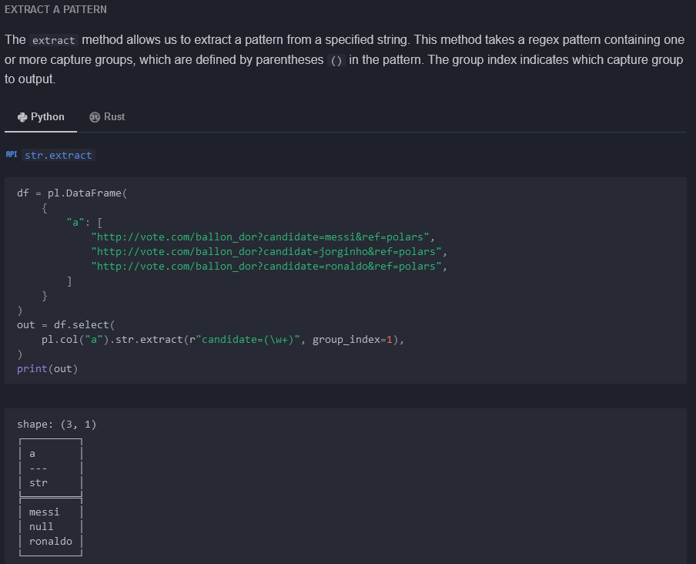

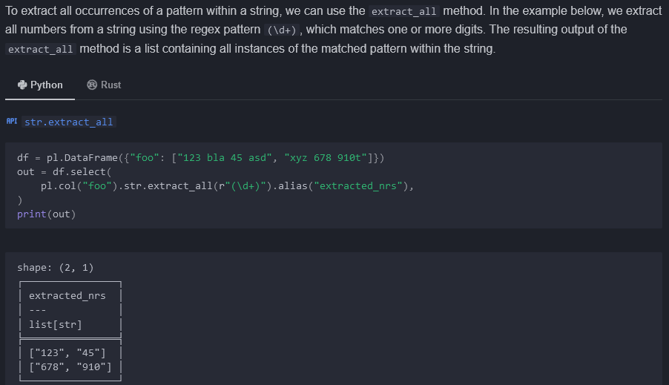

## Replace a Pattern

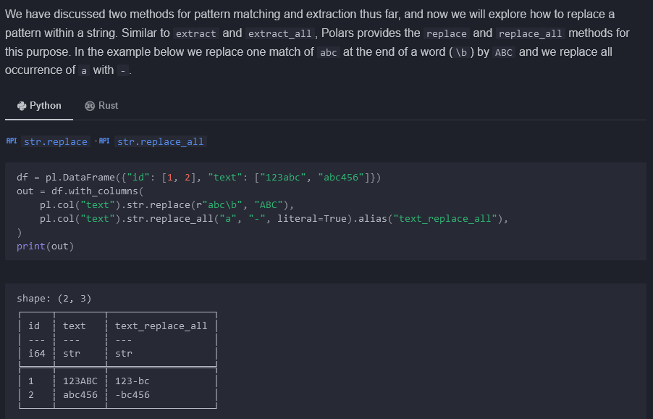

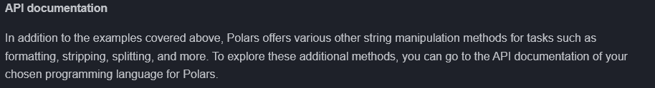

# Aggregation

## PARALLELIZATION – IMPORTANT

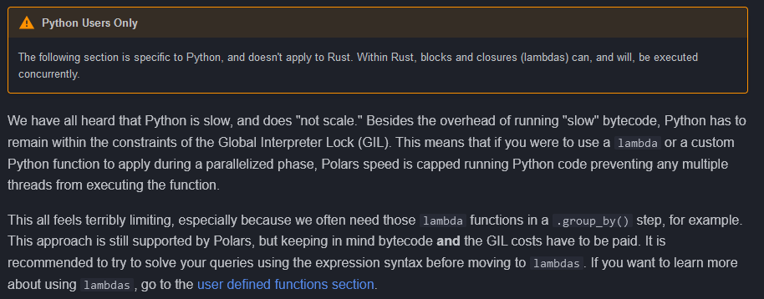

<https://docs.pola.rs/user-guide/expressions/user-defined-functions/>



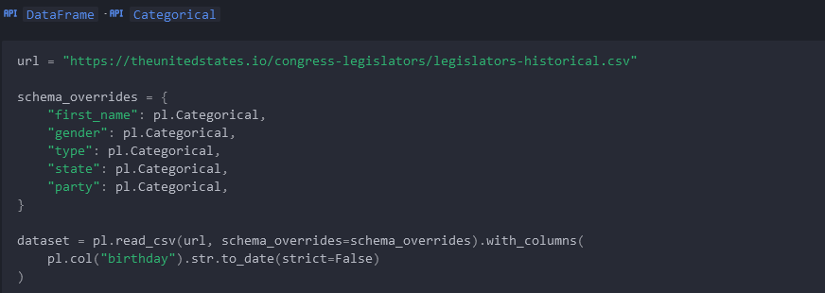

## Basic aggregations

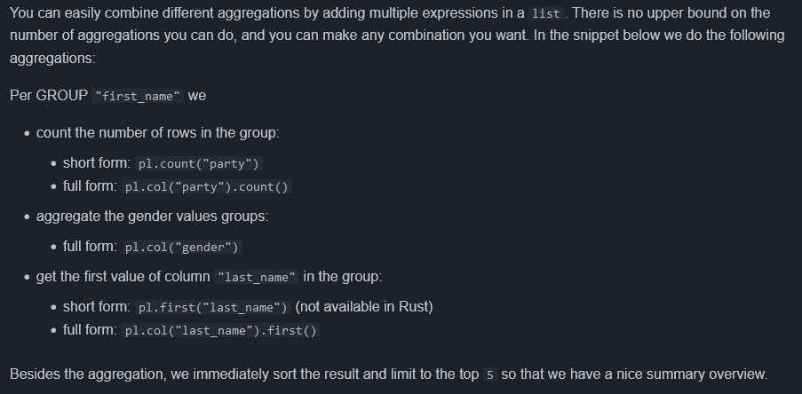

.count()

.first()

.sort( <colname>, descending=T|F)

.limit( <N>)

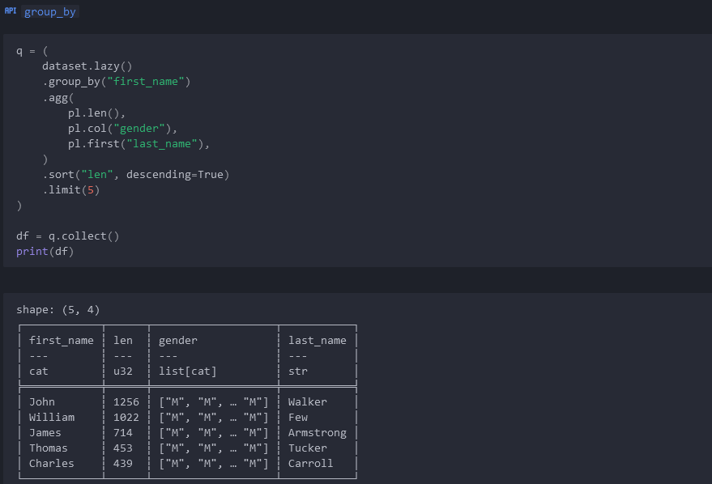

## Conditionals

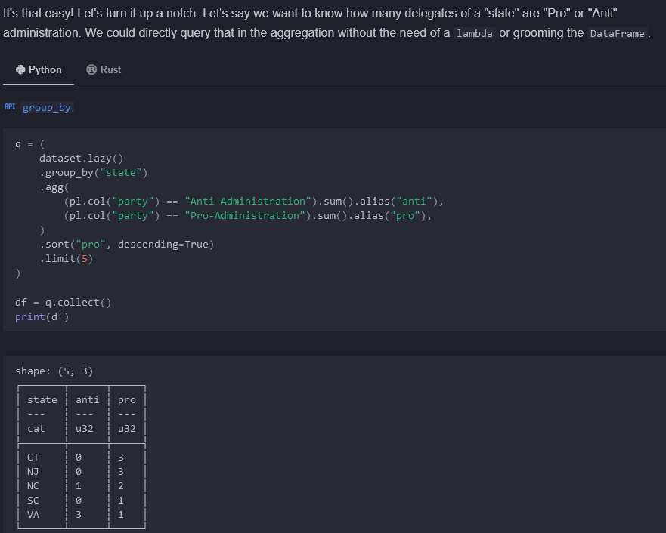

### Using nested GROUP BY

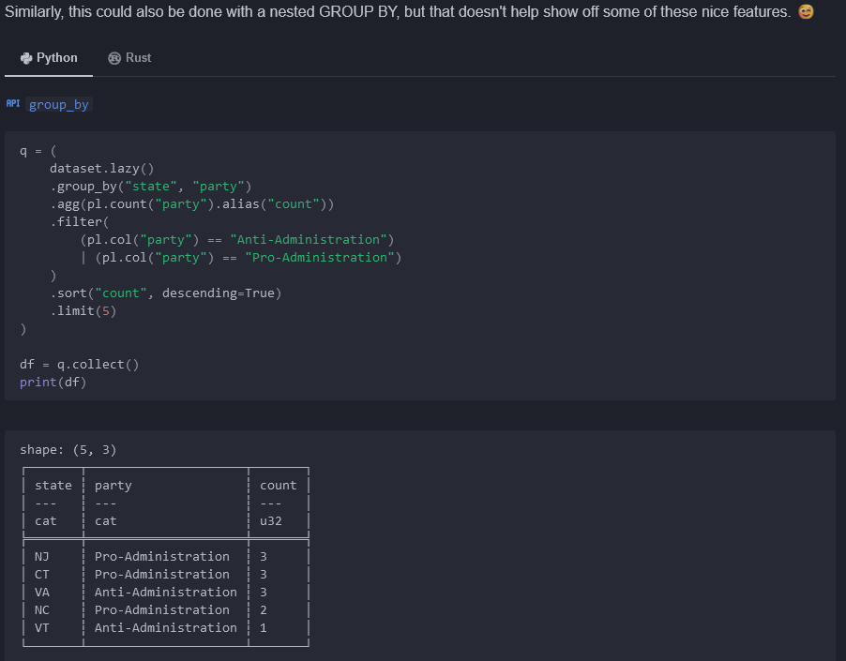

## Filtering and Functions

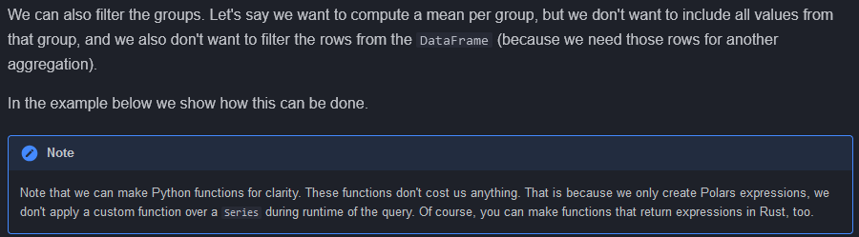

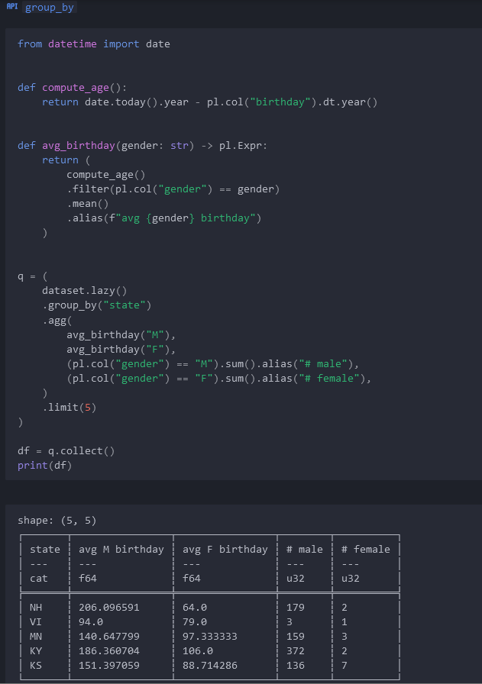

## Sorting

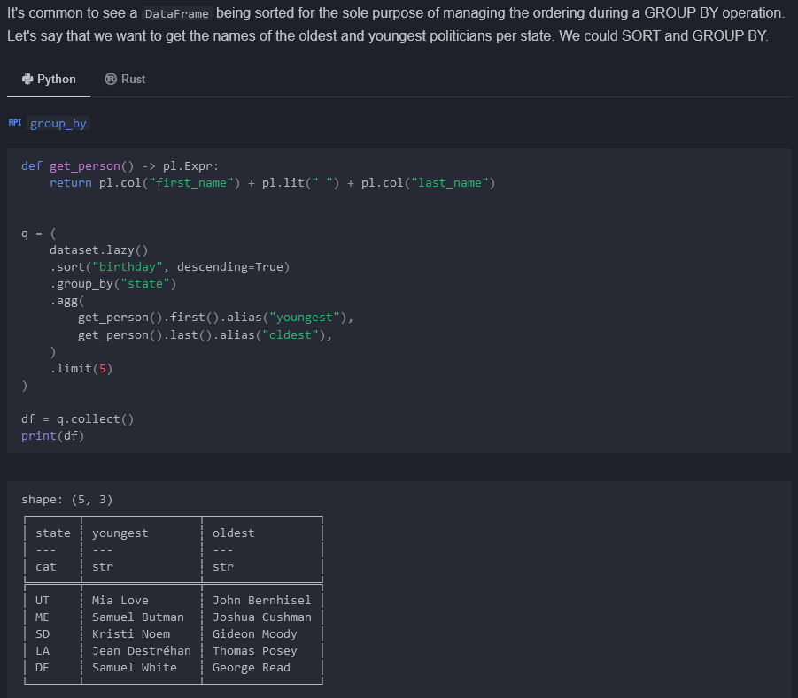

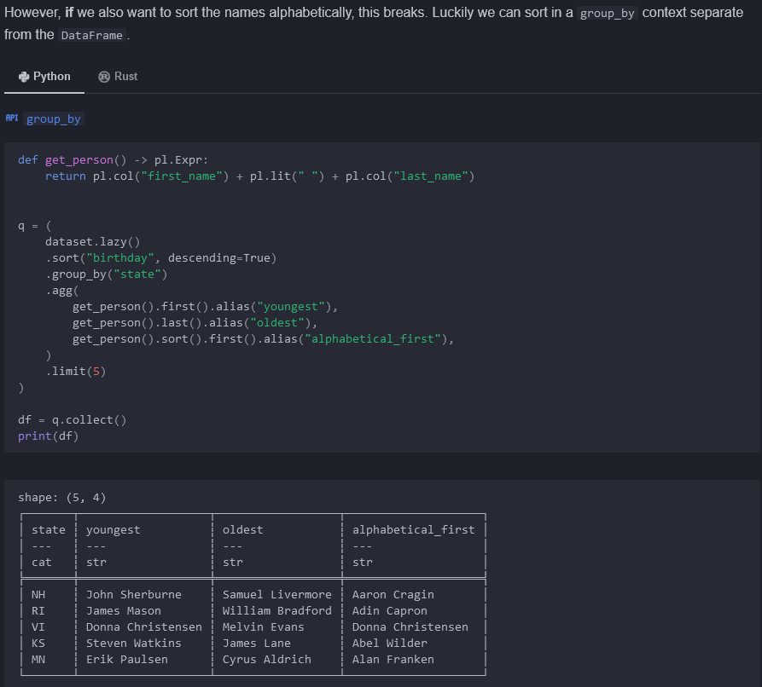

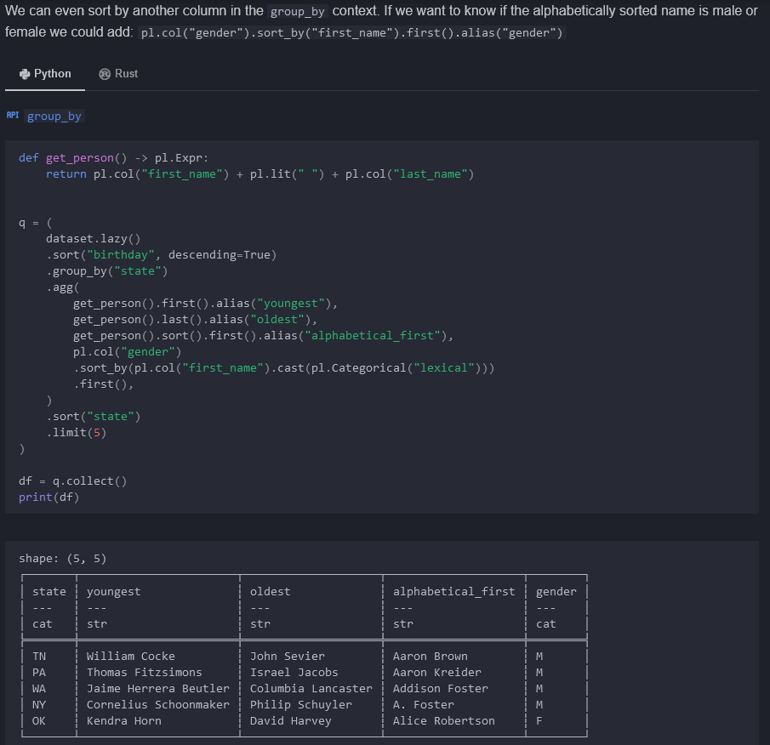

# Missing data

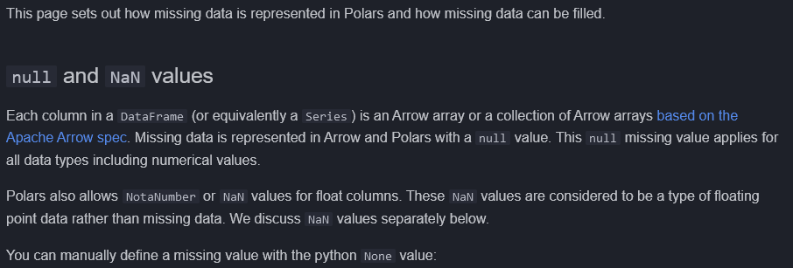

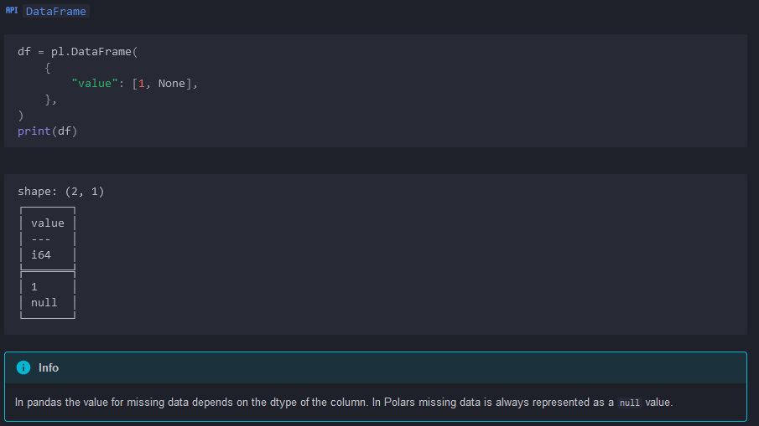

## Missing data metadata

.null_count(), .is_null()

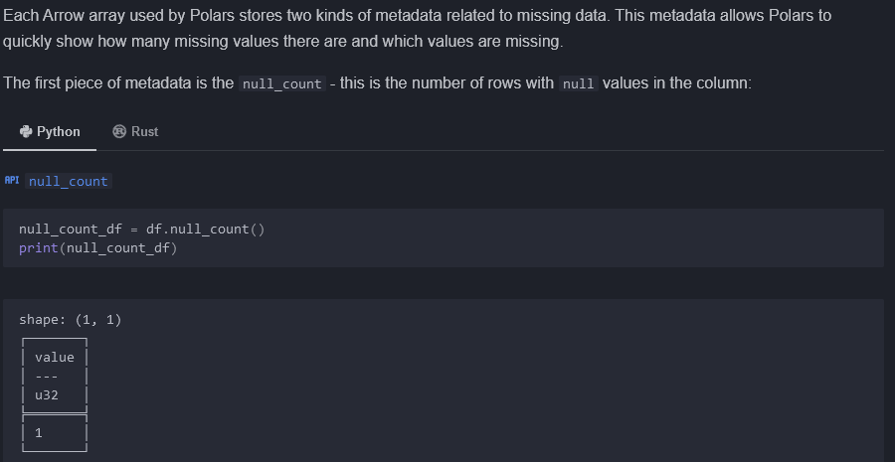

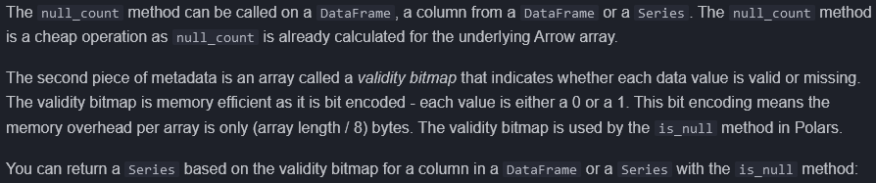

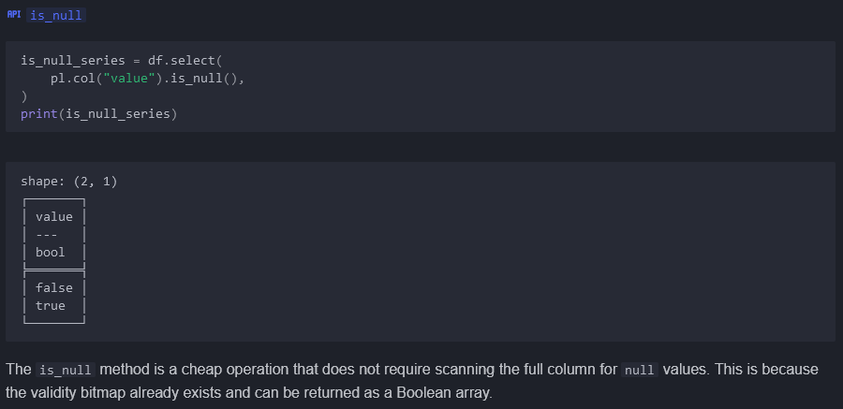

## Filling missing data

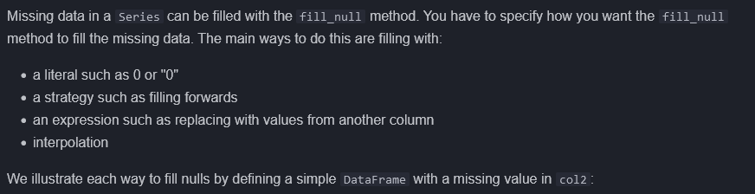

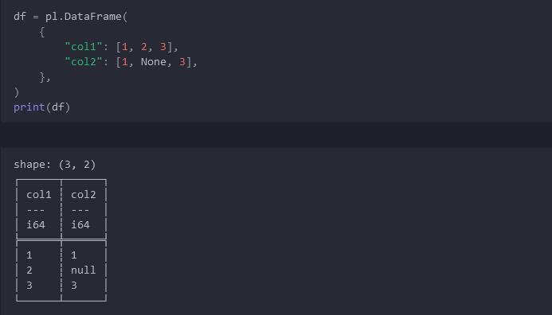

### Fill with specified literal value

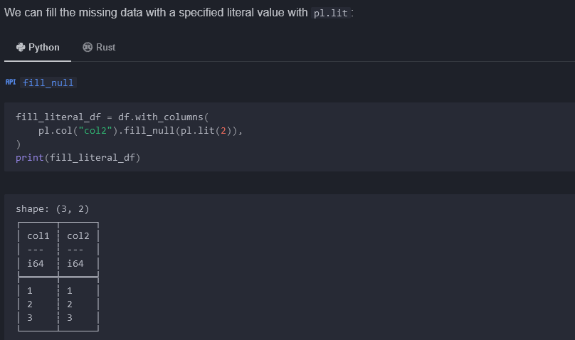

### Fill with a strategy

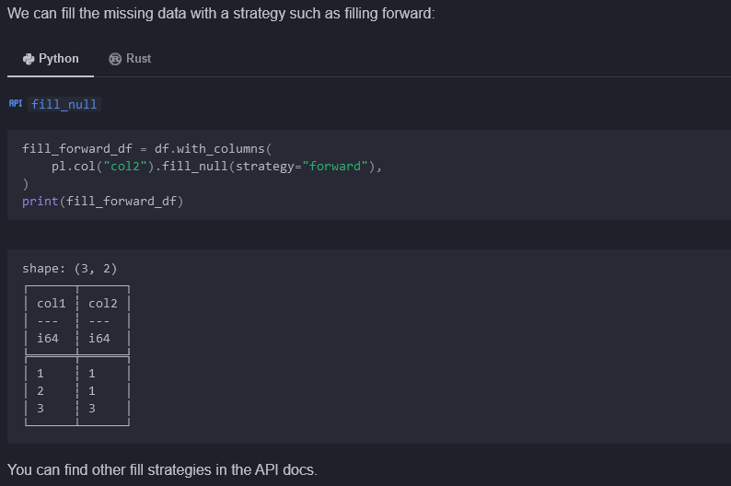

### Fill with an expression

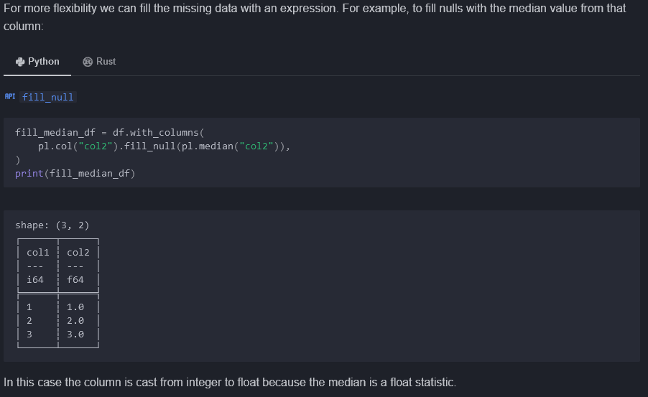

### Fill with interpolation

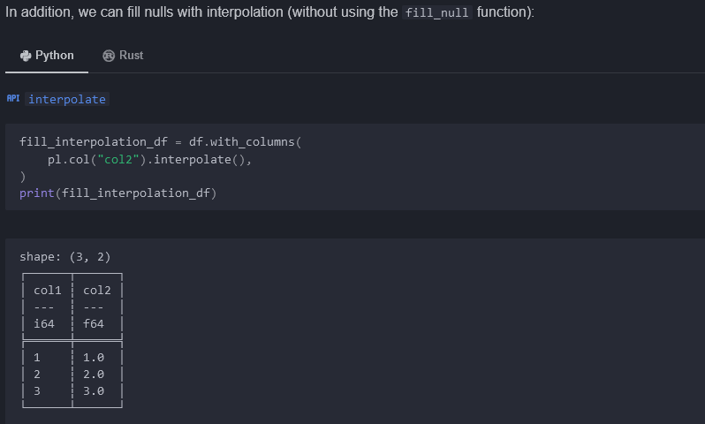

## NaN values

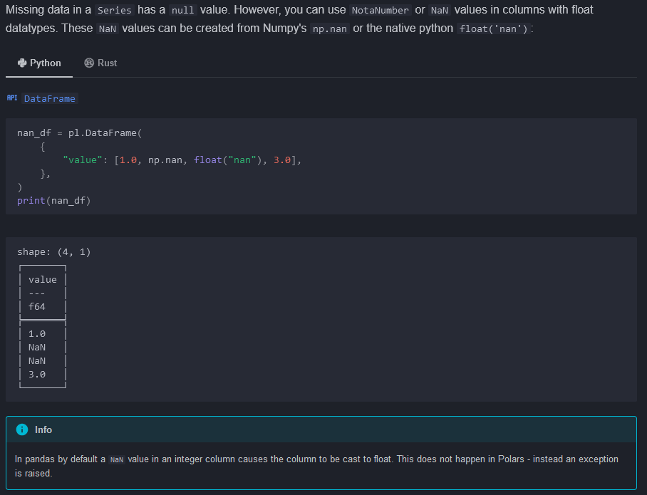

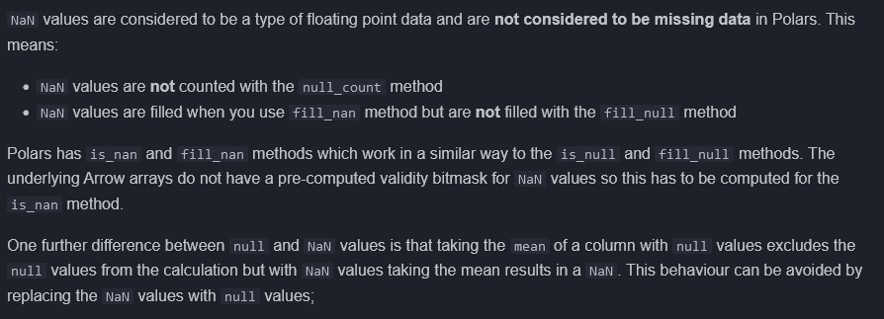

Fill_nan

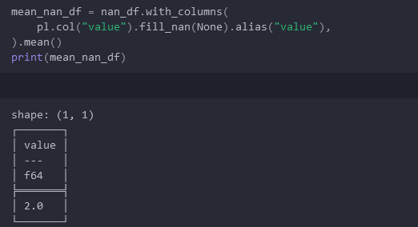

# Window functions

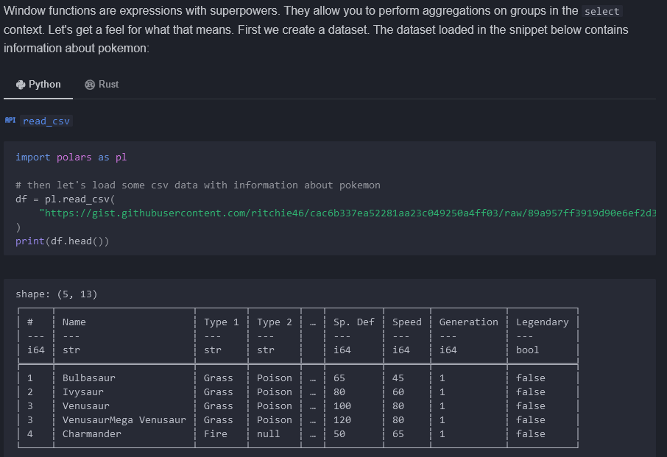

## Group by aggregations in selection

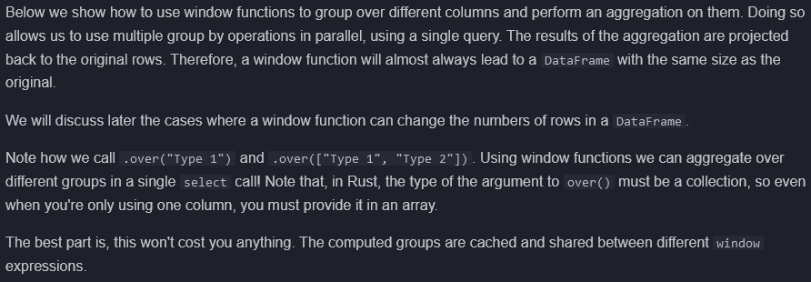

Over()

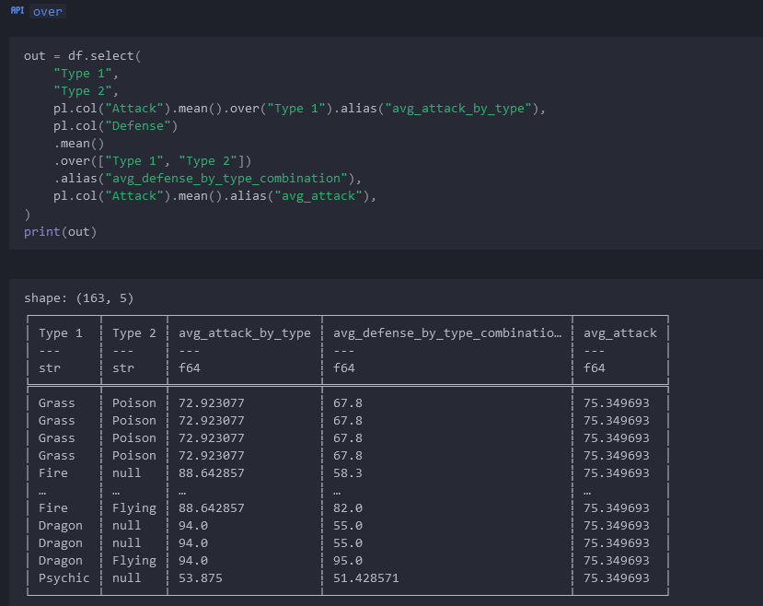

## Operations per group



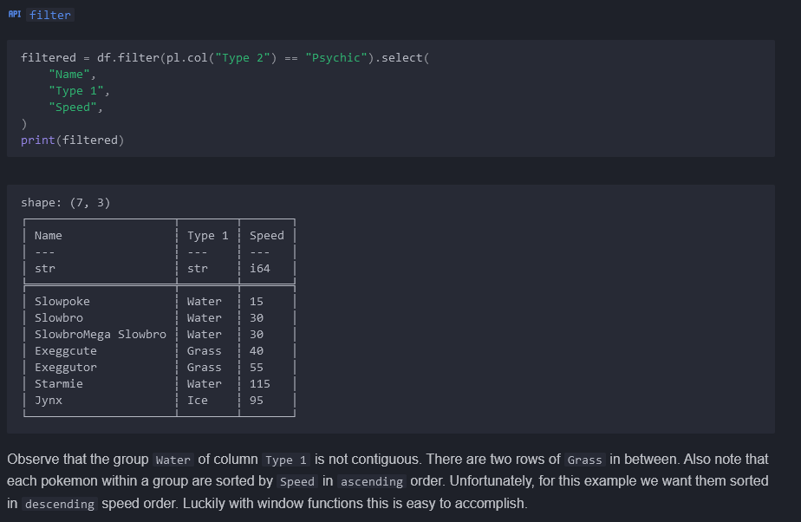

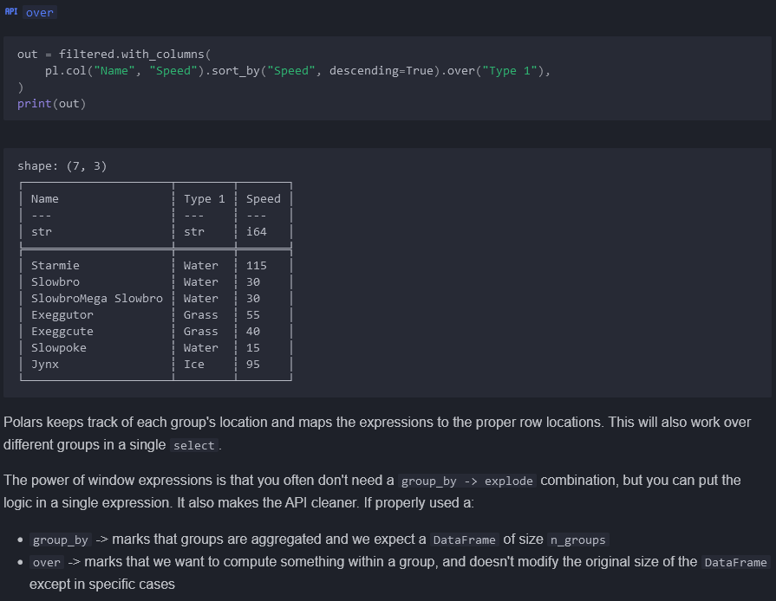

Group_by vs Over (above)

## Map the expression result to the DataFrame rows

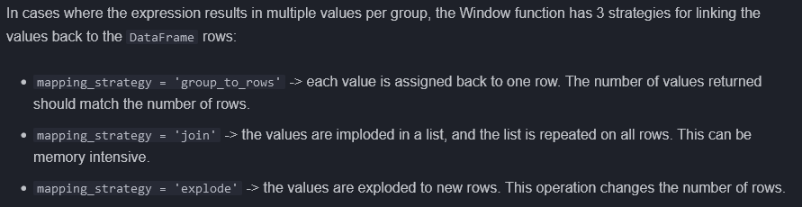

## Window expression rules

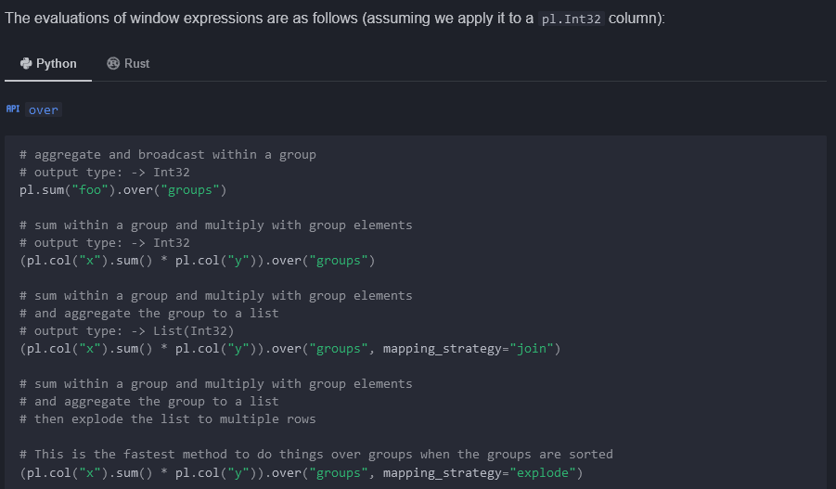

## More examples

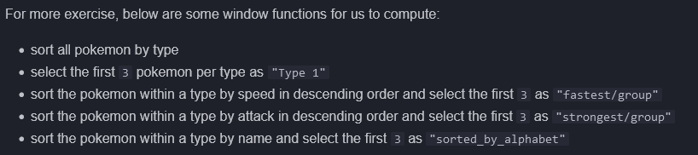

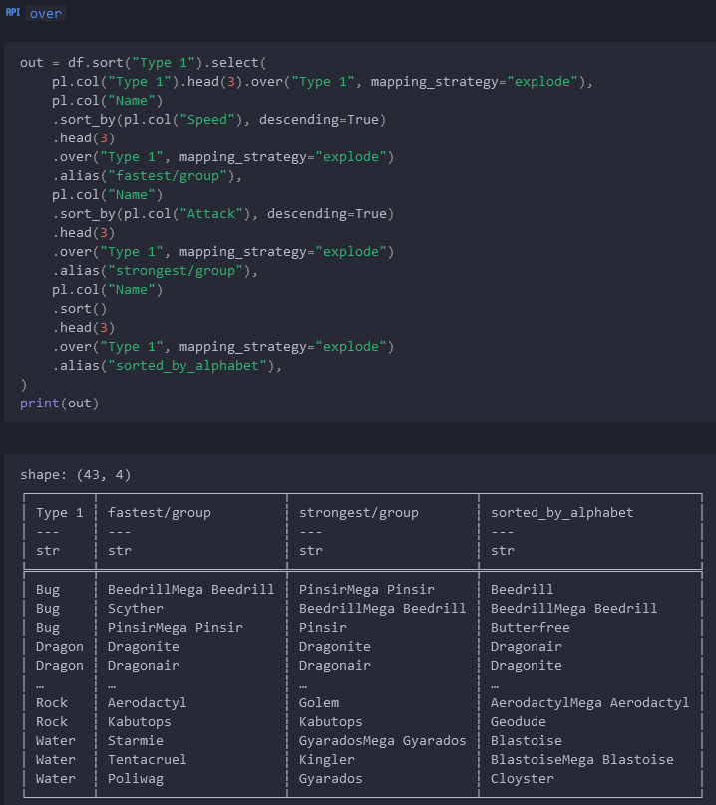

# Folds

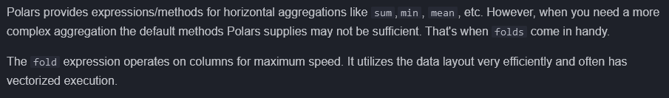

## Manual sum

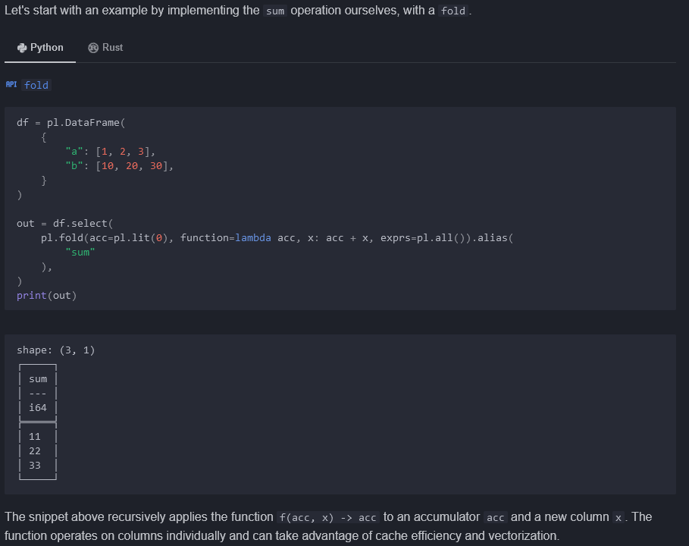

## Conditional

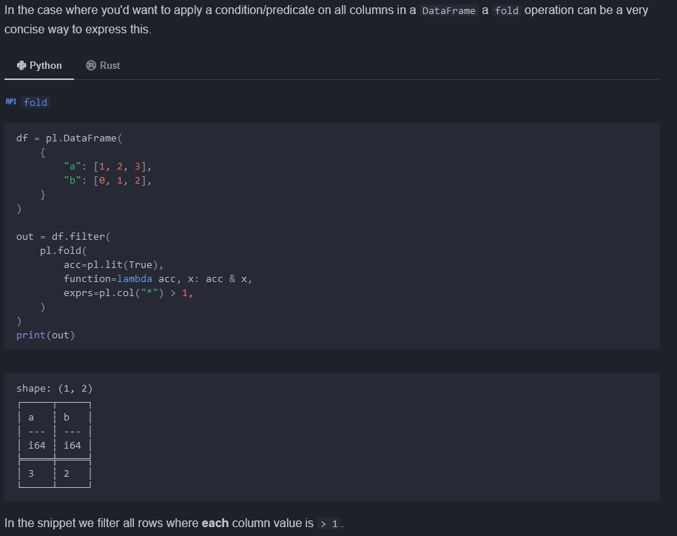

## Folds and string data

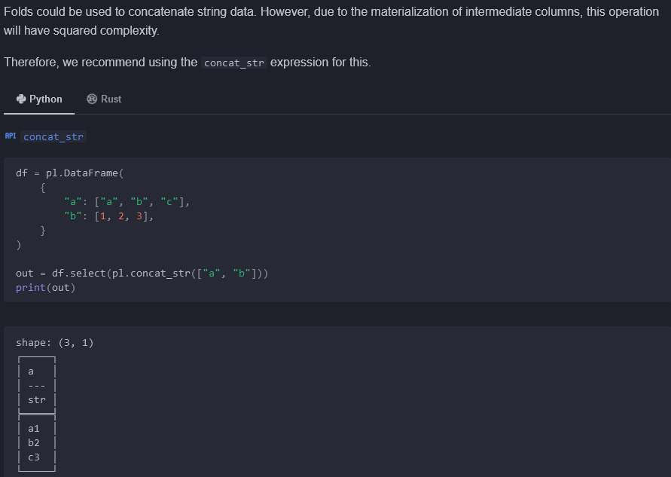

# Lists and Arrays

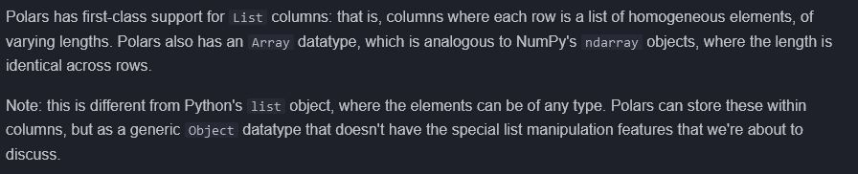

## Powerful List manipulation

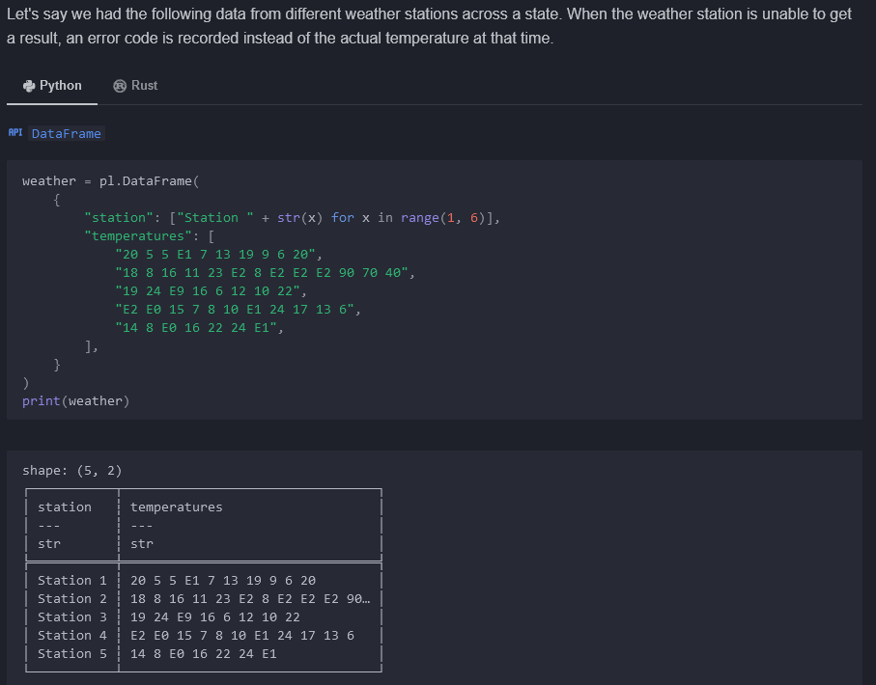

## Creating a List column

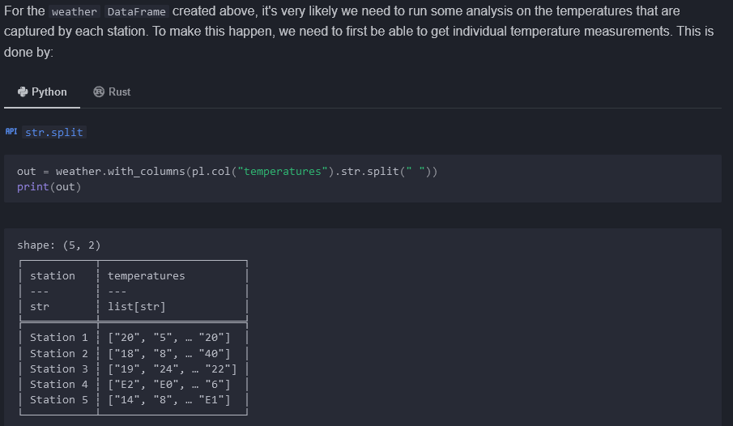

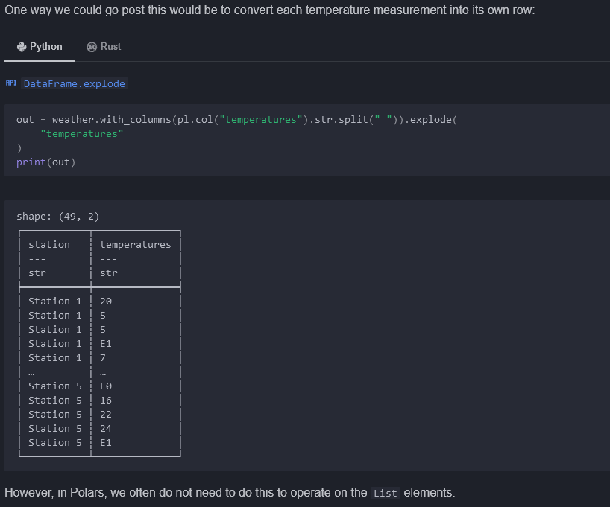

## Operating on List columns

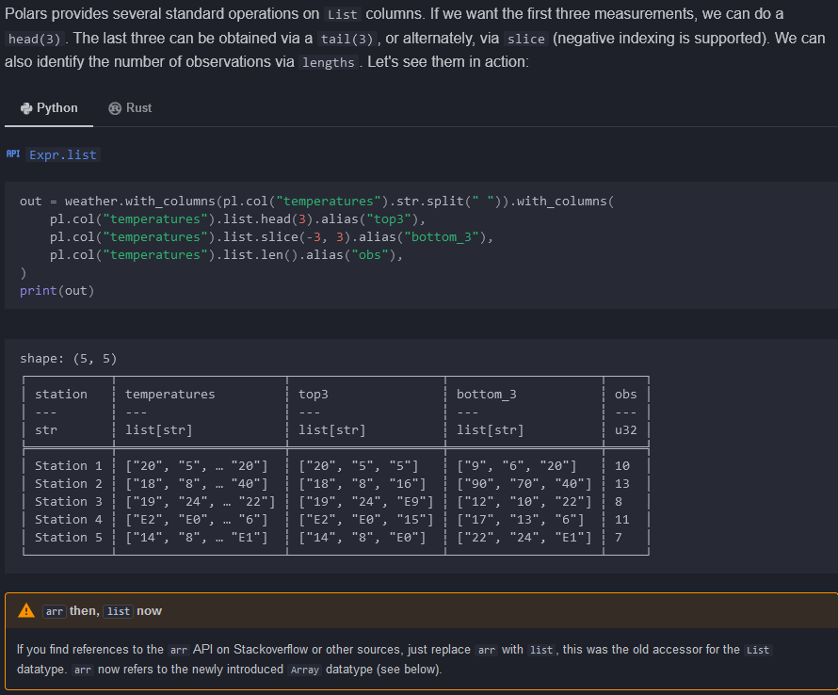

## Element-wise computation with List’s

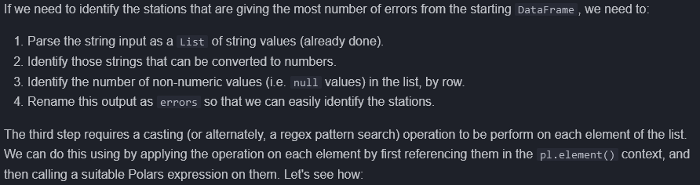

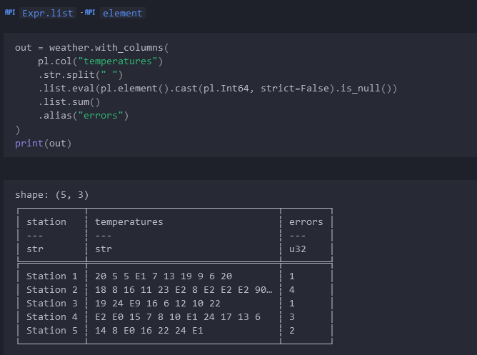

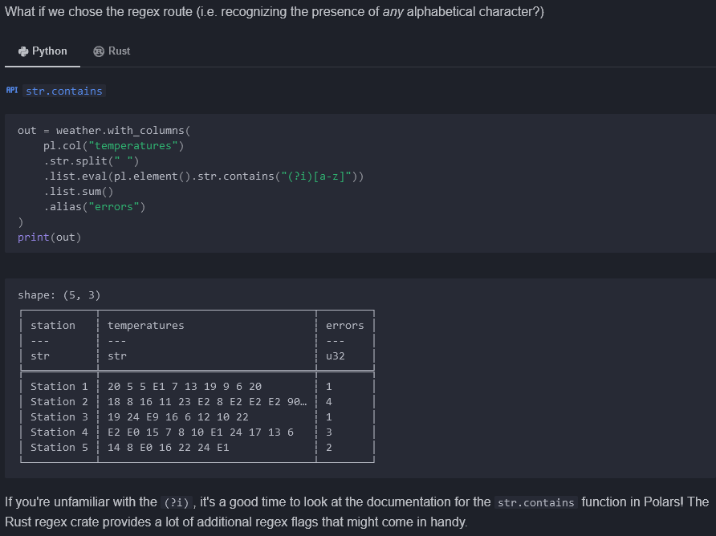

## Row-wise computations



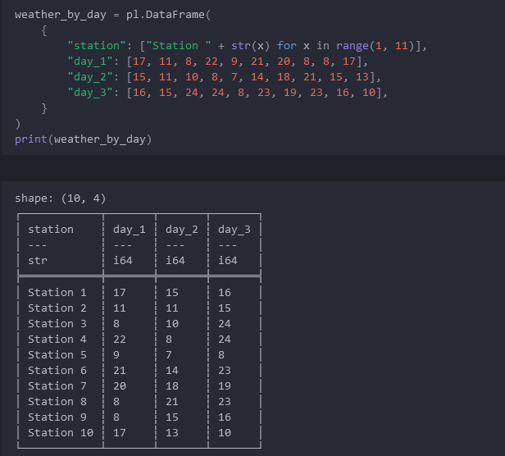

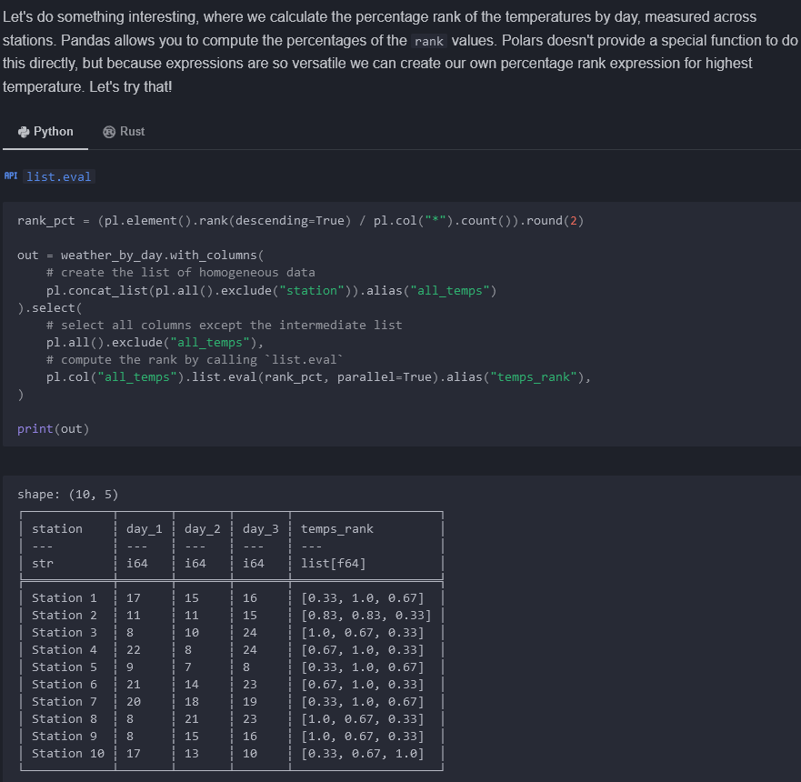

## Polars Array’s

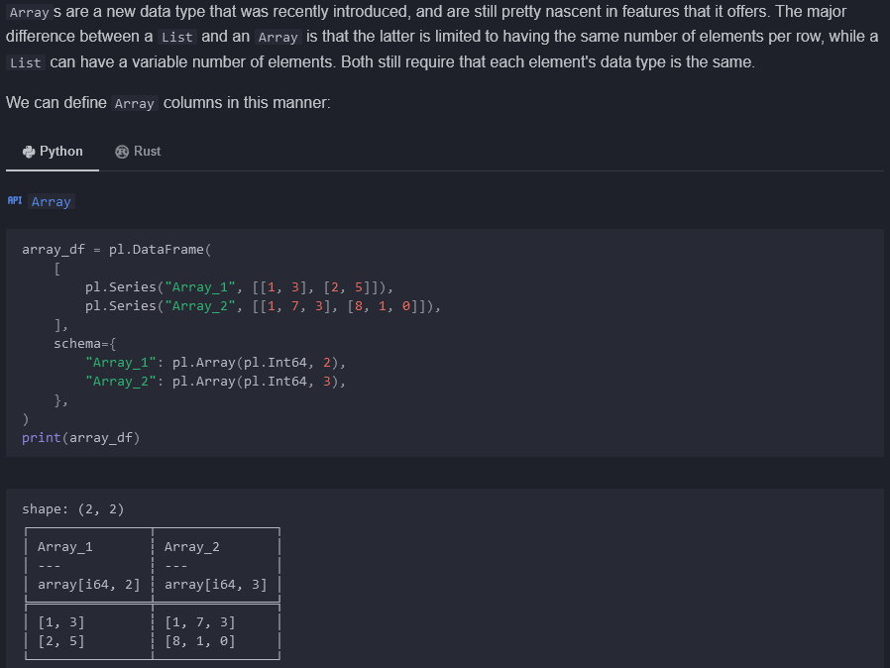

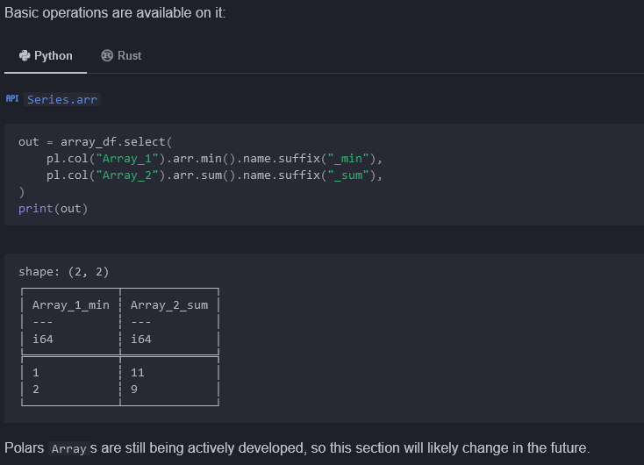

# Expression plugins

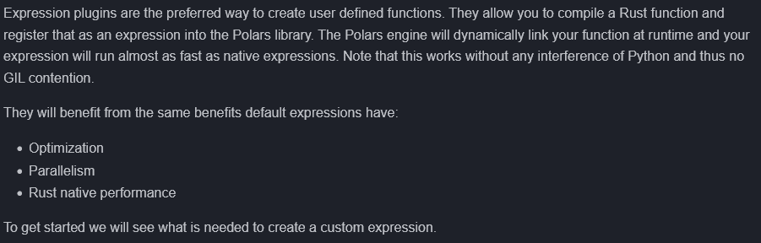

## Our first custom expression: Pig Latin

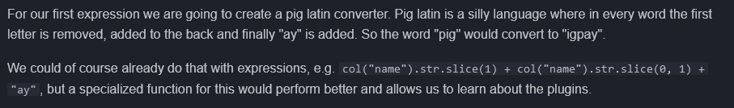

## Setting up

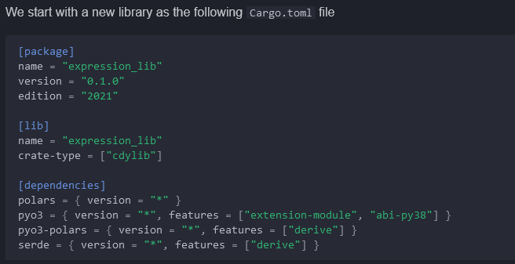

## Writing the expression

### Rust side

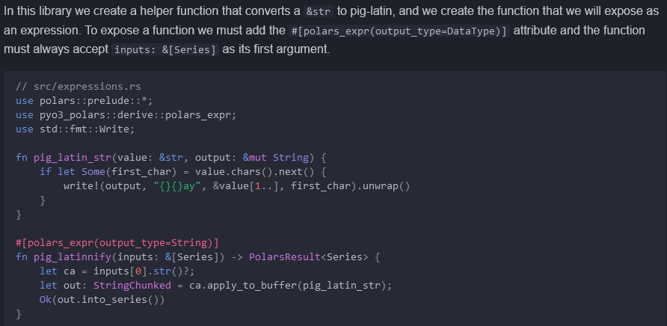

### Python side

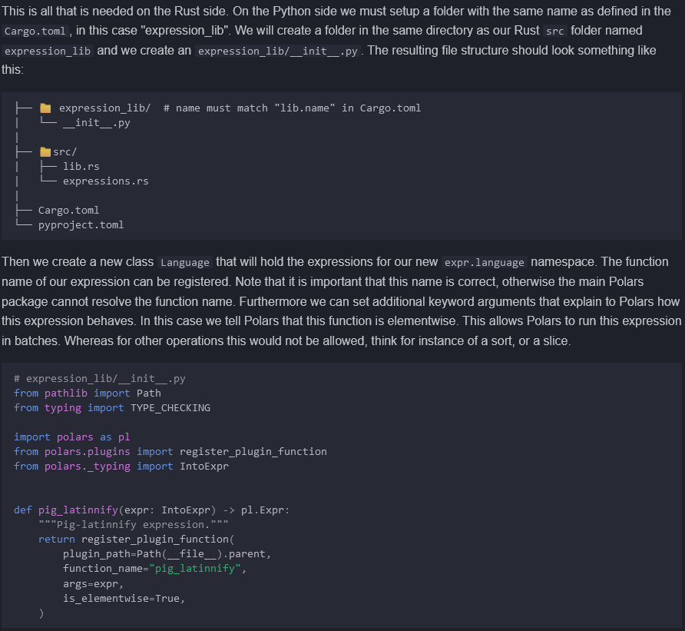

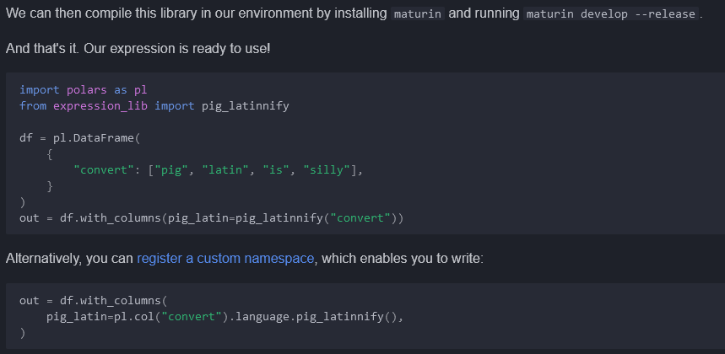

## Accepting kwargs

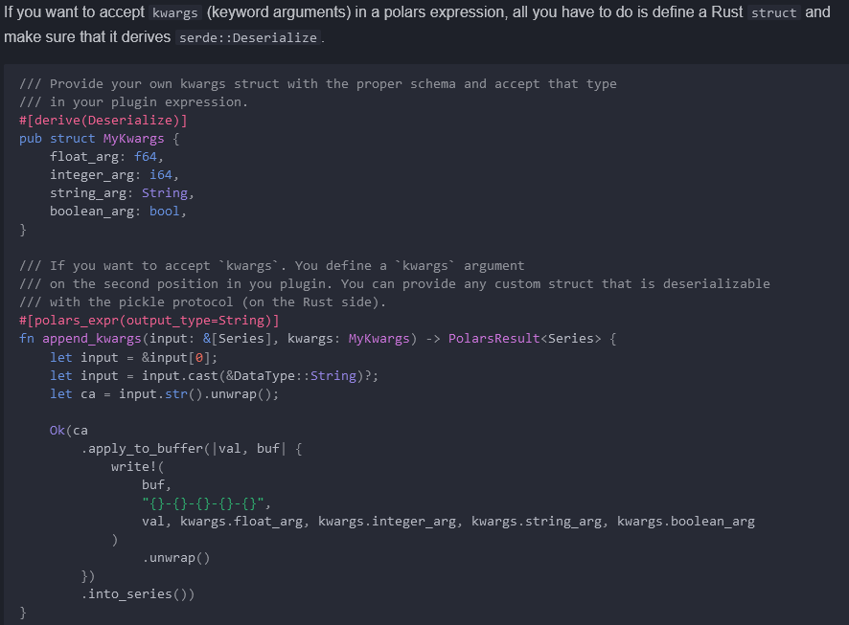

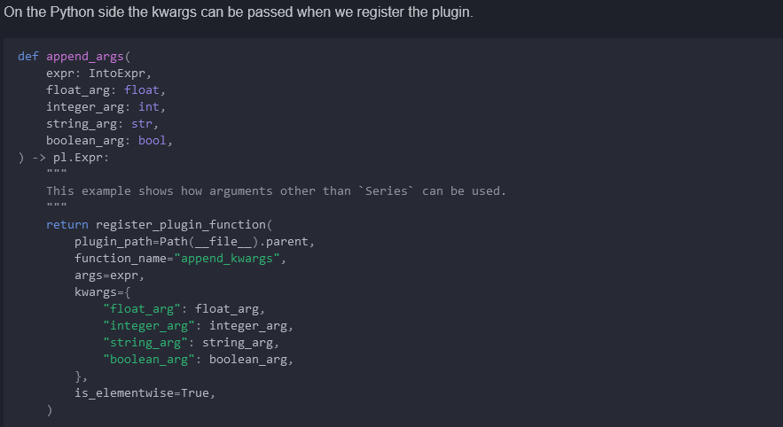

## Output data types

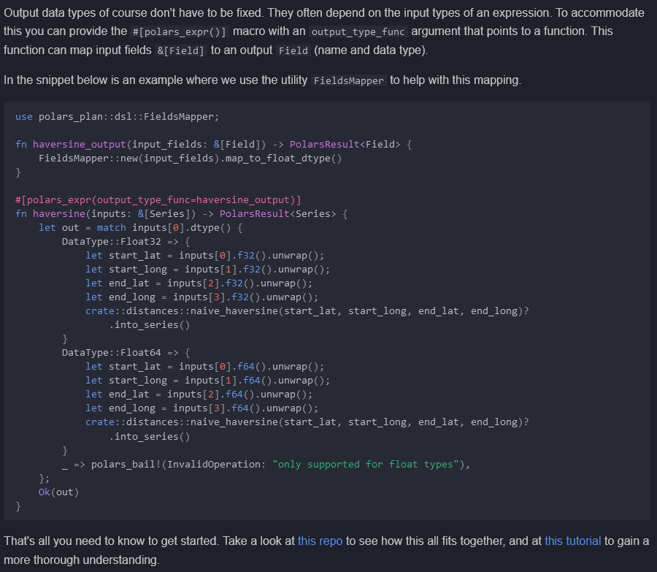

<https://github.com/pola-rs/pyo3-polars/tree/main/example/derive_expression>

<https://marcogorelli.github.io/polars-plugins-tutorial/>

# User-defined functions (Python)

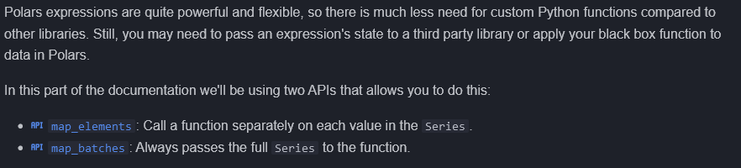

## Processing individual values with map_elements()

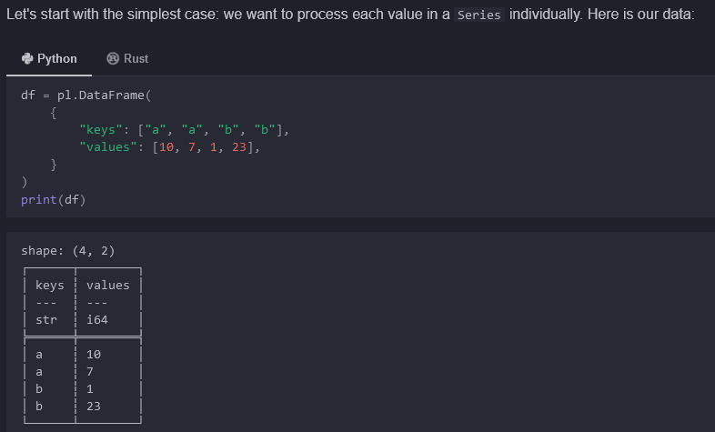

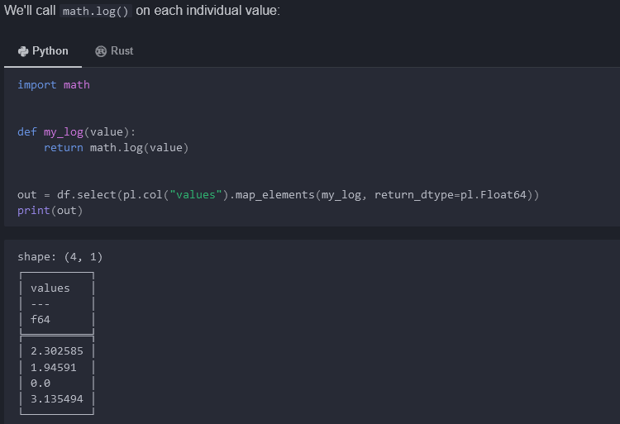

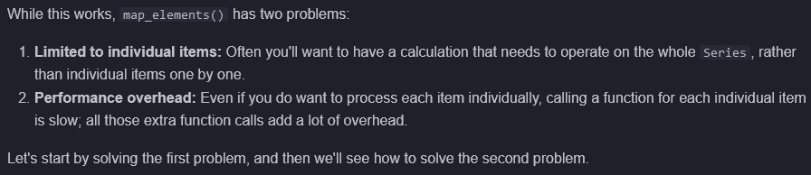

## Processing a whole Series with map_batches()

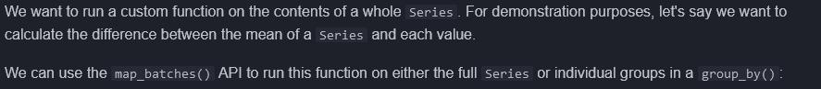

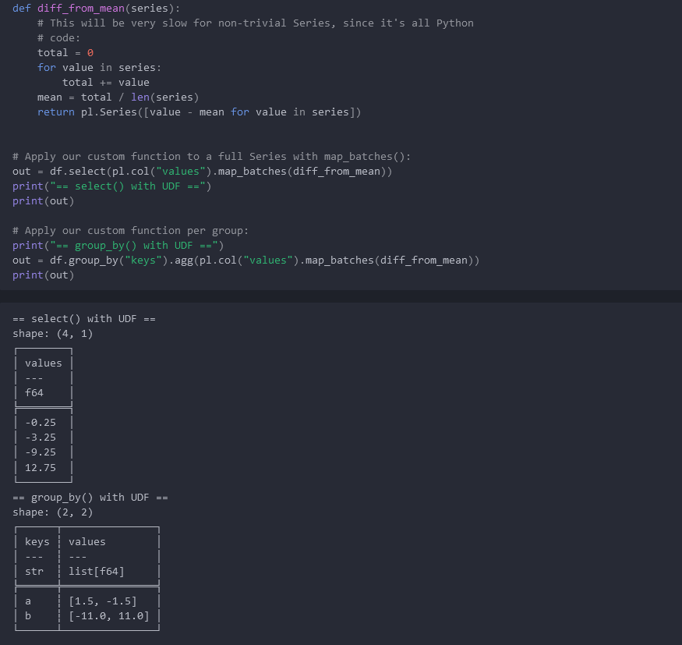

## Fast operations with user-defined functions

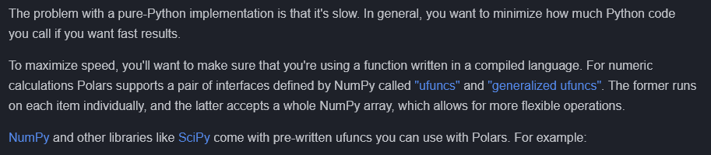

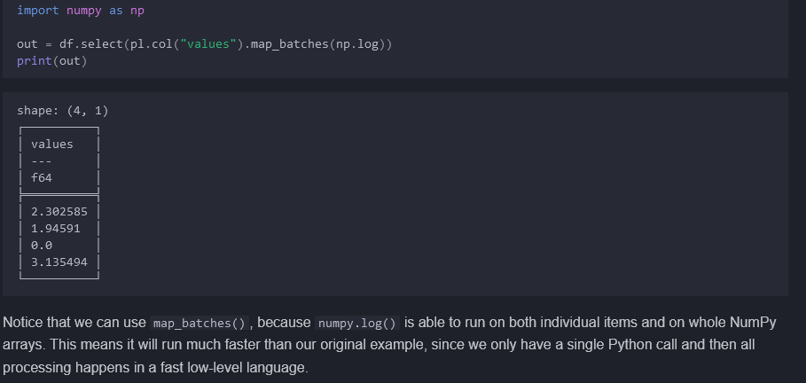

## Example: A fast custom function using Numba

<https://github.com/pola-rs/polars/issues/9175>

<https://stackoverflow.com/questions/78484792/python-polars-vectorized-operation-of-determining-current-solution-with-the-u>

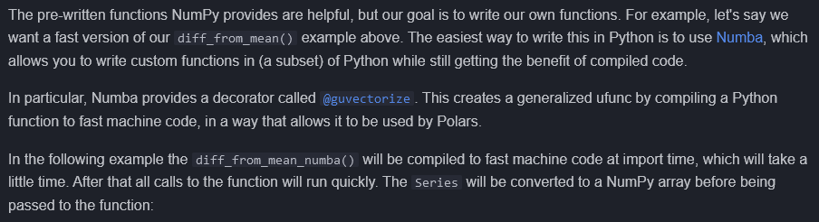

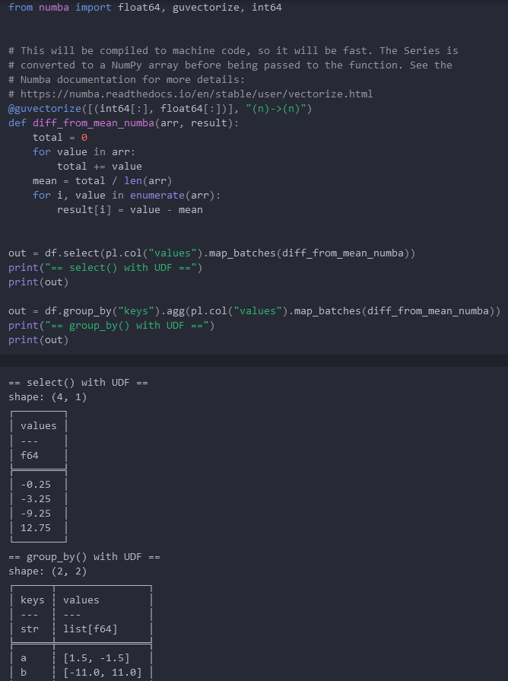

## Missing data is not allowed when calling generalized ufuncs

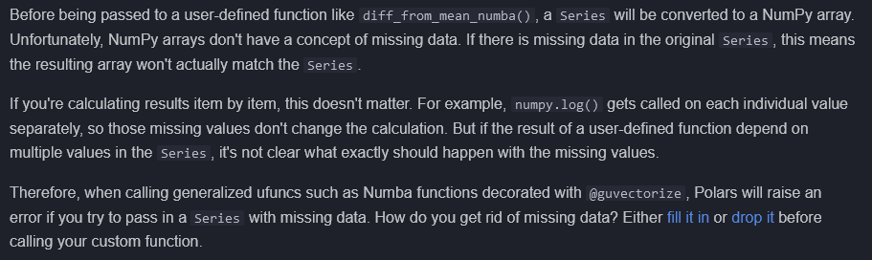

## Combining multiple column values

<https://docs.pola.rs/user-guide/expressions/structs/>

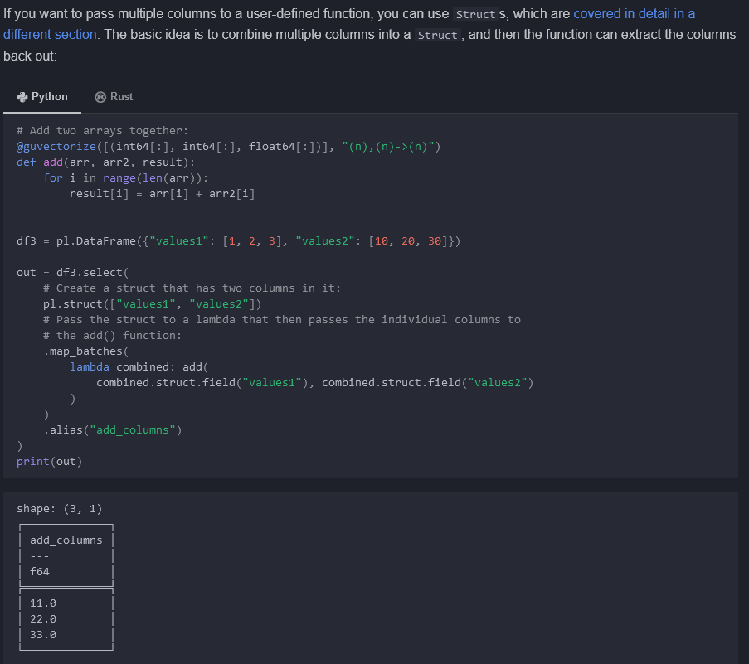

## Streaming calculations

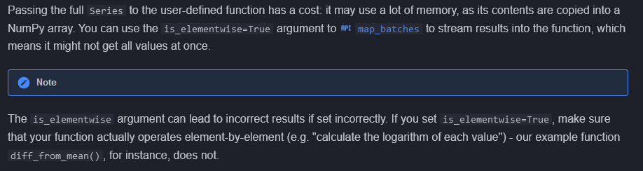

## Return types

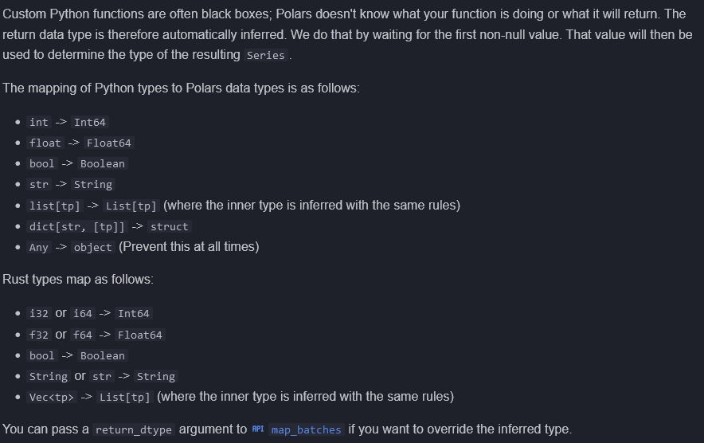

# Struct datatype



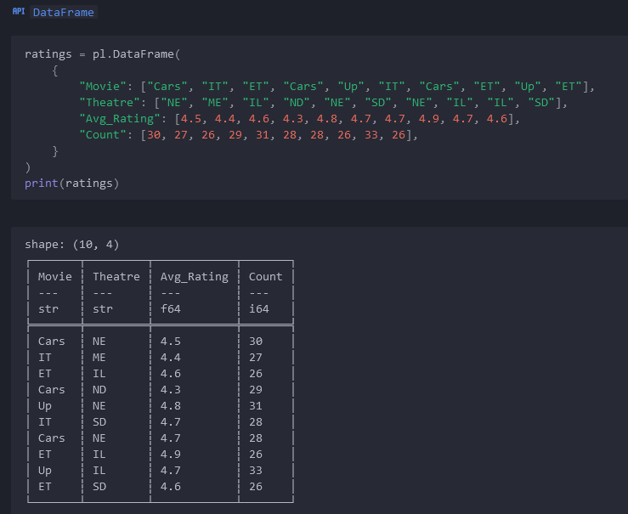

## Encountering the Struct type

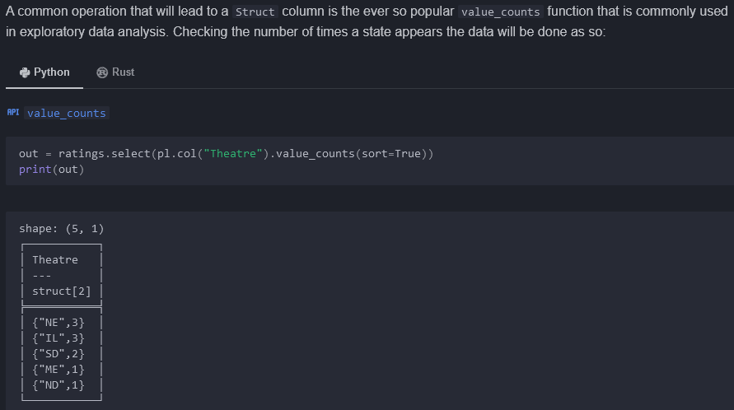

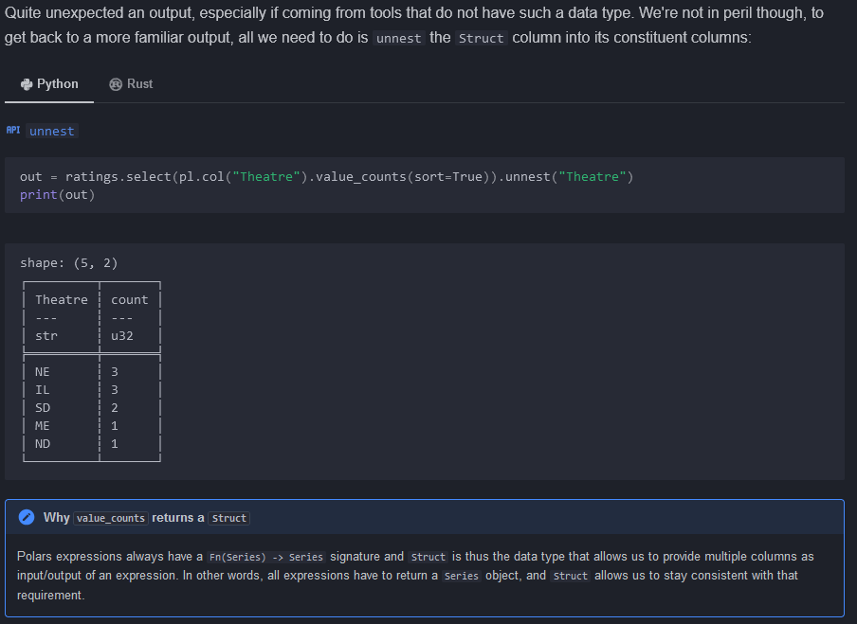

## Struct as dict’s

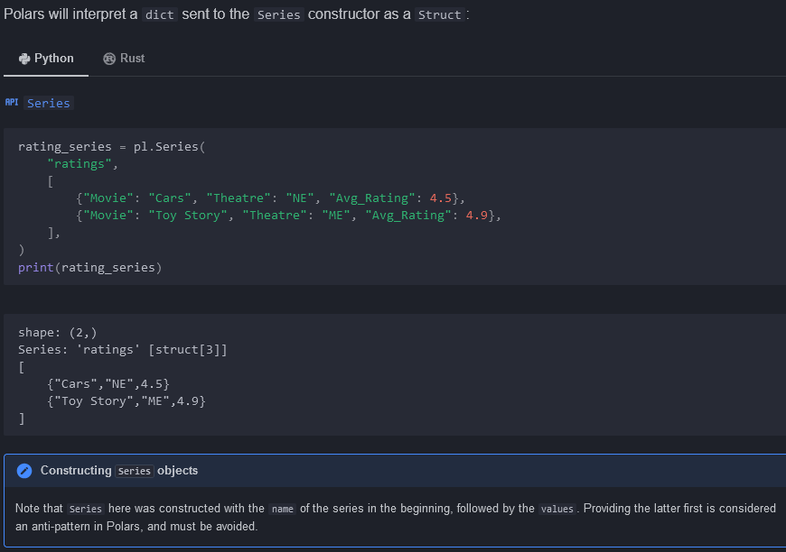

## Extracting individual values of a Struct

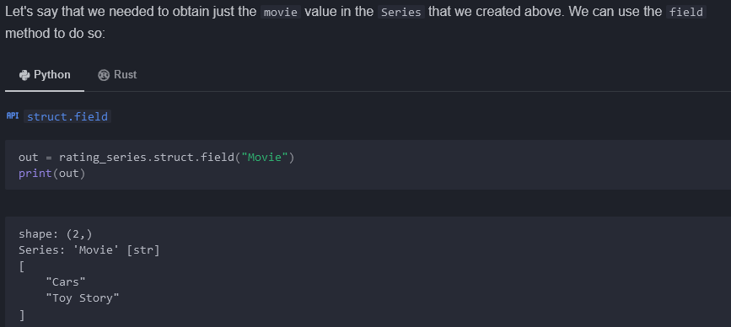

## Renaming individual keys of a Struct

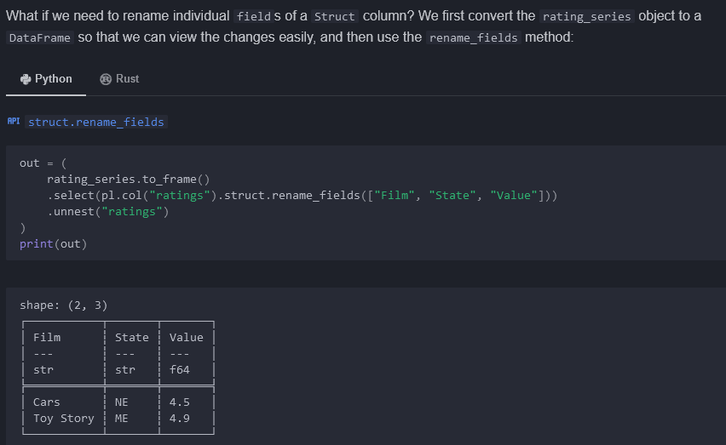

## Practical use-cases of Struct columns

### Identifying duplicate rows

Is_duplicated(), is_unique()

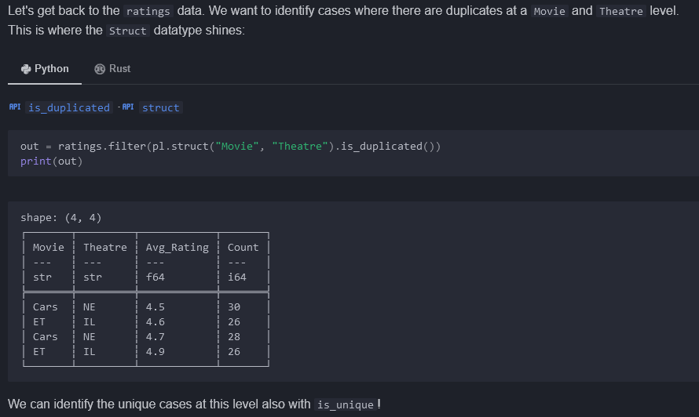

## Multi-column ranking

<https://stackoverflow.com/questions/76101516/how-to-create-a-rank-on-two-columns-in-python-polars>

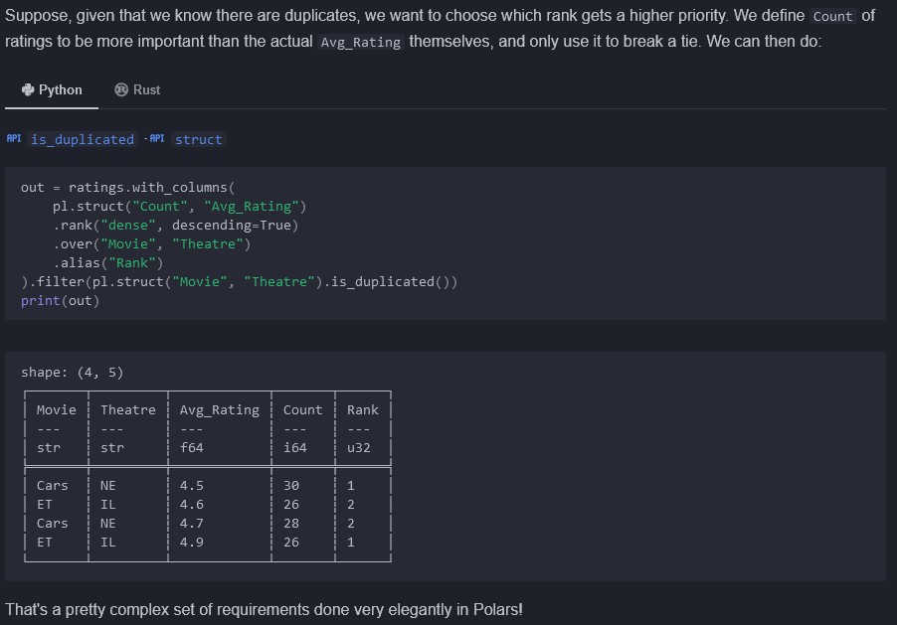

## Using multi-column apply

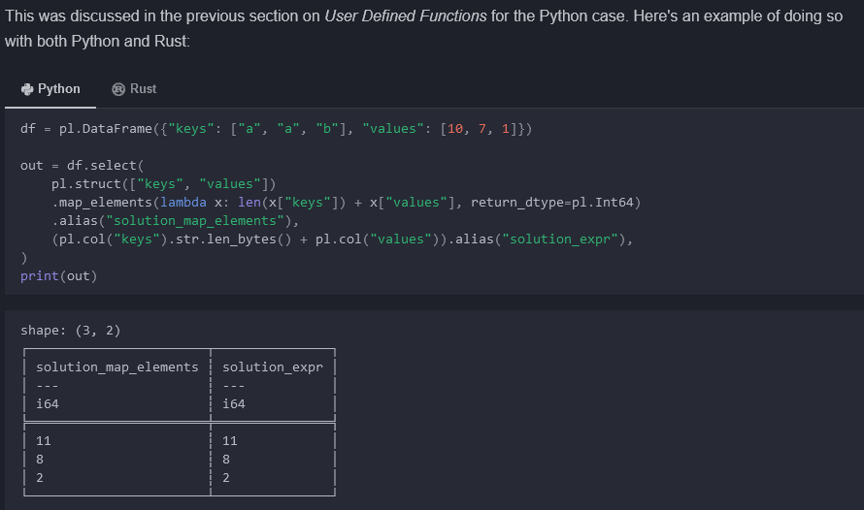

# NumPy < - > Polars

<https://numpy.org/doc/stable/reference/ufuncs.html#available-ufuncs>

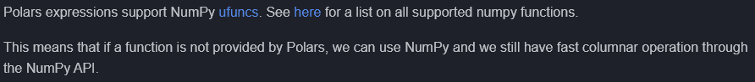

## Example

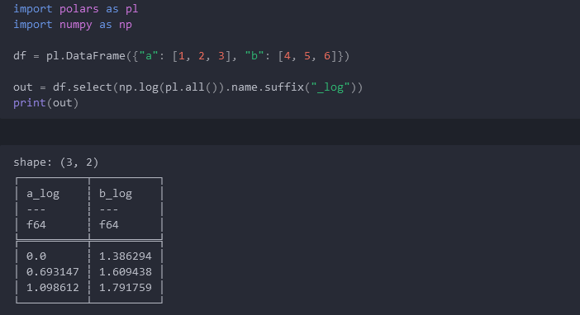

## Interoperability

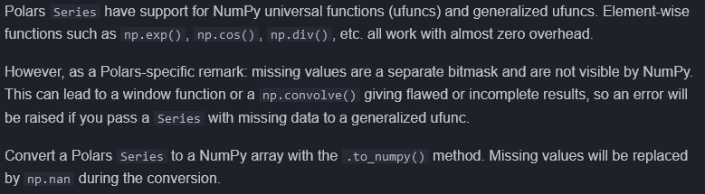

# Transformations

## Join

See also df.update(..)

### Join strategies

Df1.join(df2, left_on = , right_on = , how = inner … )

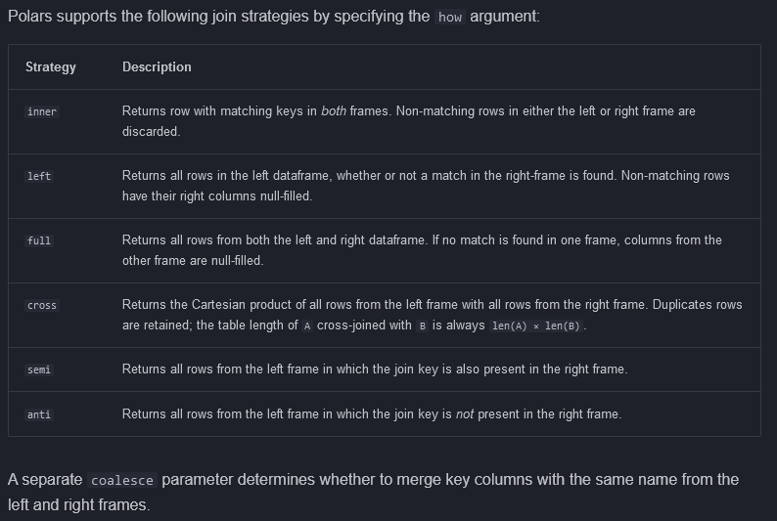

### Semi join

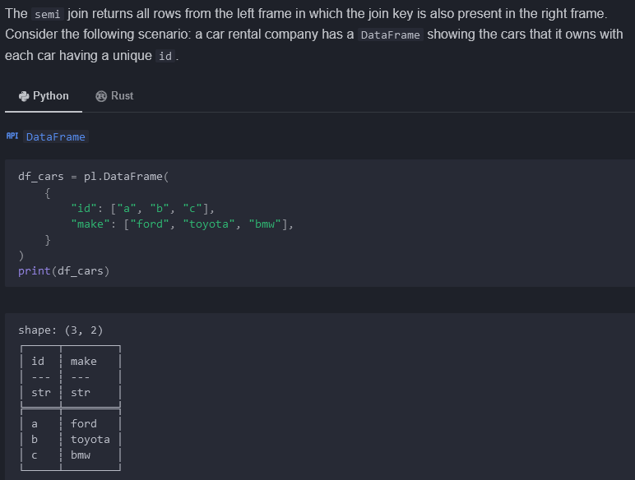

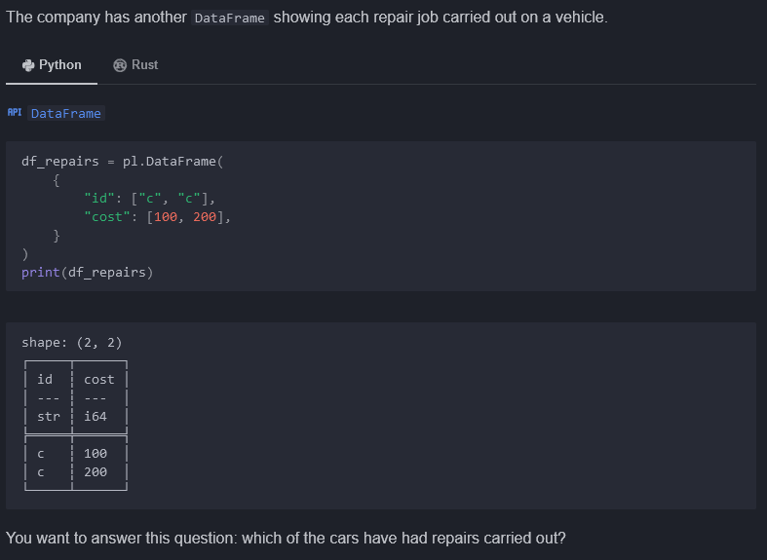

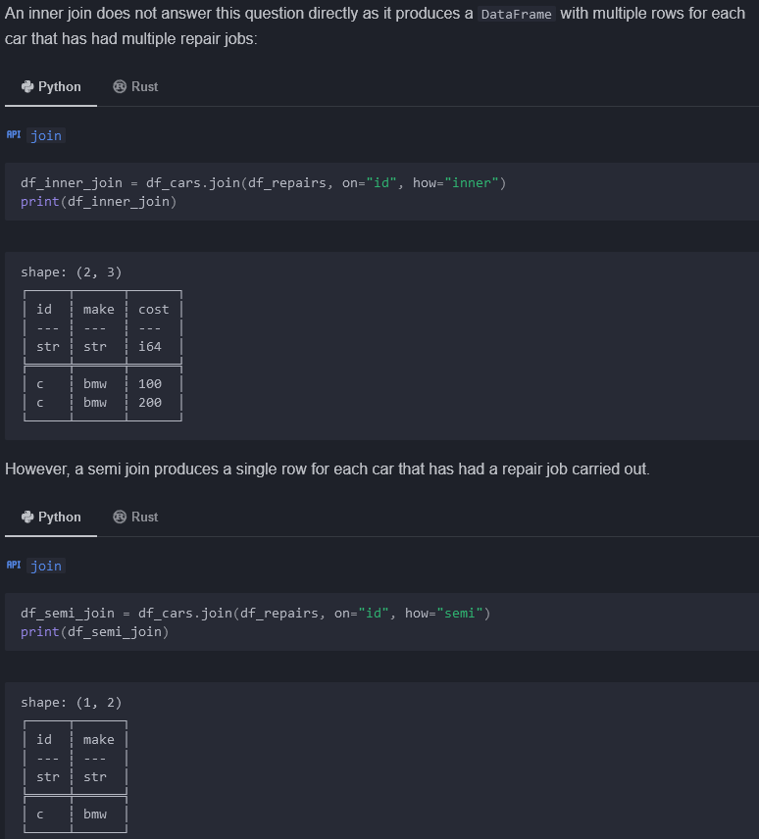

### Anti join

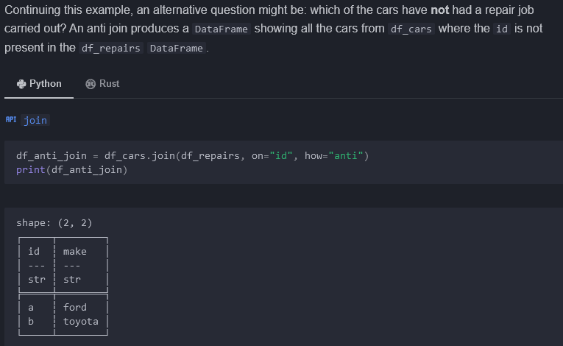

### Asof join

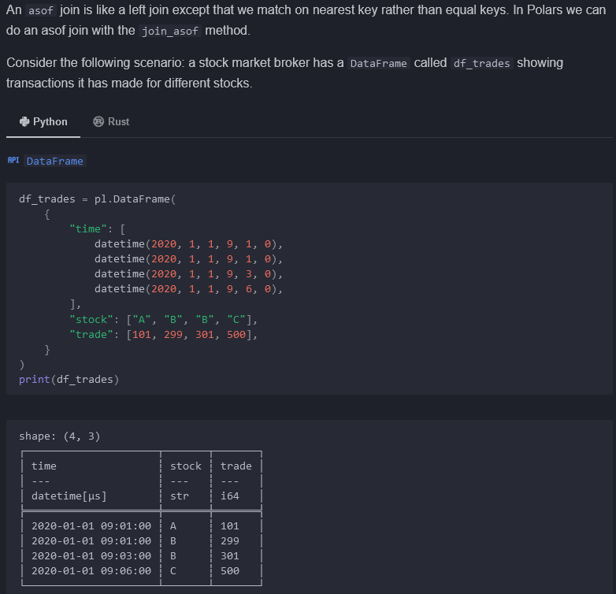

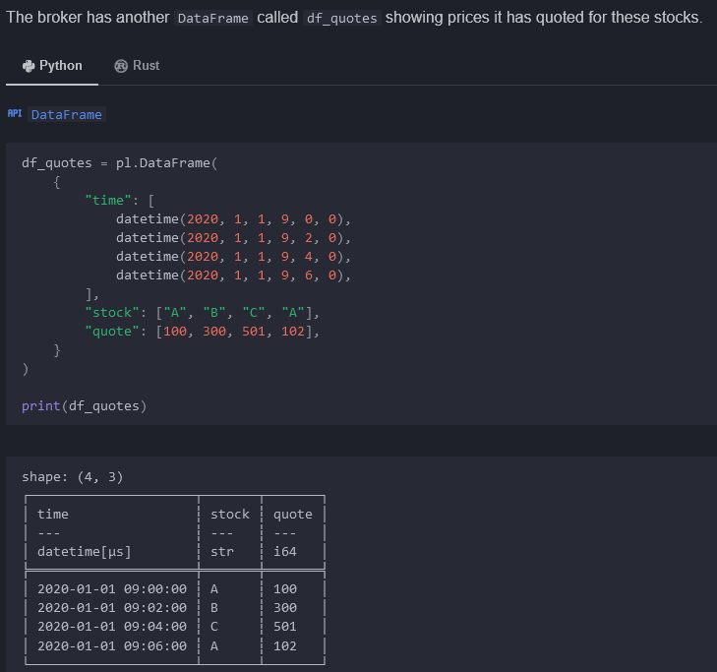

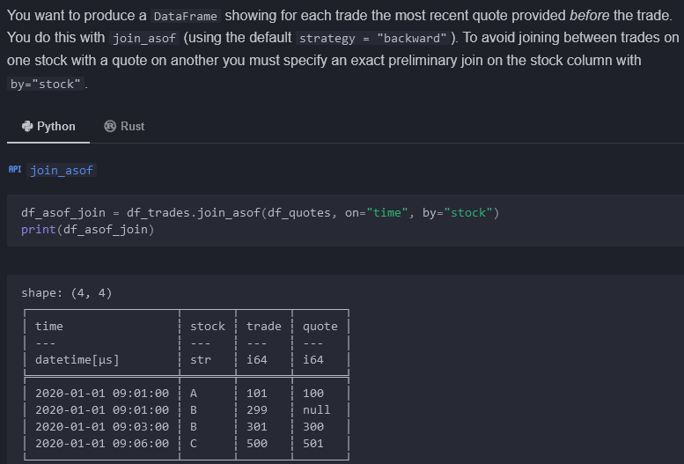

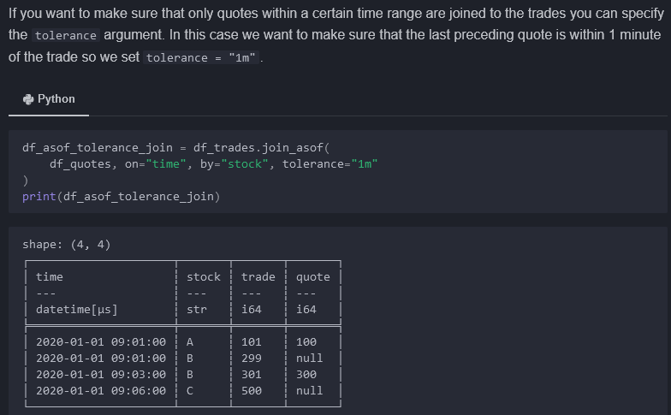

## Concatenation

Pl.concat( [df1, df2], how=”vertical” | horizontal | diagonal )

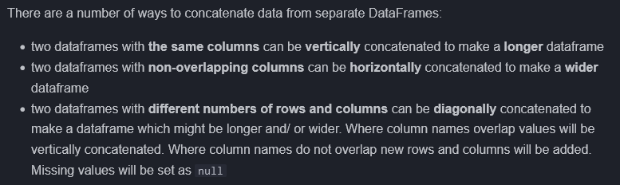

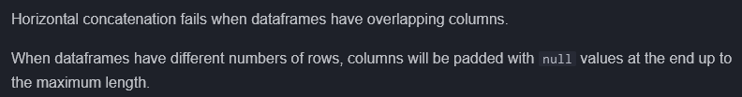

### Diagonal concatenation

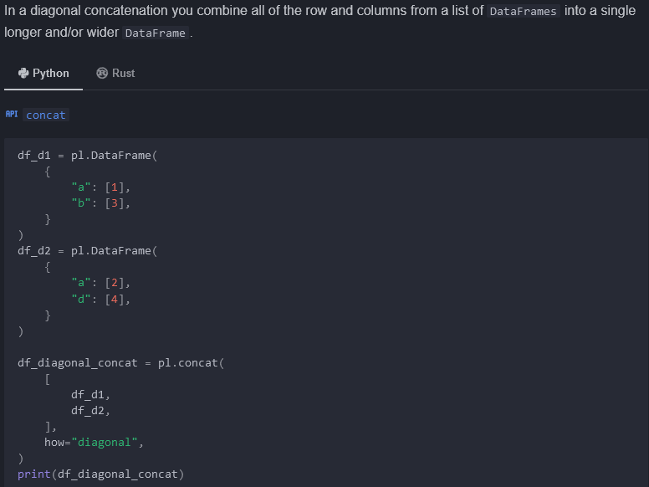

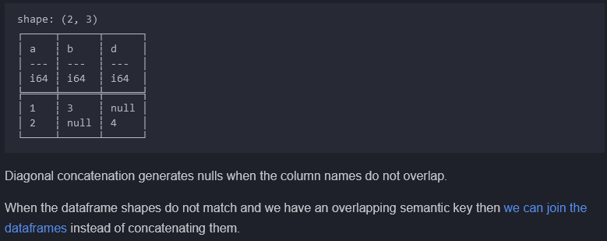

### Rechunking

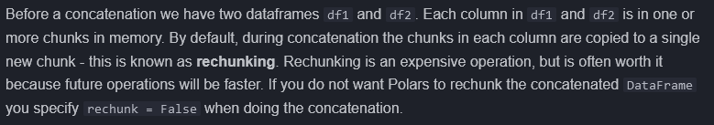

## Pivots

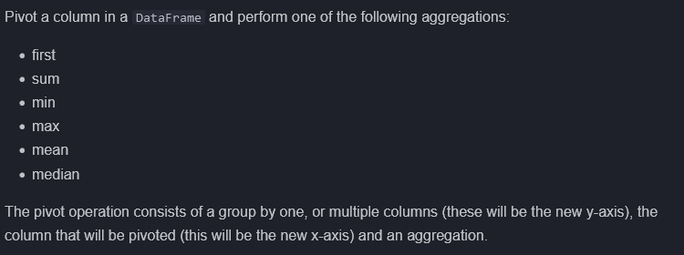

### Eager vs Lazy

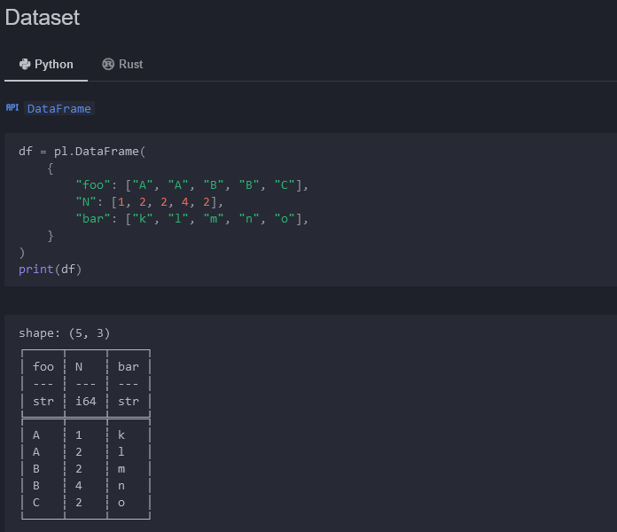

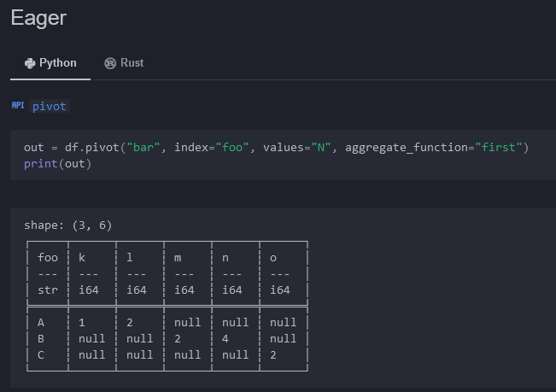

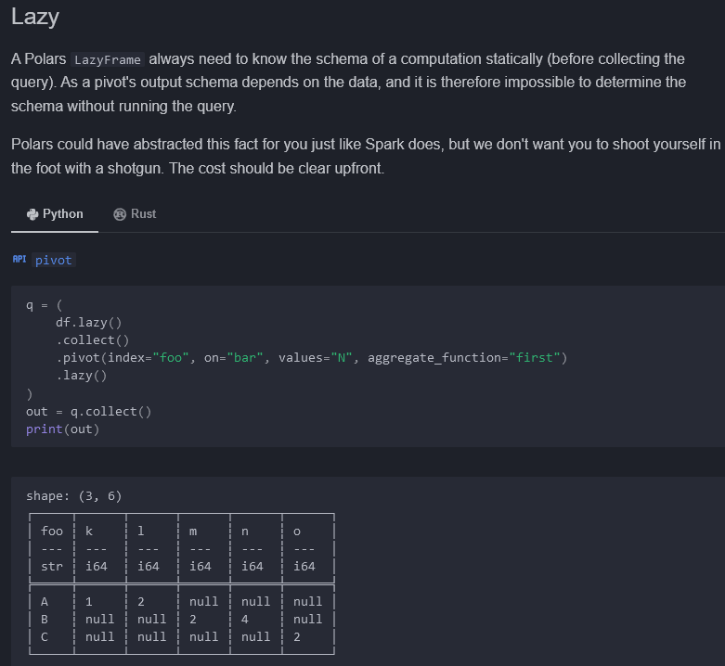

## Unpivots



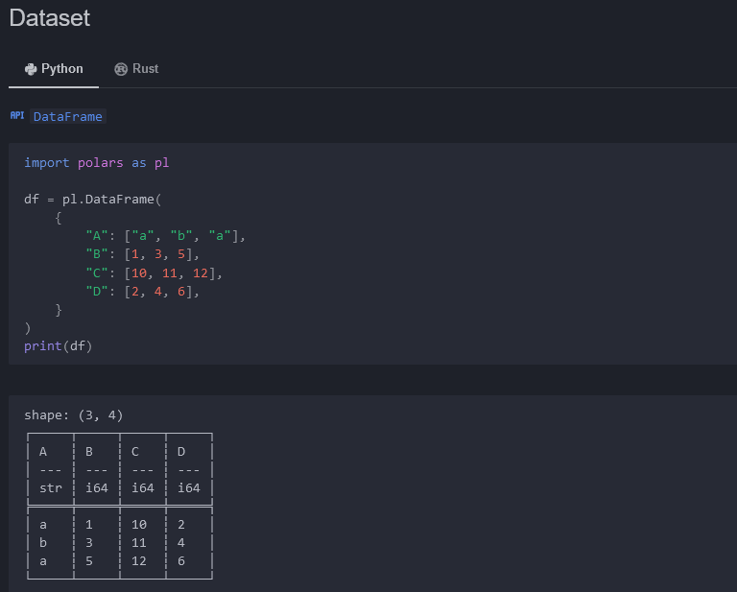

### Eager + lazy

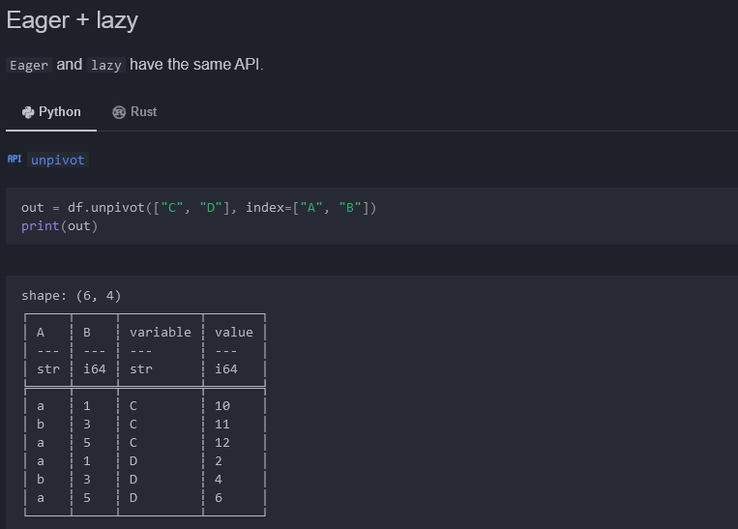

# Date Parsing



## Datatypes

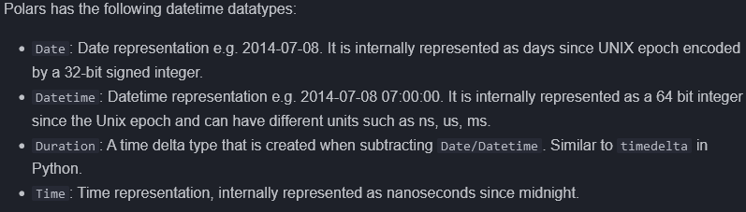

## Parsing dates from a file

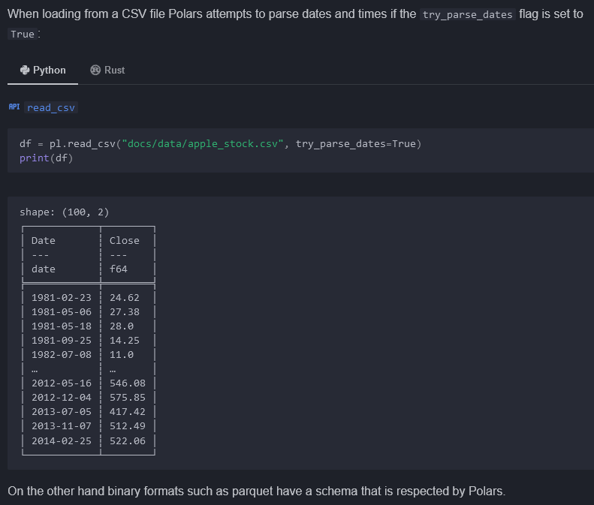

## Casting strings to dates

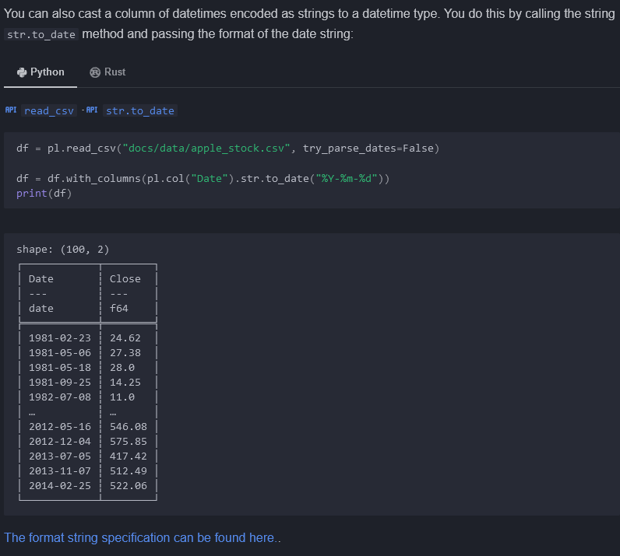

<https://docs.rs/chrono/latest/chrono/format/strftime/index.html>

## Extracting date features from a date column



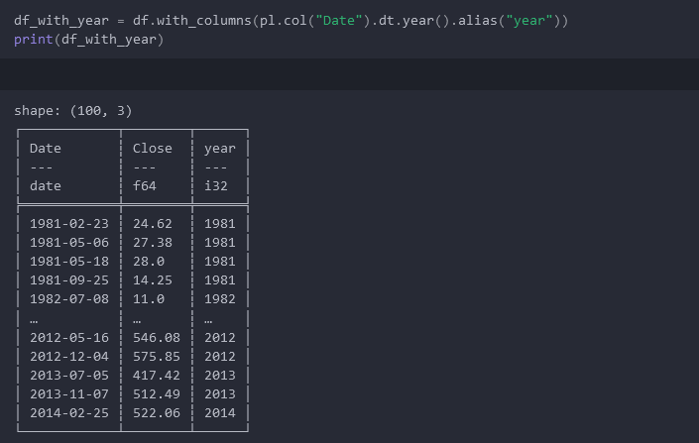

## Mixed offsets

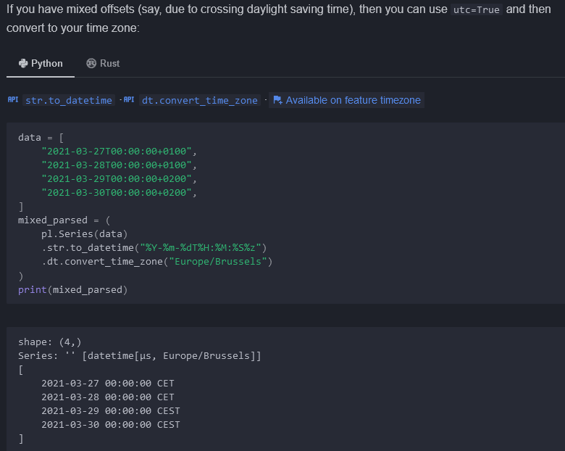

# Date Filtering

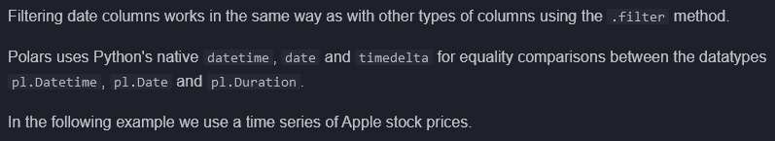

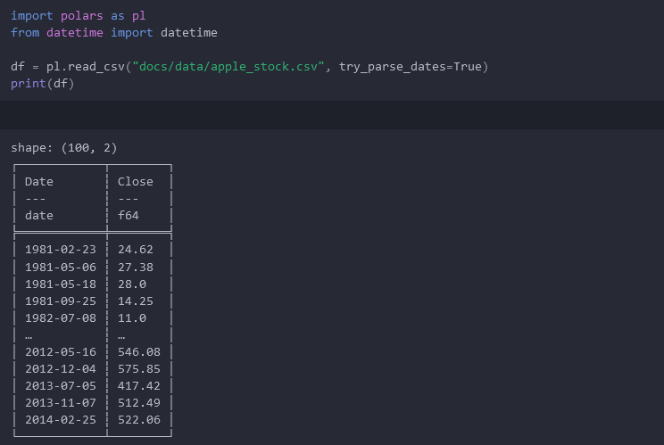

## Filtering by single dates

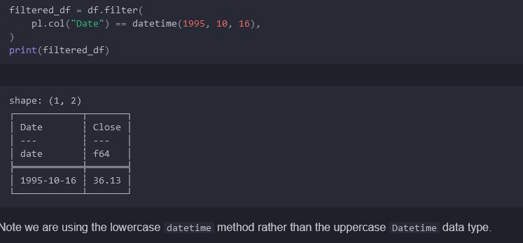

## Filtering by a date range

Is_between()

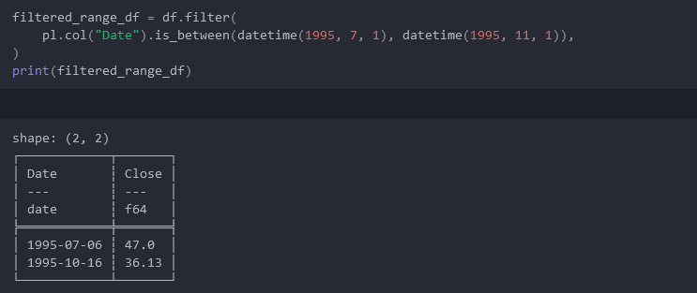

## Filtering with negative dates

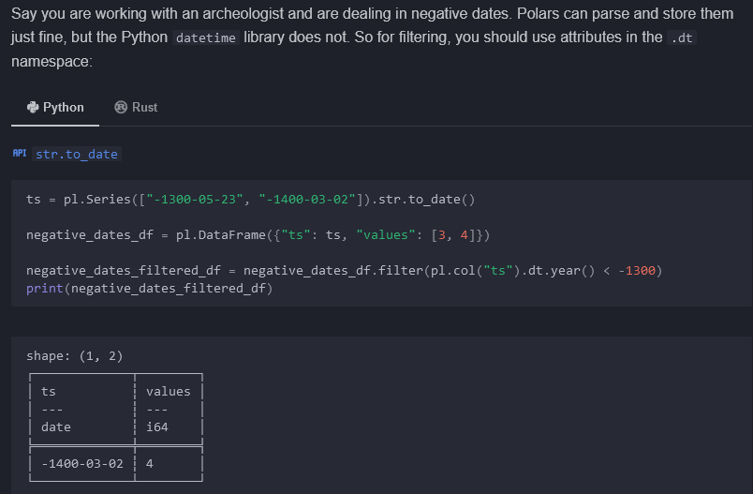

# Date Grouping

Group_by_dynamic

<https://docs.pola.rs/api/python/stable/reference/dataframe/api/polars.DataFrame.group_by_dynamic.html>

## Grouping by fixed windows



### Annual average example

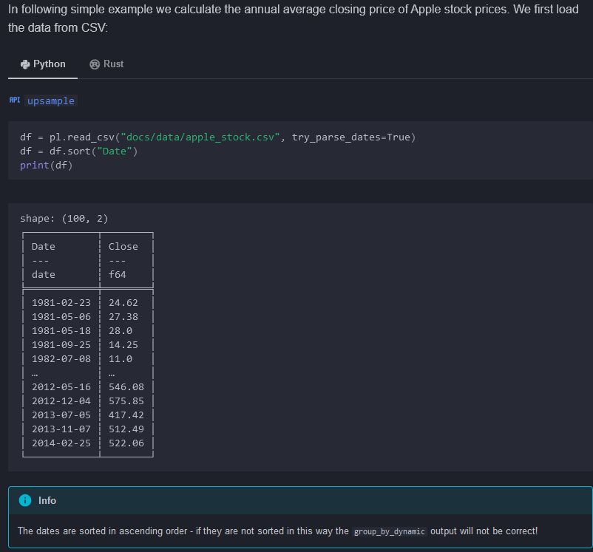

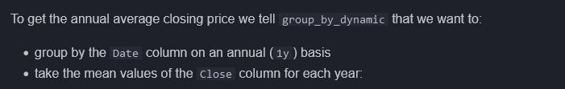

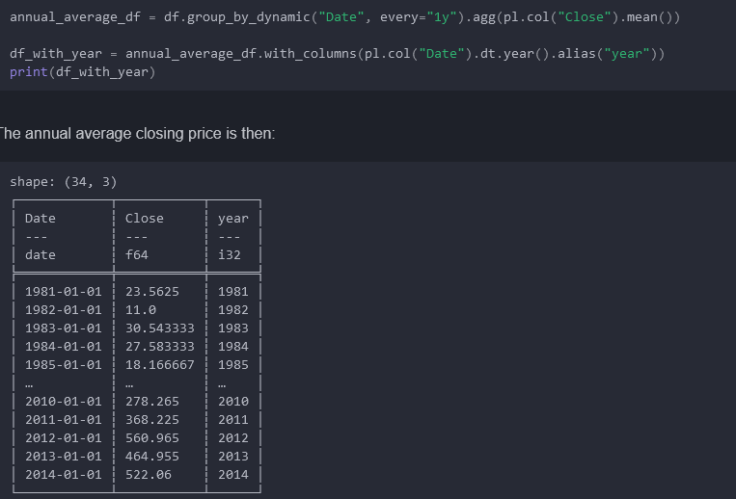

### Parameters for group_by_dynamic

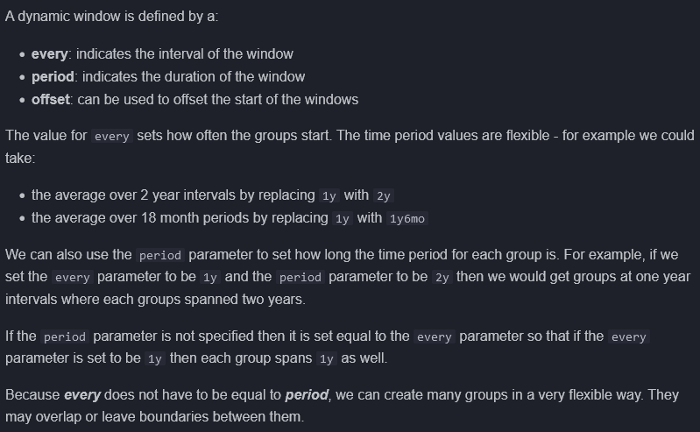

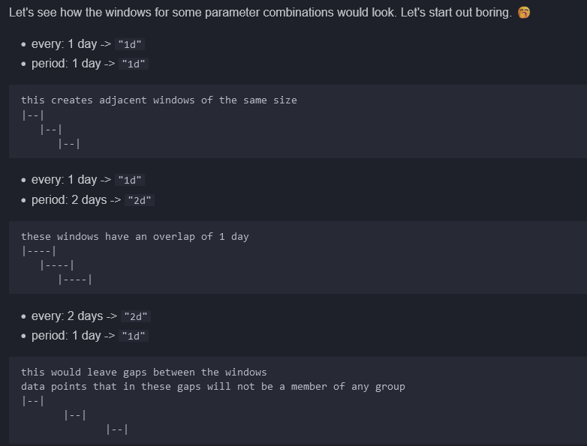

### Truncate

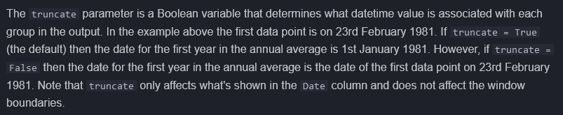

### Using expressions in group_by_dynamic

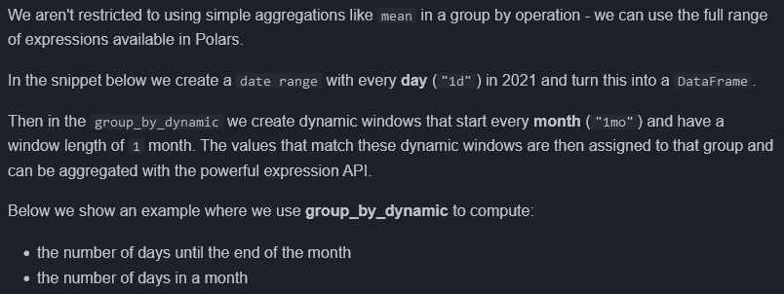

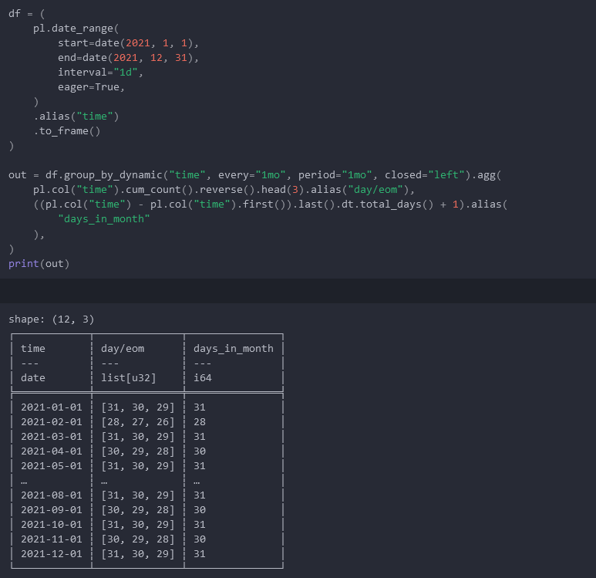

## Grouping by rolling windows

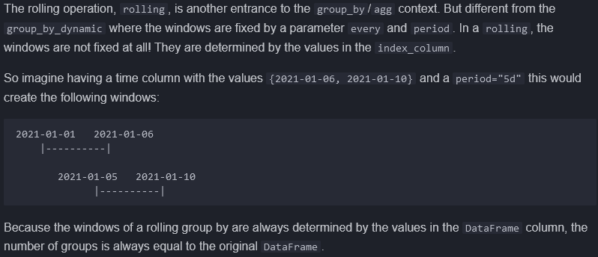

## Combining group by operations



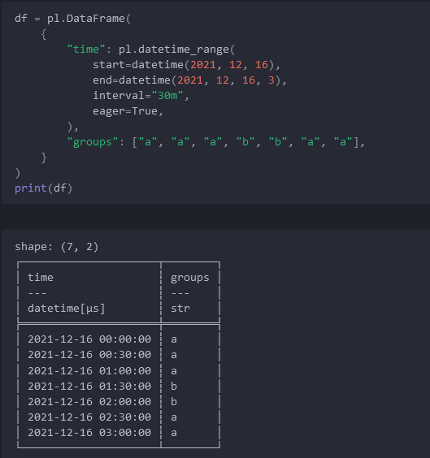

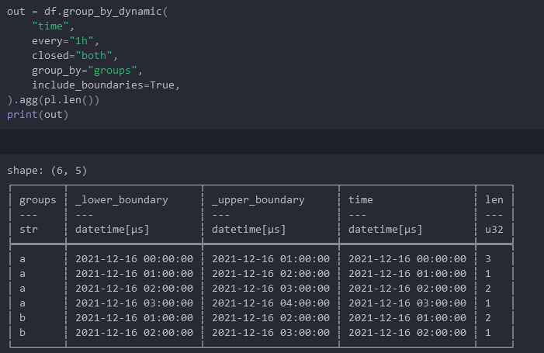

# Date Resampling (upsample/downsample)

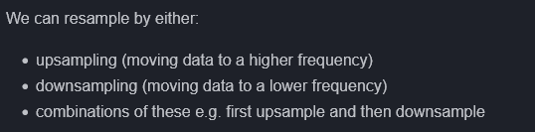

## Downsample (to lower frequency)



<https://docs.pola.rs/user-guide/transformations/time-series/rolling/>

## Upsample (to a higher frequency)

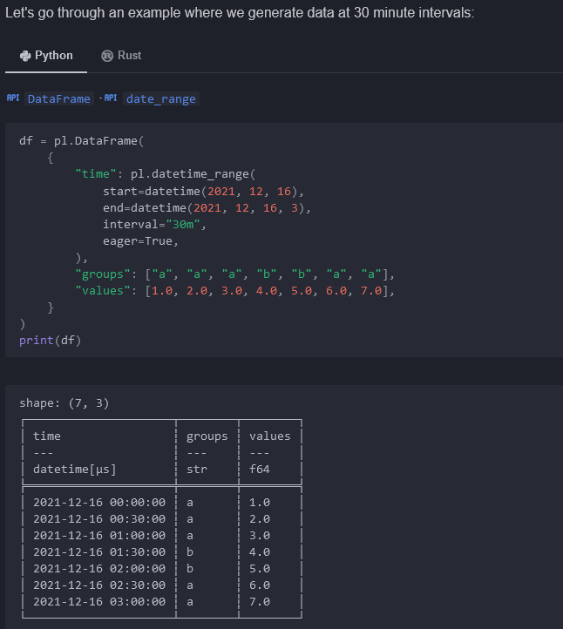

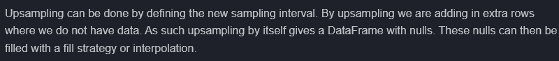

## Upsampling strategies

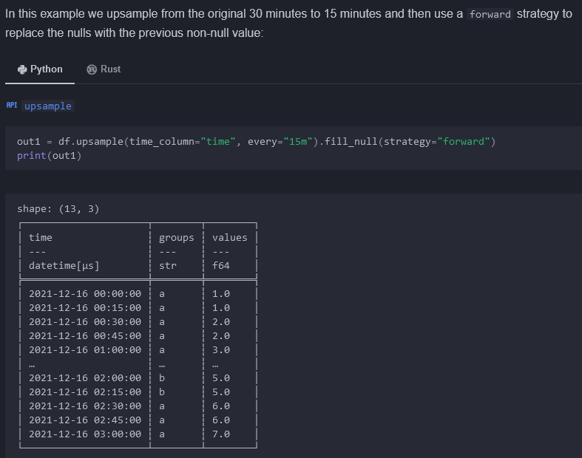

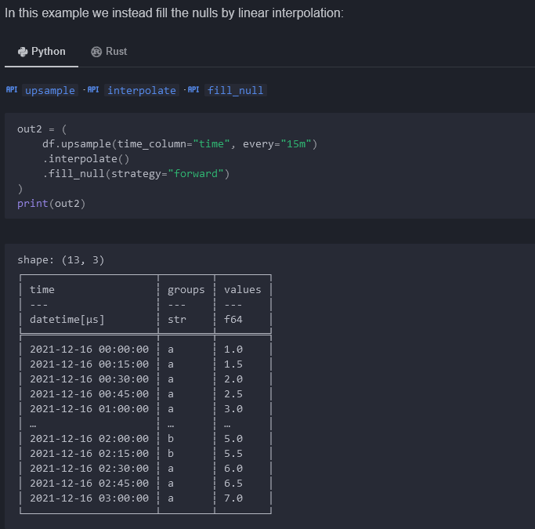

# Time Zones

<https://docs.pola.rs/user-guide/transformations/time-series/timezones/>

# Lazy

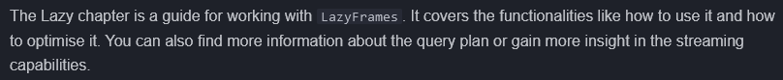

## Usage

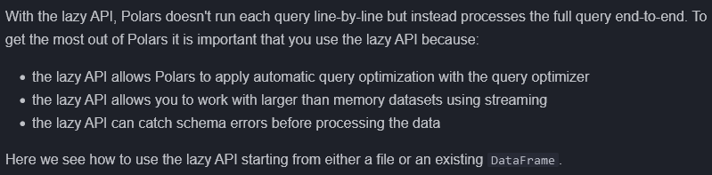

### Using lazy API from a file

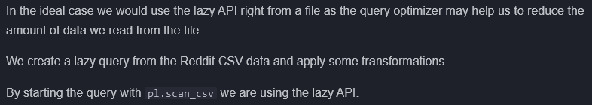

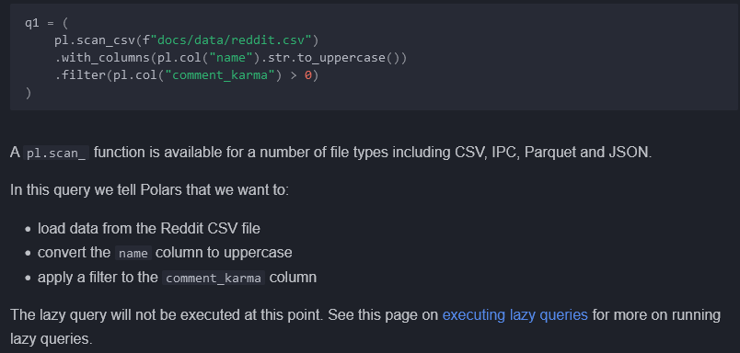

<https://docs.pola.rs/user-guide/lazy/execution/>

### Using the lazy API from a DataFrame

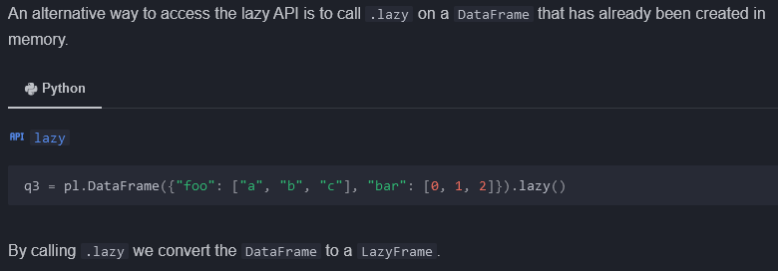

## Optimizations

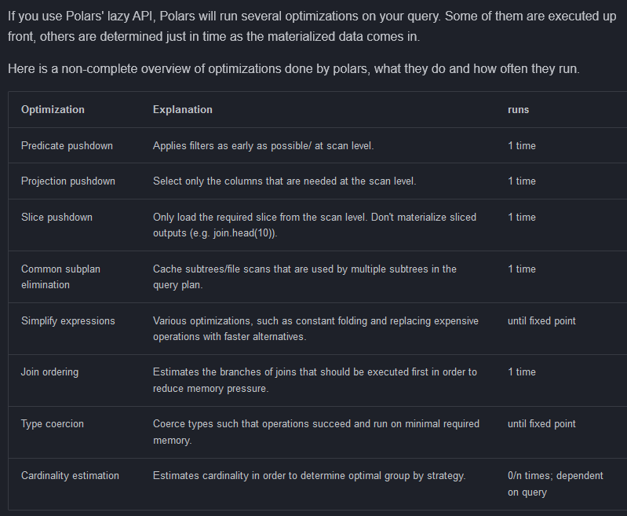

## Schema



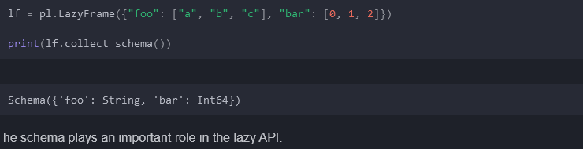

### Lazy API type checking

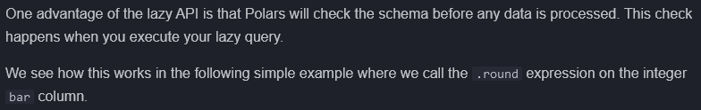

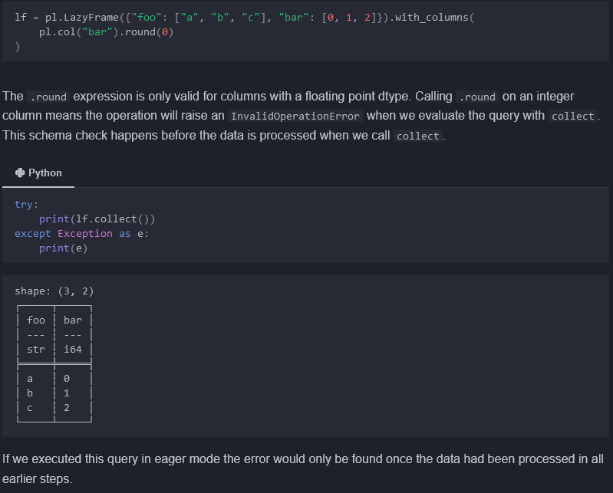



### Lazy API must know schema

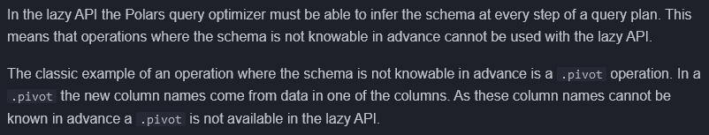

### Dealing with operations not available in lazy API

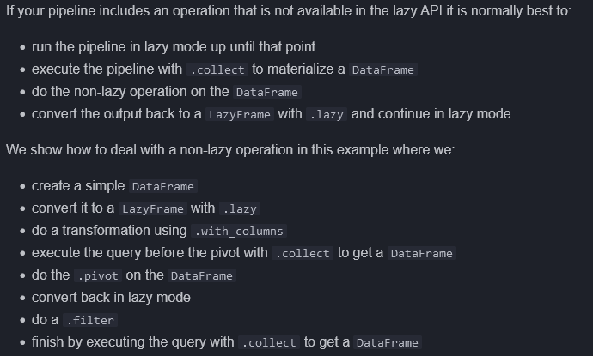

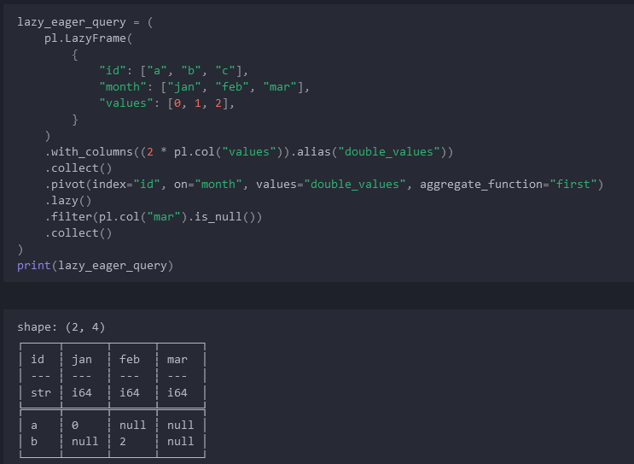

## Query plan

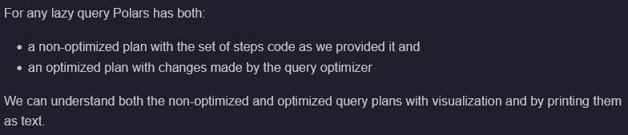

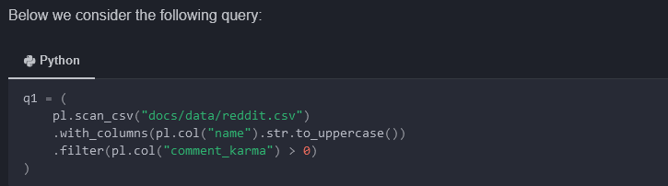

### Non-optimized query plan

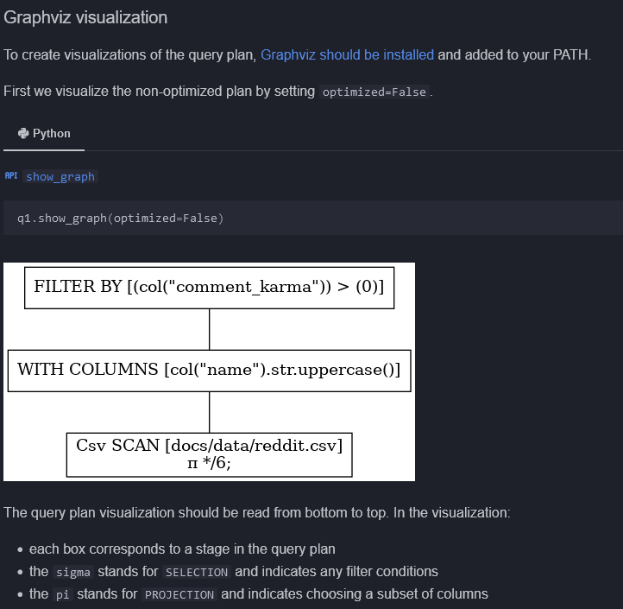

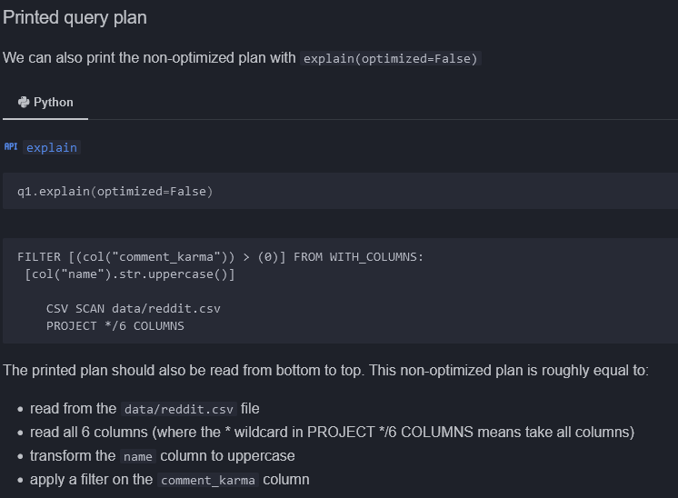

### Optimized query plan

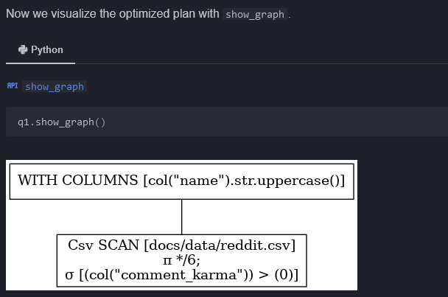

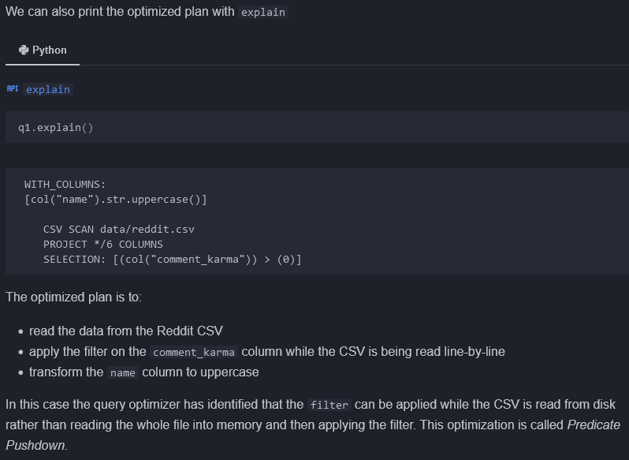

## Query execution

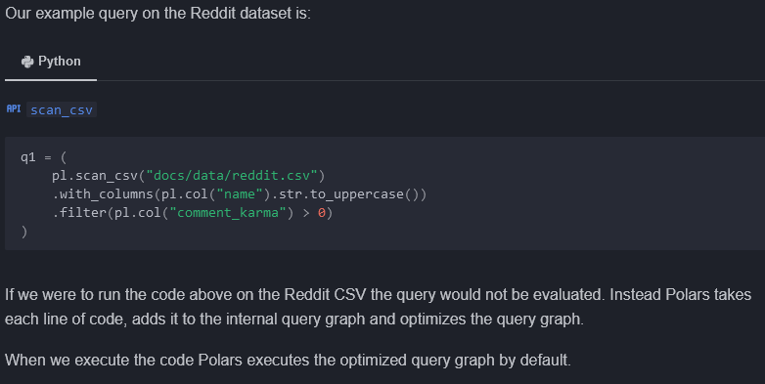

### Execution on the full dataset

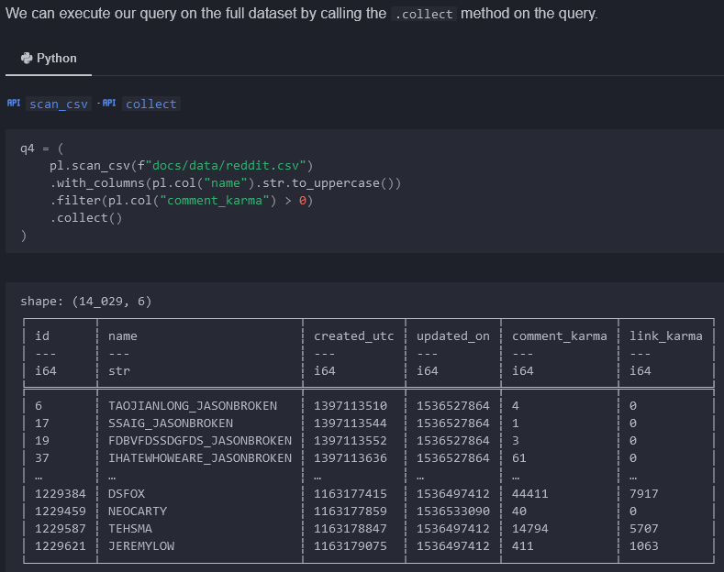

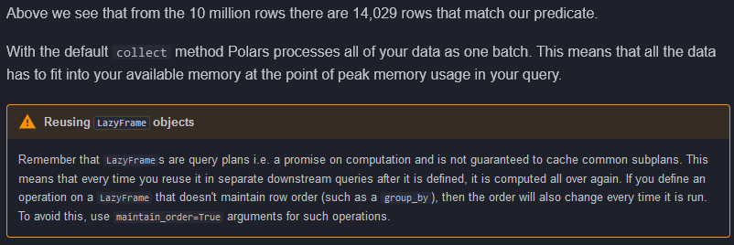

### Execution on larger-than-memory data

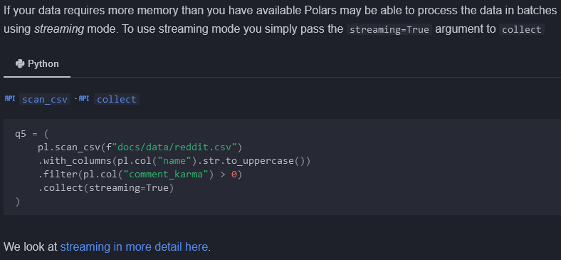

<https://docs.pola.rs/user-guide/lazy/streaming/>

### Execution on a partial dataset

.fetch(n_rows, .. )

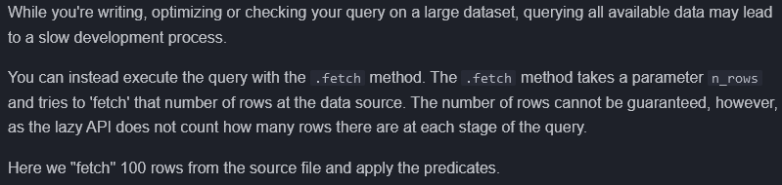

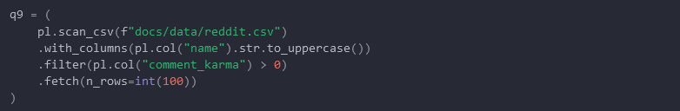

# IO Read/Write

<https://docs.pola.rs/api/python/stable/reference/io.html>

## CSV

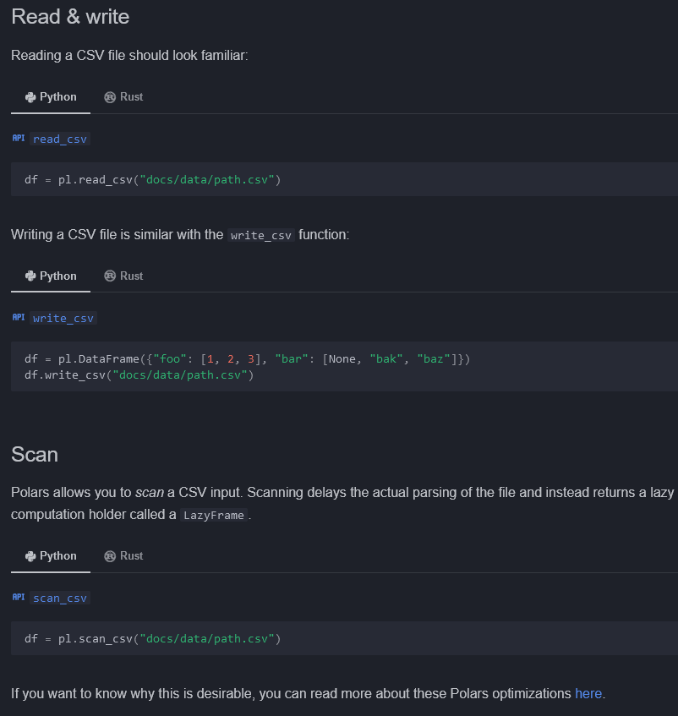

<https://docs.pola.rs/user-guide/concepts/lazy-vs-eager/>

## Excel

Conda install xlsx2csv openpyxl fastexcel xlsxwriter



### Read

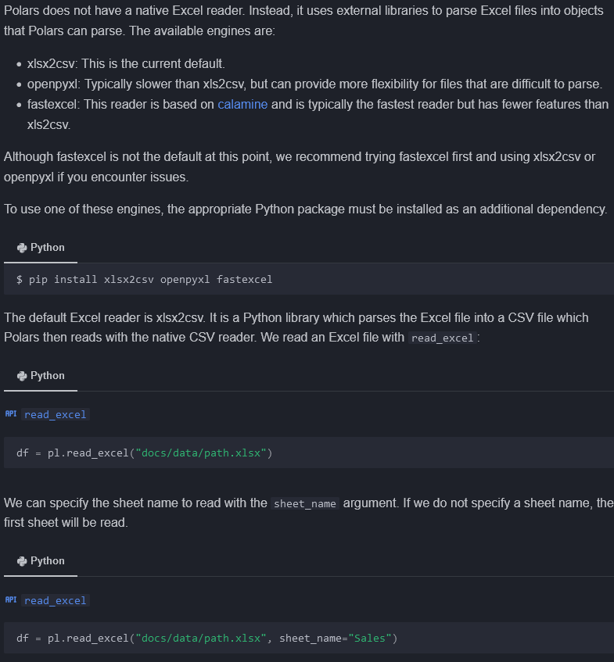

### Write

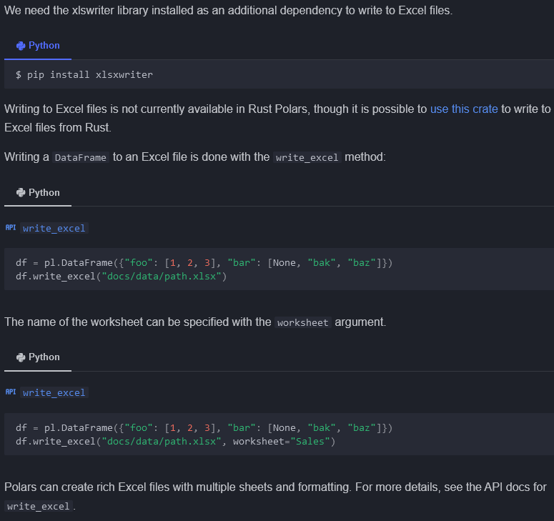

## Parquet

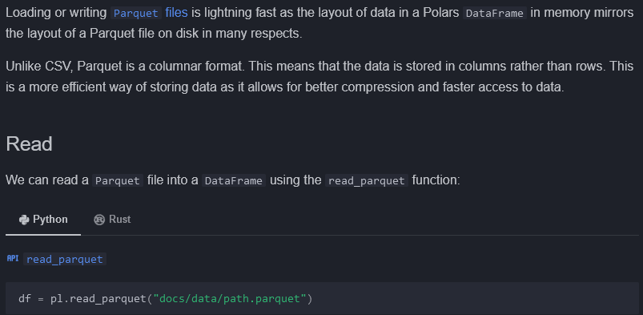

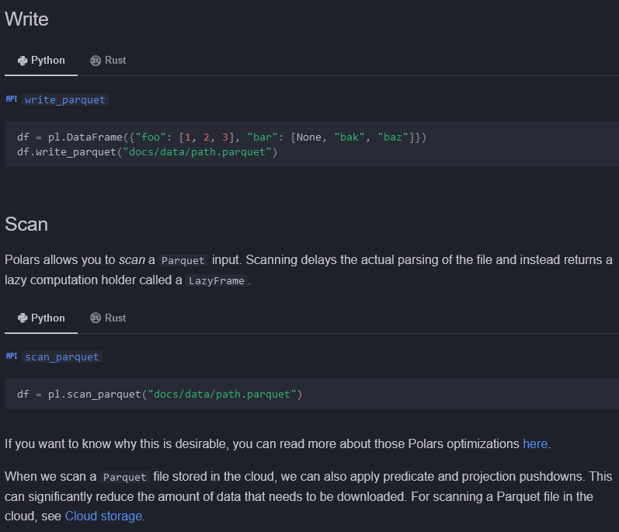

<https://docs.pola.rs/user-guide/io/cloud-storage/#scanning-from-cloud-storage-with-query-optimisation>

## JSON

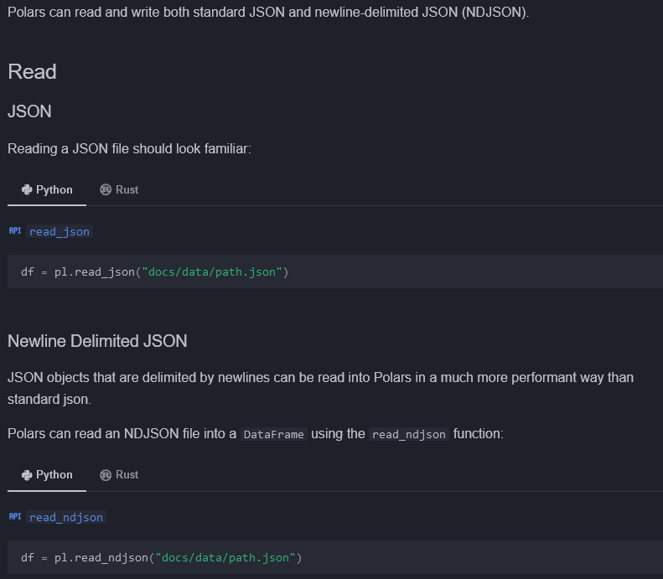

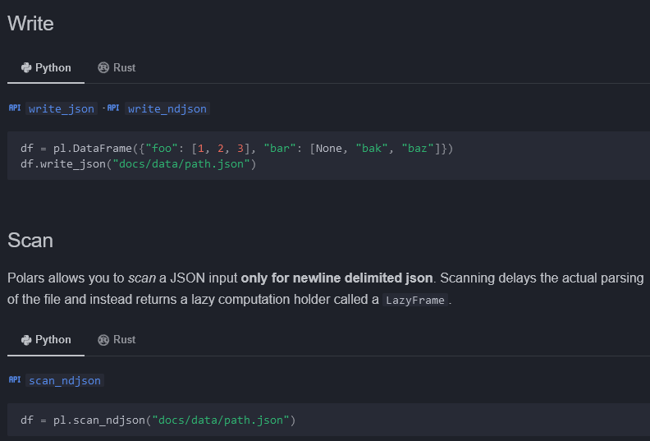

## Multiple files

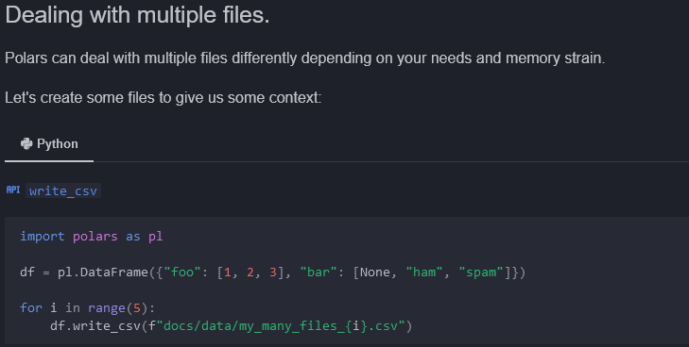

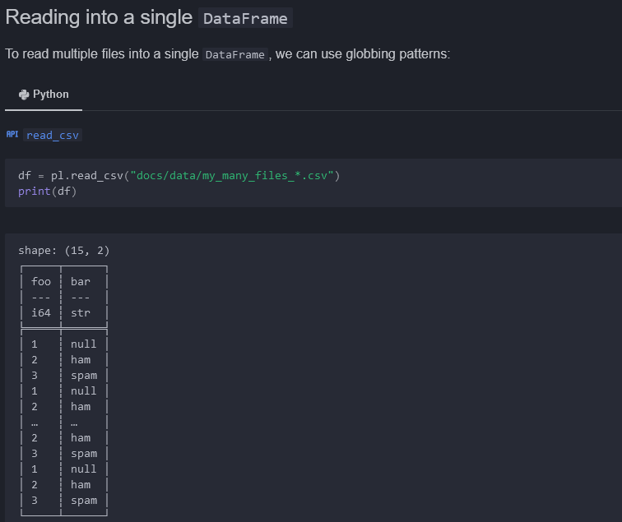

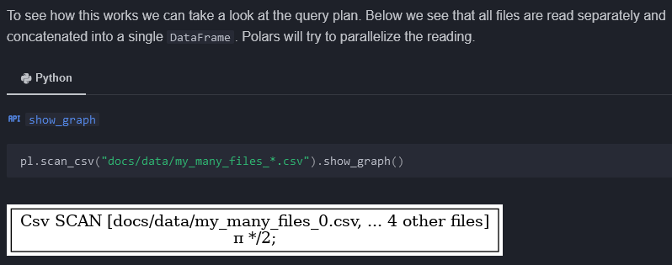

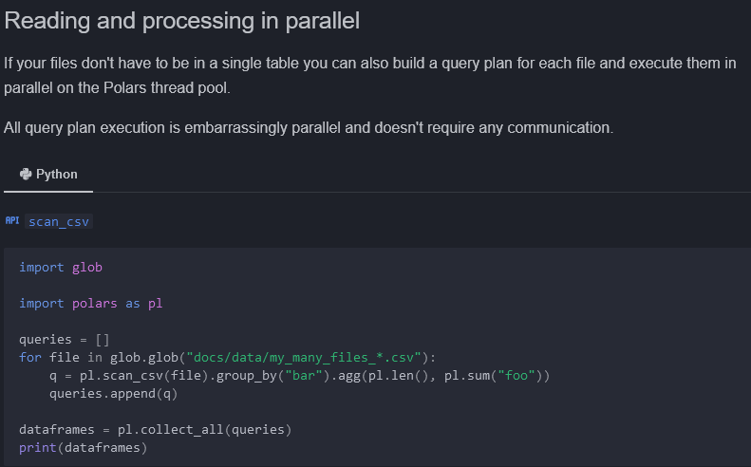

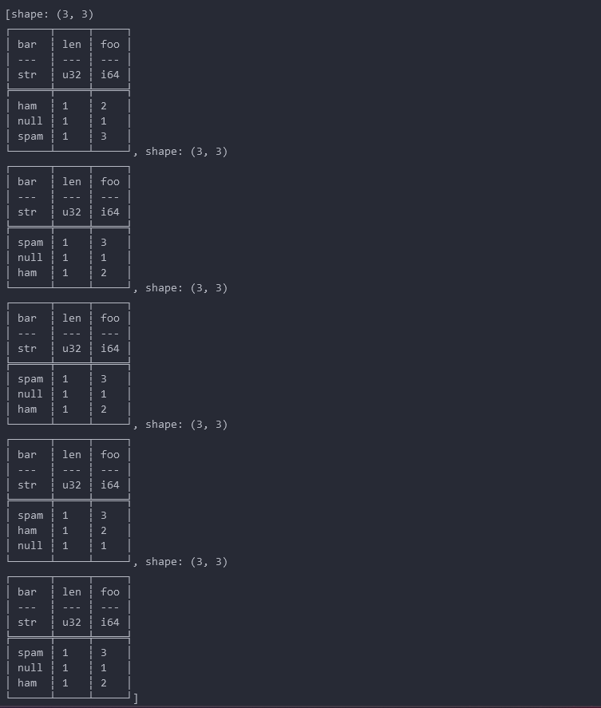

## Databases

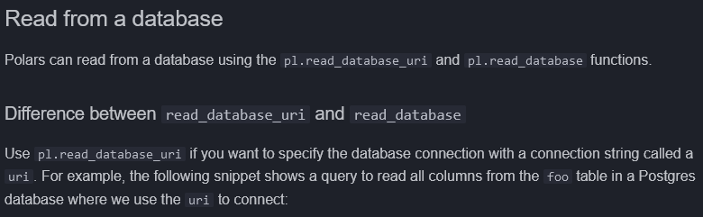

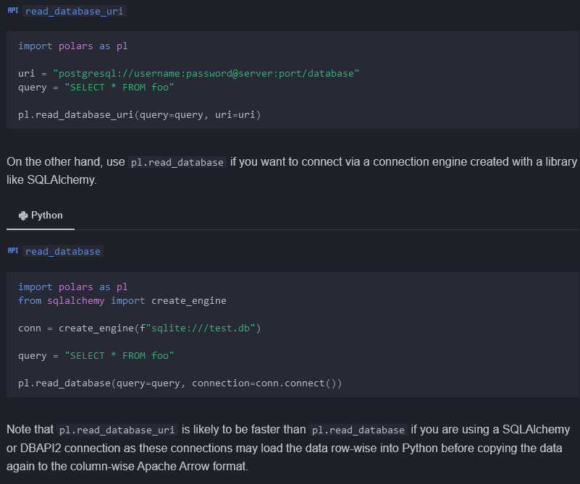

### Engines

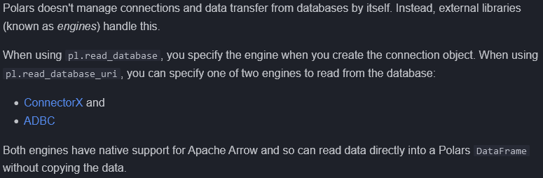

#### ConnectorX

Pip install connectorx

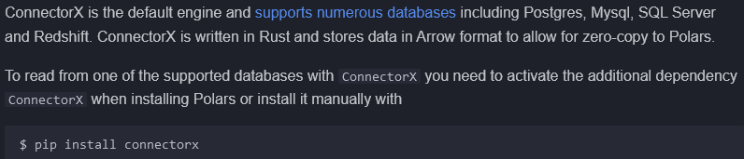

#### ADBC

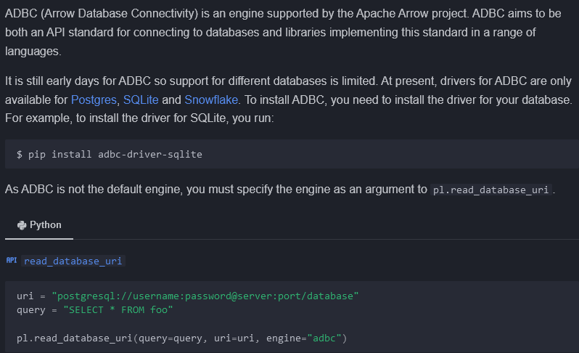

### Write to a database



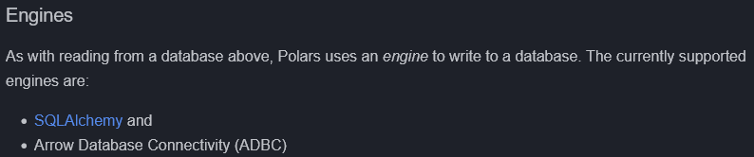

#### SQLAlchemy

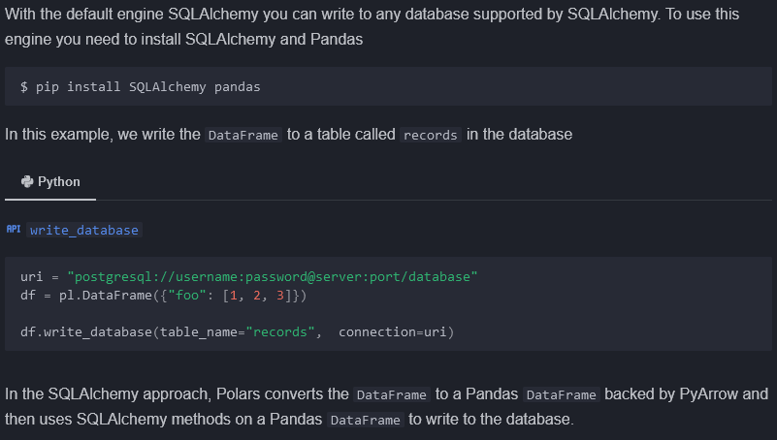

#### ADBC

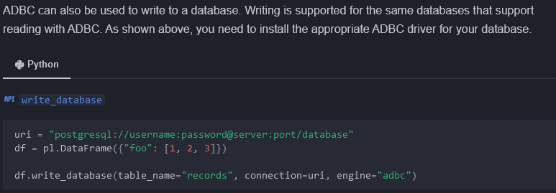

## Cloud storage / Google BigQuery

<https://docs.pola.rs/user-guide/io/cloud-storage/>

<https://docs.pola.rs/user-guide/io/bigquery/>

# SQL

## Introduction

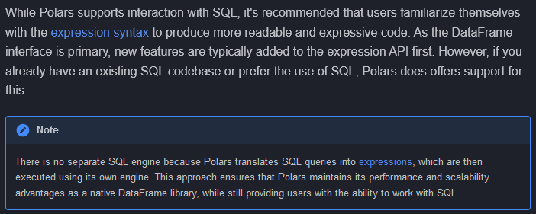

### Context

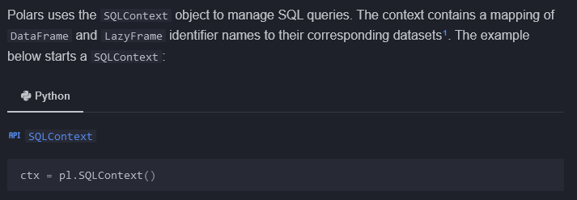

### Register DataFrames

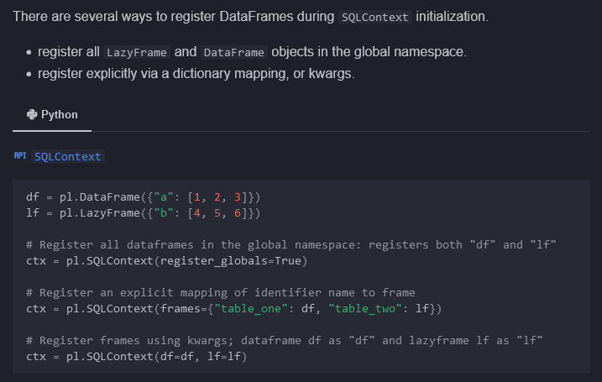

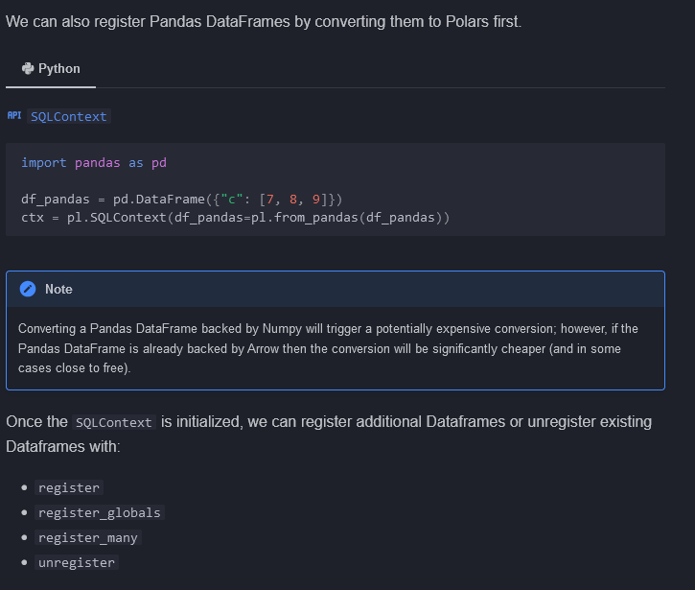

### Execute queries and collect results

### A screenshot of a computer Description automatically generatedExecute queries from multiple sources

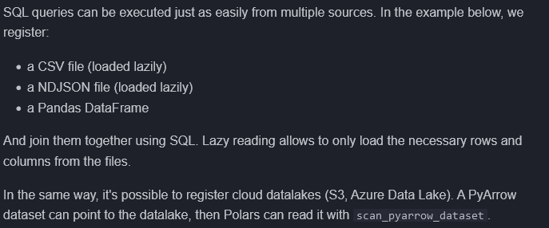

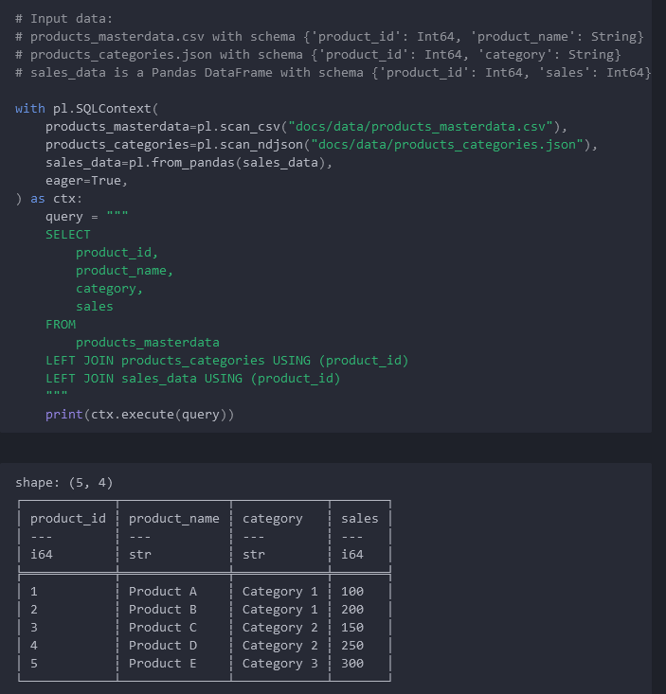

### Compatibility (SQL Syntax / Functionality)

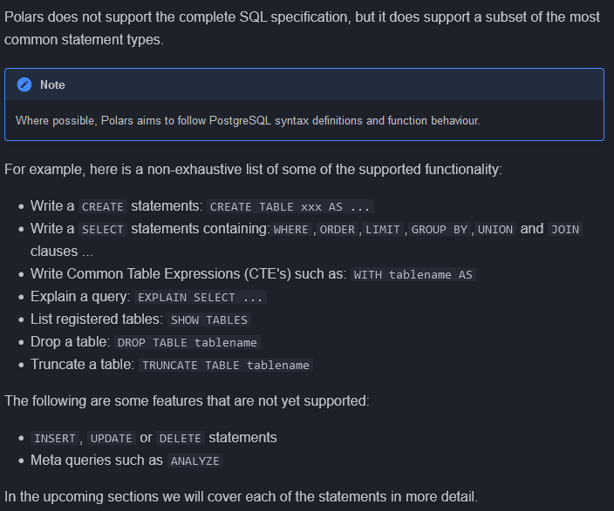

## SHOW TABLES

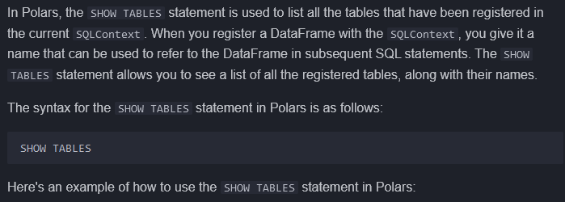

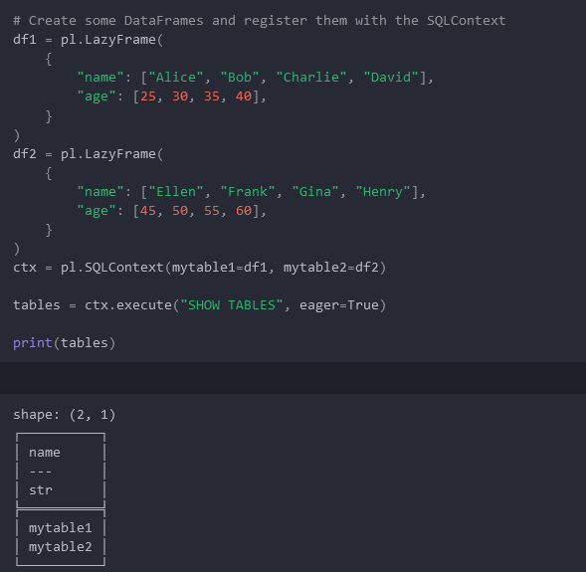

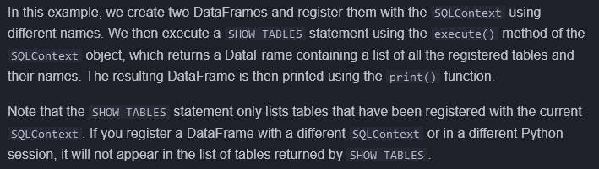

## STATEMENTS (SELECT etc.)

Select from, group by, order by, joins,

### Functions

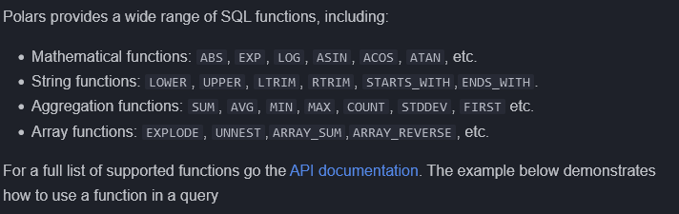

<https://docs.rs/polars-sql/latest/src/polars_sql/keywords.rs.html>

### Table Functions

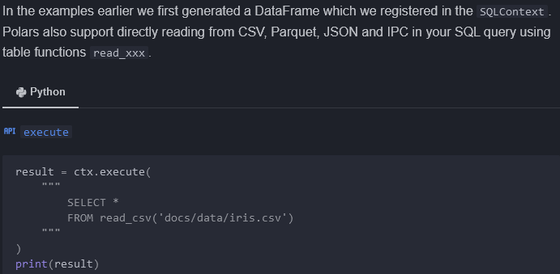

## CREATE

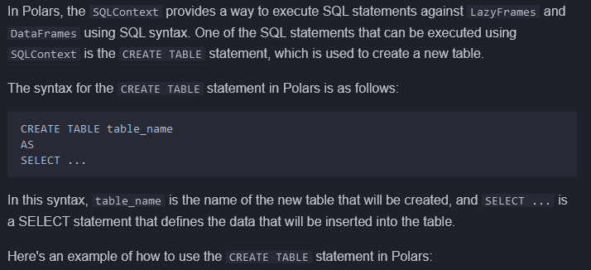

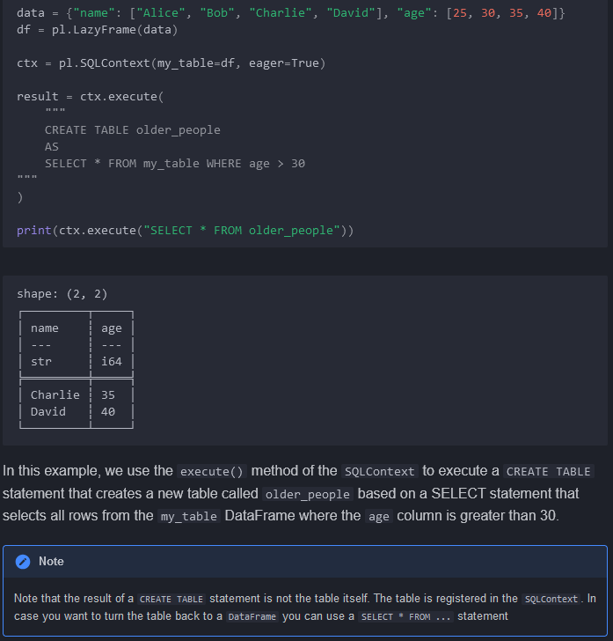

## CTEs

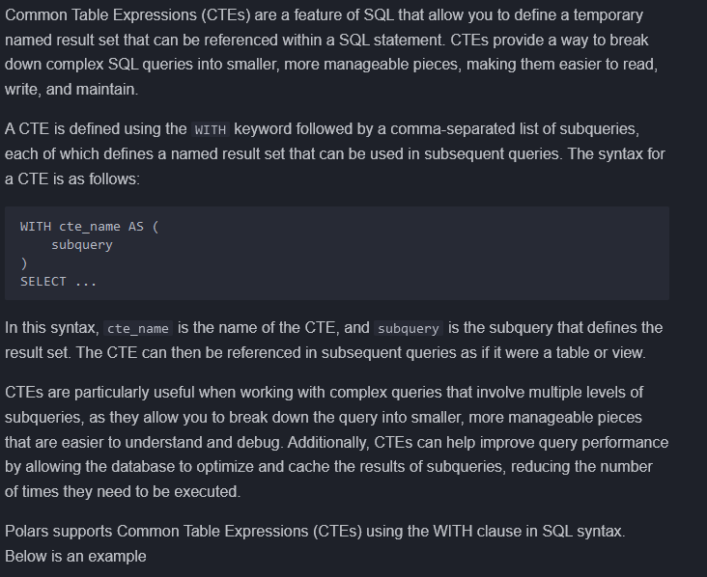

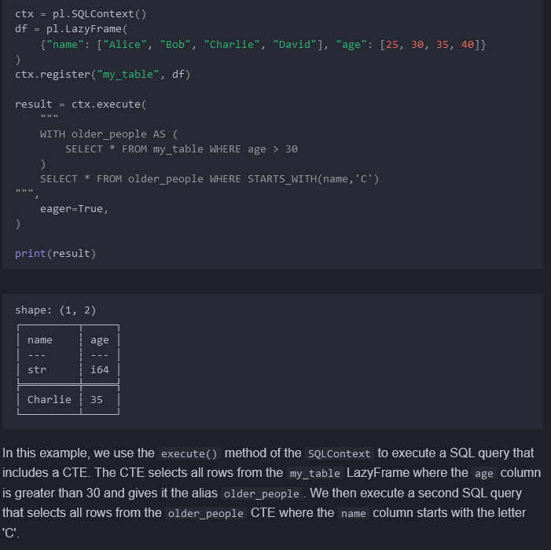

# DataFrame, DataFrame.lazy()

## Lazy specific operations (triggers operations)

.collect()

.describe_plan()

.describe_optimized_plan()

.show_graph(..)

.collect_schema()

.fetch(nrows=?) ?

### Differences of LazyFrame with DataFrame

No .product?, no_horizontal versions for aggregations

No .shape attribute? 🡪 should not use attributes for LazyFrames but use collect_schema()

## GroupBy

### Iteration over the groups

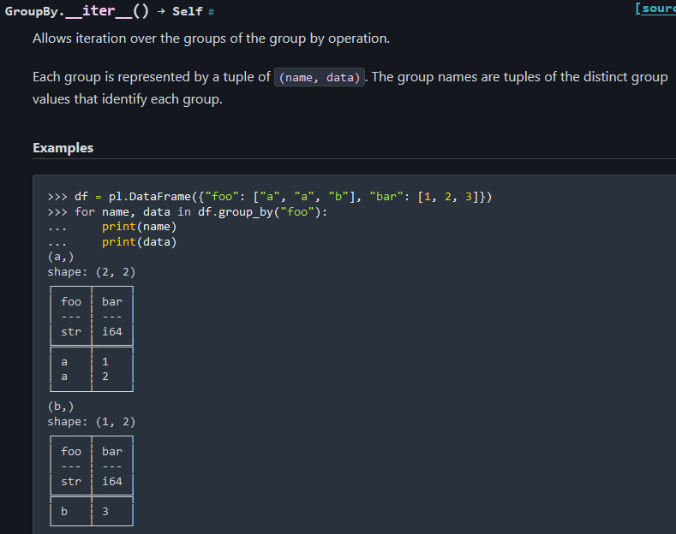

### Aggregations over groups

|  |  |
| --- | --- |
| [GroupBy.agg](https://docs.pola.rs/api/python/stable/reference/dataframe/api/polars.dataframe.group_by.GroupBy.agg.html#polars.dataframe.group_by.GroupBy.agg)(*aggs, **named_aggs) | Compute aggregations for each group of a group by operation. |
| [GroupBy.all](https://docs.pola.rs/api/python/stable/reference/dataframe/api/polars.dataframe.group_by.GroupBy.all.html#polars.dataframe.group_by.GroupBy.all)() | Aggregate the groups into Series. |
| [GroupBy.count](https://docs.pola.rs/api/python/stable/reference/dataframe/api/polars.dataframe.group_by.GroupBy.count.html#polars.dataframe.group_by.GroupBy.count)() (DEPRECATED) | Return the number of rows in each group. |
| [GroupBy.first](https://docs.pola.rs/api/python/stable/reference/dataframe/api/polars.dataframe.group_by.GroupBy.first.html#polars.dataframe.group_by.GroupBy.first)() | Aggregate the first values in the group. |
| [GroupBy.head](https://docs.pola.rs/api/python/stable/reference/dataframe/api/polars.dataframe.group_by.GroupBy.head.html#polars.dataframe.group_by.GroupBy.head)([n]) | Get the first n rows of each group. |
| [GroupBy.last](https://docs.pola.rs/api/python/stable/reference/dataframe/api/polars.dataframe.group_by.GroupBy.last.html#polars.dataframe.group_by.GroupBy.last)() | Aggregate the last values in the group. |
| [GroupBy.len](https://docs.pola.rs/api/python/stable/reference/dataframe/api/polars.dataframe.group_by.GroupBy.len.html#polars.dataframe.group_by.GroupBy.len)([name]) | Return the number of rows in each group. |
| [GroupBy.map_groups](https://docs.pola.rs/api/python/stable/reference/dataframe/api/polars.dataframe.group_by.GroupBy.map_groups.html#polars.dataframe.group_by.GroupBy.map_groups)(function) | Apply a custom/user-defined function (UDF) over the groups as a sub-DataFrame. |
| [GroupBy.max](https://docs.pola.rs/api/python/stable/reference/dataframe/api/polars.dataframe.group_by.GroupBy.max.html#polars.dataframe.group_by.GroupBy.max)() | Reduce the groups to the maximal value. |
| [GroupBy.mean](https://docs.pola.rs/api/python/stable/reference/dataframe/api/polars.dataframe.group_by.GroupBy.mean.html#polars.dataframe.group_by.GroupBy.mean)() | Reduce the groups to the mean values. |
| [GroupBy.median](https://docs.pola.rs/api/python/stable/reference/dataframe/api/polars.dataframe.group_by.GroupBy.median.html#polars.dataframe.group_by.GroupBy.median)() | Return the median per group. |
| [GroupBy.min](https://docs.pola.rs/api/python/stable/reference/dataframe/api/polars.dataframe.group_by.GroupBy.min.html#polars.dataframe.group_by.GroupBy.min)() | Reduce the groups to the minimal value. |
| [GroupBy.n_unique](https://docs.pola.rs/api/python/stable/reference/dataframe/api/polars.dataframe.group_by.GroupBy.n_unique.html#polars.dataframe.group_by.GroupBy.n_unique)() | Count the unique values per group. |
| [GroupBy.quantile](https://docs.pola.rs/api/python/stable/reference/dataframe/api/polars.dataframe.group_by.GroupBy.quantile.html#polars.dataframe.group_by.GroupBy.quantile)(quantile[, interpolation]) | Compute the quantile per group. |
| [GroupBy.sum](https://docs.pola.rs/api/python/stable/reference/dataframe/api/polars.dataframe.group_by.GroupBy.sum.html#polars.dataframe.group_by.GroupBy.sum)() | Reduce the groups to the sum. |
| [GroupBy.tail](https://docs.pola.rs/api/python/stable/reference/dataframe/api/polars.dataframe.group_by.GroupBy.tail.html#polars.dataframe.group_by.GroupBy.tail)([n]) | Get the last n rows of each group. |

## Aggregation

### .count / .null_count

# of **non-null** elements per column

Below are done per column, except the horizontal versions

### .min/max/mean/median/quantile/std/var

### .min/max/mean/sum HORIZONTAL

### .sum/product

## Attributes

.columns 🡪 list of column names

For column in df … :

.dtypes 🡪 list of dtypes

.flags

.height 🡪 number of rows

.width 🡪 number of columns

.shape 🡪 (# rows, # columns)

.schema or .collect_schema() 🡪 ordered mapping of col names to dtypes

Collect_schema() is to unify API with LazyFrame

## Computation

.hash_rows?

### .fold

Function that reduces across the columns (horizontal)

## Descriptive

### .n_unique/approx_n_unique

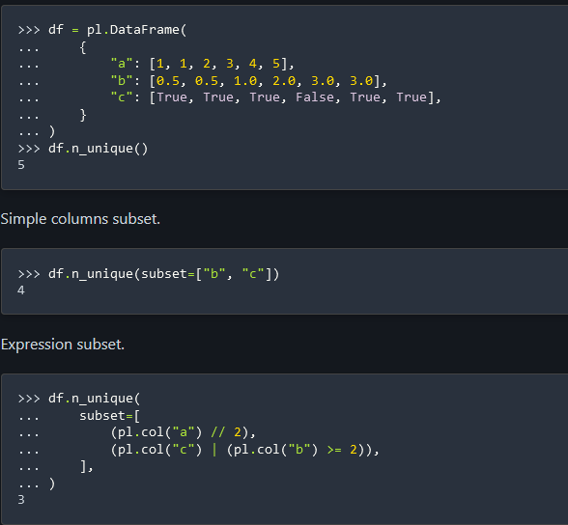

### .unique(..)/is_duplicated()/is_unique()

<https://docs.pola.rs/api/python/stable/reference/dataframe/api/polars.DataFrame.unique.html>

.unique(subset) drops duplicate rows from dataframe based on column subset and other factors

Df.filter(df.is_duplicated())

### .describe( percentiles=list optional, interpolation=)

### .corr( .. )

<https://docs.pola.rs/api/python/stable/reference/dataframe/api/polars.DataFrame.corr.html>

### .estimated_size([unit]), .n_chunks([strategy])

### .is_empty

## Export

<https://docs.pola.rs/api/python/stable/reference/dataframe/export.html>

• [polars.DataFrame.__dataframe__](https://docs.pola.rs/api/python/stable/reference/dataframe/api/polars.DataFrame.__dataframe__.html)

• [polars.DataFrame.to_arrow](https://docs.pola.rs/api/python/stable/reference/dataframe/api/polars.DataFrame.to_arrow.html)

• [polars.DataFrame.to_dict](https://docs.pola.rs/api/python/stable/reference/dataframe/api/polars.DataFrame.to_dict.html)

• [polars.DataFrame.to_dicts](https://docs.pola.rs/api/python/stable/reference/dataframe/api/polars.DataFrame.to_dicts.html)

• [polars.DataFrame.to_init_repr](https://docs.pola.rs/api/python/stable/reference/dataframe/api/polars.DataFrame.to_init_repr.html)

• [polars.DataFrame.to_jax](https://docs.pola.rs/api/python/stable/reference/dataframe/api/polars.DataFrame.to_jax.html)

• [polars.DataFrame.to_numpy](https://docs.pola.rs/api/python/stable/reference/dataframe/api/polars.DataFrame.to_numpy.html)

• [polars.DataFrame.to_pandas](https://docs.pola.rs/api/python/stable/reference/dataframe/api/polars.DataFrame.to_pandas.html)

• [polars.DataFrame.to_struct](https://docs.pola.rs/api/python/stable/reference/dataframe/api/polars.DataFrame.to_struct.html)

## Selection/View

### .glimpse(max_items_per_column, max_colname_length, return_as_string) 🡪 View

### .head(n | -ve) = limit(n), .tail(n)

Selection AND to View

## Manipulation/selection

### Column manipulation

#### Polars.selectors as cs

#### .select, .select_seq, .rename(dict|func)

<https://docs.pola.rs/api/python/stable/reference/dataframe/api/polars.DataFrame.select.html>

pl.Config.set_auto_structify(True)?

Pl.select_seq is like pl.select but runs sequentially rather than in parallel?

#### .with_columns, with_columns_seq

Similar to .select, .select_seq except it has all the columns in df rather than dropping them

#### .with_row_index( my_name, offset)

Add row index as first column in df

#### .get_column(colname), .to_series(index)

* Equivalent, where one specifies column name, other specifies index 🡪 returns column as a Series from df

#### .get_columns()🡪List[Series]

* Get df as list of Series.

#### get_column_index(colname),

#### .insert_column(index, Series),

Both operations are in place.

#### .replace_column(index, Series)

Both operations are in place.

#### .drop/drop_in_place (dropping column(s))

#### Pl.all() vs df.iter_columns

<https://docs.pola.rs/api/python/stable/reference/dataframe/api/polars.DataFrame.iter_columns.html>

### Row manipulation

#### .row, .rows, .rows_by_key, .iter_rows, .map_rows

<https://docs.pola.rs/api/python/stable/reference/dataframe/api/polars.DataFrame.iter_rows.html>

.row to get values of a single row by index or by predicate (i.e. filter). Predicate version must return only one row (no more no less, or RowsError exception)

.rows returns all data in the DataFrame as a list of rows of python-native values. NOT OPTIMAL

.iter_rows is like .rows but returns an iterator rather than all the data at once.

.rows_by_key(key, … ) is like rows, but instead of returning rows in a flat list, rows are grouped by the values in the key column(s) and returned as a dictionary. NOT OPTIMAL

.map_rows applies a custom/user-defined function (UDF) over the rows of the DataFrame. SLOW and NOT OPTIMAL. See link

<https://docs.pola.rs/api/python/stable/reference/dataframe/api/polars.DataFrame.map_rows.html>

#### .iter_slices(n_rows)

#### .gather_every(n, offset) => every nth row

### Concatenation

#### .hstack/.vstack/.extend/pl.concat comparison

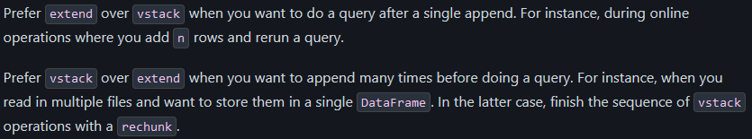

<https://docs.pola.rs/api/python/stable/reference/dataframe/api/polars.DataFrame.extend.html>

<https://www.rhosignal.com/posts/polars-extend-vstack/>

#### .shrink_to_fit? , and .rechunk(), related to concat operations

### Null manipulation

#### .drop_nulls(subset= … )

[https://docs.pola.rs/api/python/stable/reference/dataframe/api/polars.DataFrame.drop_nulls.html#](https://docs.pola.rs/api/python/stable/reference/dataframe/api/polars.DataFrame.drop_nulls.html)

Default to drop rows where ANY column is null

Subset specifies to drop if ANY (not ALL) of the selected columns have nulls

See link for dropping columns/rows based on if ALL are nulls

#### .fill_nan, fill_null, .interpolate(),

linear interpolation for all columns to fill nulls

### .top_k(k, by’s) / .bottom_k

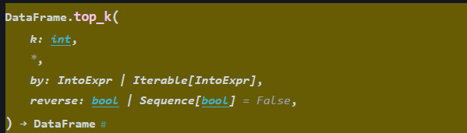

### .cast, .clone, .clear(#of_null_rows_to_keep)

### .explode(ListColumnTypesOnly)

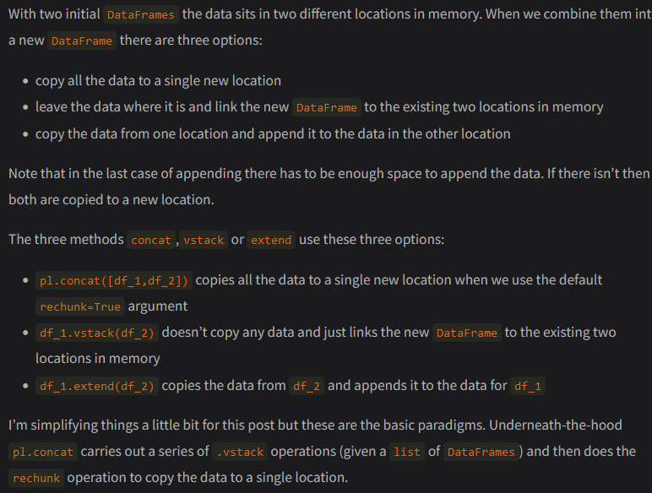

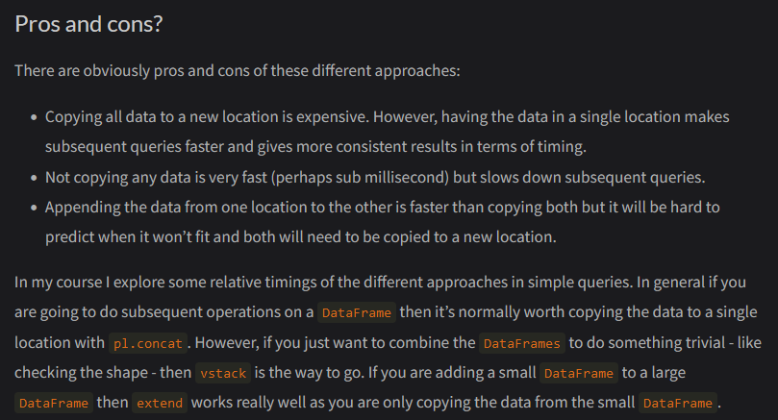

### .filter, .item(..), .row(..), .slice(..)

### .groupby( … )

<https://docs.pola.rs/api/python/stable/reference/dataframe/api/polars.DataFrame.group_by.html>

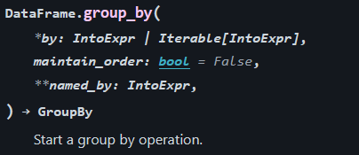

Can use expressions as a group ( i.e. pl.col(“b”) // 2 )

Can iterate over group_by object🡪 for group_val, grouped_data in df.group_by(“segment”):

### .partition_by( … ) 🡪 List[DataFrame partitions] | dict…

[https://docs.pola.rs/api/python/stable/reference/dataframe/api/polars.DataFrame.partition_by.html#](https://docs.pola.rs/api/python/stable/reference/dataframe/api/polars.DataFrame.partition_by.html)

### .rolling vs .group_by_dynamic

See Date Grouping heading or the below link



Rolling based on the individual values in the data (+effect of the arguments ‘period’ and ‘offset’ ) rather than of specific intervals like quarter, month, year? (Group_by_dynamic?)

<https://docs.pola.rs/api/python/stable/reference/dataframe/api/polars.DataFrame.group_by_dynamic.html>

<https://docs.pola.rs/api/python/stable/reference/dataframe/api/polars.DataFrame.rolling.html>

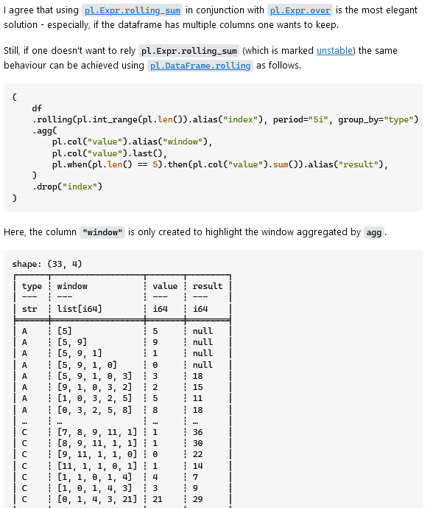

### .shift (SQL-LEAD-LAG)

<https://docs.pola.rs/api/python/stable/reference/dataframe/api/polars.DataFrame.shift.html>

### .sort, .merge_sorted, .reverse, .set_sorted(..)

* df.sort(..) is basically same as Expr.sort_by(..) with same arguments etc.

### .pivot, .unpivot, .transpose, .unstack

### .unnest

<https://docs.pola.rs/api/python/stable/reference/dataframe/api/polars.DataFrame.unnest.html>

### .pipe(func, *args, **kwargs)

Func will receive (data)frame as first parameter

Use df.lazy() or LazyFrames to take advantage of query optim and parallelization.

### .sample(n|fraction, with_replacement, … )

### .sql( query, ..)

### .to_dummies( col, ..)

### .equals(df2), pl.testing.assert_ …

Pl.testing.assert_frame_equal

Pl.testing.assert_frame_not_equal

Pl.testing.assert_series_equal

Pl.testing.assert_series_not_equal

### .serialize, .deserialize

<https://docs.pola.rs/api/python/stable/reference/dataframe/api/polars.DataFrame.deserialize.html>

## Plots

<https://docs.pola.rs/api/python/stable/reference/dataframe/plot.html>

## Styles

<https://docs.pola.rs/api/python/stable/reference/dataframe/style.html>

# Series

## Aggregation – diff with DataFrame

.arg_max()

.arg_min()

Nan_max, nan_min 🡪 poisoned by NaN’s but NOT the None python type.

.mode() 🡪 most occurring value(s) (but not duplicate of same distinct values)

.implode() 🡪 aggregate to list

.all(ignore_nulls), .any(ignore_nulls), .not_(), note that for .not_() it negates every element in Series

## Export

• [polars.Series.to_arrow](https://docs.pola.rs/api/python/stable/reference/series/api/polars.Series.to_arrow.html)

• [polars.Series.to_frame](https://docs.pola.rs/api/python/stable/reference/series/api/polars.Series.to_frame.html)

• [polars.Series.to_jax](https://docs.pola.rs/api/python/stable/reference/series/api/polars.Series.to_jax.html)

• [polars.Series.to_list](https://docs.pola.rs/api/python/stable/reference/series/api/polars.Series.to_list.html)

• [polars.Series.to_numpy](https://docs.pola.rs/api/python/stable/reference/series/api/polars.Series.to_numpy.html)

• [polars.Series.to_pandas](https://docs.pola.rs/api/python/stable/reference/series/api/polars.Series.to_pandas.html)

• [polars.Series.to_init_repr](https://docs.pola.rs/api/python/stable/reference/series/api/polars.Series.to_init_repr.html)

# Expressions

<https://docs.pola.rs/api/python/stable/reference/expressions/index.html>

## Functions (in Polars namespace, not Expr)

### Generate literals or ranges of values

lit(value[, dtype, allow_object])

* Return an expression representing a literal value.

repeat(value, n, *[, dtype, eager])

* Construct a column of length n filled with the given value.

repeat_by( by= int|Series or Expr)

* Repeat the elements in this Series as specified in the given expression.
* The repeated elements are expanded into a List.
* E.g. df.select(pl.col("a").repeat_by("n")) 🡪 row-by-row repetition and row-by-row lists output with lengths based on the row-by-row values in column “n”.

arange([start, end, step, dtype, eager])

int_range([start, end, step, dtype, eager])

* Generate a range of integers.

int_ranges([start, end, step, dtype, eager])

* Generate a range of integers for each row of the input columns.

ones(n[, dtype, eager])

* Construct a column of length n filled with ones.

zeros(n[, dtype, eager])

* Construct a column of length n filled with zeros.

date_range(start, end[, interval, closed, eager])

* Generate a date range.

date_ranges(start, end[, interval, closed, ...])

* Create a column of date ranges.

datetime_range(start, end[, interval, ...])

* Generate a datetime range.

datetime_ranges(start, end[, interval, ...])

* Create a column of datetime ranges.

time_range([start, end, interval, closed, eager])

* Generate a time range.

time_ranges([start, end, interval, closed, ...])

* Create a column of time ranges.

### Date-related literals creation and other Date

date(year, month, day)

* Create a Polars literal expression of type Date.

datetime(year, month, day[, hour, minute, ...])

* Create a Polars literal expression of type Datetime.

time([hour, minute, second, microsecond])

* Create a Polars literal expression of type Time.

duration(*[, weeks, days, hours, minutes, ...])

* Create polars Duration from distinct time components.

business_day_count(start, end[, week_mask, ...])

* Count the number of business days between start and end (not including end).

from_epoch(column[, time_unit])

* Utility function that parses an epoch timestamp (or Unix time) to Polars Date(time).

### Bool aggregation – across row/columns

all(*names[, ignore_nulls])

* Either return an expression representing all columns, or evaluate a bitwise AND operation DOWN columns

all_horizontal(*exprs)

* Compute the bitwise AND horizontally across columns.

any(*names[, ignore_nulls])

* Evaluate a bitwise OR operation DOWN columns.

any_horizontal(*exprs)

* Compute the bitwise OR horizontally across columns.

### Len / Unique / Counts

len()

* Return the number of rows **in the context**.

approx_n_unique(*columns)

* Approximate count of unique values.

n_unique(*columns)

* Count unique values.

count(*columns)

* Return the number of non-null values in the column.

### Statistics / Aggregation / Math

implode(*columns)

* Aggregate all column values into a list.

sum(*names)

* Sum all values.

max(*names)

* Get the maximum value.

mean(*columns)

* Get the mean value.

median(*columns)

* Get the median value.

min(*names)

* Get the minimum value.

quantile(column, quantile[, interpolation])

* Syntactic sugar for pl.col("foo").quantile(..).

std(column[, ddof])

* Get the standard deviation.

var(column[, ddof])

* Get the variance.

corr(a, b, *[, method, ddof, propagate_nans])

* Compute the Pearson's or Spearman rank correlation correlation between two columns.

cov(a, b[, ddof])

* Compute the covariance between two columns/ expressions.

arctan2(y, x)

* Compute two argument arctan in radians.

arctan2d(y, x)

* Compute two argument arctan in degrees.

### .when, .arg_sort_by, .arg_where

when(*predicates, **constraints)

* Start a when-then-otherwise expression.

arg_sort_by(exprs, *more_exprs[, ...])

* Return the row indices that would sort the column(s).

arg_where(condition, *[, eager])

* Return indices where condition evaluates True.

### Folding horizontally across columns

fold(acc, function, exprs)

* Accumulate over multiple columns horizontally/ row wise with a left fold.
* If you simply want the first encountered expression as accumulator, consider using reduce

reduce(function, exprs)

* Accumulate over multiple columns horizontally/ row wise with a left fold.

cum_fold(acc, function, exprs, *[, include_init])

* Cumulatively fold horizontally across columns with a left fold.

cum_reduce(function, exprs)

* Cumulatively reduce horizontally across columns with a left fold.

cum_sum_horizontal(*exprs)

* Cumulatively sum all values horizontally across columns.

coalesce(exprs, *more_exprs, (can include a scalar value as well incase none match)

* Folds the columns from left to right, keeping the first non-null value.

concat_list(exprs, *more_exprs)

* Horizontally concatenate columns into a single list column.

concat_str(exprs, *more_exprs[, separator, ...])

* Horizontally concatenate columns into a single string column.

sum_horizontal(*exprs)

* Sum all values horizontally across columns.

max_horizontal(*exprs)

* Get the maximum value horizontally across columns.

mean_horizontal(*exprs)

* Compute the mean of all values horizontally across columns.

min_horizontal(*exprs)

* Get the minimum value horizontally across columns.

### Cumulative / Rolling

#### Cumulative

cum_count(*columns[, reverse])

* Return the cumulative count of the non-null values in the column.

cum_sum(*names)

* Cumulatively sum all values.

#### Rolling

rolling_corr(a, b, *, window_size[, ...])

* Compute the rolling correlation between two columns/ expressions.

rolling_cov(a, b, *, window_size[, ...])

* Compute the rolling covariance between two columns/ expressions.

### Indexing

head(column[, n])

* Get the first n rows.

tail(column[, n])

* Get the last n rows.

first(*columns)

* Get the first column or value.

last(*columns)

* Get the last column or value.

### SQL

sql(query, *[, eager])

* Execute a SQL query against frames in the global namespace.

sql_expr(sql)

* Parse one or more SQL expressions to Polars expression(s).

### Columns / Structs / Selection

select(*exprs, **named_exprs)

* Run polars expressions without a context.

exclude(columns, *more_columns)

* Represent all columns except for the given columns.

struct(*exprs[, schema, eager])

* Collect columns into a struct column.

groups(column)

* Syntactic sugar for pl.col("foo").agg_groups().

nth(*indices)

* Get the nth column(s) of the context.

### Mapping

element()

* Alias for an element being evaluated in an eval expression.

pipe(func, *args, **kwargs)

* Can operate similar to map_batches?

map_batches(exprs, function[, return_dtype])

* Map a custom function over multiple columns/expressions.

map_groups(exprs, function[, return_dtype, ...])

* Apply a custom/user-defined function (UDF) in a GroupBy context.

format(f_string, *args)

* Format expressions as a string. Uses values from multiple columns per row to generate the new column?

### .from_<> / Miscellaneous

<https://docs.pola.rs/api/python/stable/reference/functions.html>

|  |  |
| --- | --- |
| [from_arrow](https://docs.pola.rs/api/python/stable/reference/api/polars.from_arrow.html#polars.from_arrow)(data[, schema, schema_overrides, ...]) | Create a DataFrame or Series from an Arrow Table or Array. |
| [from_dataframe](https://docs.pola.rs/api/python/stable/reference/api/polars.from_dataframe.html#polars.from_dataframe)(df, *[, allow_copy]) | Build a Polars DataFrame from any dataframe supporting the interchange protocol. |
| [from_dict](https://docs.pola.rs/api/python/stable/reference/api/polars.from_dict.html#polars.from_dict)(data[, schema, schema_overrides, ...]) | Construct a DataFrame from a dictionary of sequences. |
| [from_dicts](https://docs.pola.rs/api/python/stable/reference/api/polars.from_dicts.html#polars.from_dicts)(data[, schema, schema_overrides, ...]) | Construct a DataFrame from a sequence of dictionaries. |
| [from_numpy](https://docs.pola.rs/api/python/stable/reference/api/polars.from_numpy.html#polars.from_numpy)(data[, schema, schema_overrides, ...]) | Construct a DataFrame from a NumPy ndarray. |
| [from_pandas](https://docs.pola.rs/api/python/stable/reference/api/polars.from_pandas.html#polars.from_pandas)(data, *[, schema_overrides, ...]) | Construct a Polars DataFrame or Series from a pandas DataFrame, Series, or Index. |
| [from_records](https://docs.pola.rs/api/python/stable/reference/api/polars.from_records.html#polars.from_records)(data[, schema, ...]) | Construct a DataFrame from a sequence of sequences. |
| [from_repr](https://docs.pola.rs/api/python/stable/reference/api/polars.from_repr.html#polars.from_repr)(data) | Construct a Polars DataFrame or Series from its string representation. |
| [json_normalize](https://docs.pola.rs/api/python/stable/reference/api/polars.json_normalize.html#polars.json_normalize)(data, *[, separator, ...]) | Normalize semi-structured deserialized JSON data into a flat table. |

## Computation / Descriptive / Aggregation

<https://docs.pola.rs/api/python/stable/reference/series/computation.html>

A lot of them also in DataFrame section?

### Len / Unique / Counts

* .count, .len, .null_count
  + .len counts nulls (all elements in Series)
  + Polars version 🡪 pl.len for counting all rows, pl.count to count non-null values
* .value_counts 🡪 for each unique value, get the count of them
* .unique_counts() 🡪 returns Series with count of unique values in order of appearance
  + Won’t be a scalar or a list of same length generally due to unique values.
* .n_unique(), .approx_n_unique()🡪 # unique values, Scalar
* .unique() 🡪 the unique values, Series
* .arg_unique() 🡪 Series containing index values that would locate the unique values

### Statistics / Aggregation

#### .agg_groups() / .implode()

.agg_groups() is EXPR ONLY, not Series

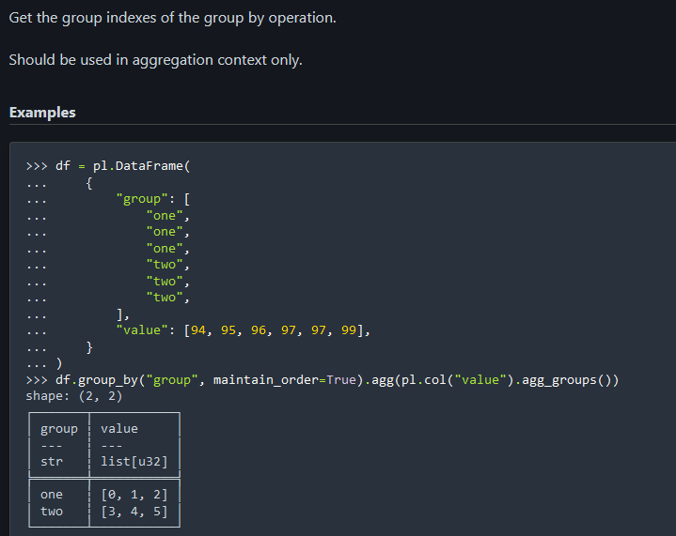

#### .arg_max() / .arg_min() / .arg_true() / arg_unique() / arg_sort() / pl.arg_sort_by / pl.arg_where

#### .mean() / .median() / .mode()

#### .std(ddof=1) / .var(ddof=1), .skew( .. ) , .kurtosis(..)

#### .quantile(q, … ), .describe(percentiles, interpolation) 🡪 Series only

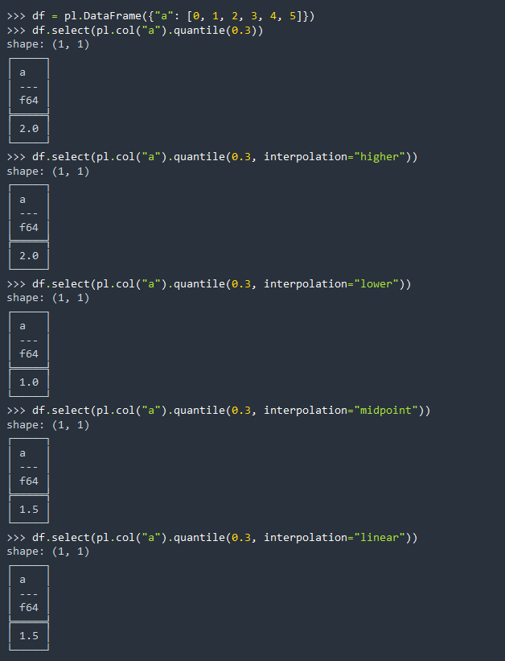

#### .max() / .min() / .nan_max() / .nan_min()

* .nan_max, nan_min 🡪 poisoned by NaN’s but NOT the None python type.

#### .sum() / .product()

#### .str.join(delimiter)

* concatenate Series together into a scalar string

#### POLARS namespace extras

corr(a, b, *[, method, ddof, propagate_nans])

* Compute the Pearson's or Spearman rank correlation correlation between two columns.

cov(a, b[, ddof])

* Compute the covariance between two columns/ expressions.

arctan2(y, x)

* Compute two argument arctan in radians.

arctan2d(y, x)

* Compute two argument arctan in degrees.

### Math / Trig

* .abs, .sign,
* .sqrt, .cbrt
* .exp(), .log([base]), .log10, .log1p ( i.e. log(1+array) )
* .ceil(), .floor(), .round(decimals), .round_sig_figs(n)
* .entropy( ..) 🡪 related to probability / discrete
* .dot(series2) 🡪 sumproduct which returns a scalar rather than a Series  
  sin , cos , tan
* sinh , cosh , tanh
* arc (inverse) versions of the above 6
* cot, (sec and cosec?)

### Sorting/Ranking/Binning/Hist

* .search_sorted( elem, [side] )
* .rank(method, desc, ..)
* .hist( bins|bin_count, ..)
* .sort(desc=, nulls_last)
  + When used in a projection/selection context, the whole column is sorted. When used in a group by context, the groups are sorted.
* .arg_sort(desc=, nulls_last)
* pl.sort_by( by(s), descending(s), nulls_last(s), multithreaded?, maintain_order = )
  + (s) 🡪 multiple column specific
  + Essentially supersedes .sort(), but .sort() can just not specify column to sort (saves a bit of time)
* pl.arg_sort_by(exprs, *more_exprs[, ...])
  + Return the row indices that would sort the column(s).
* .top_k_by / .bottom_k_by( by(s), k, reverse(s) )
* .reverse()

### Boolean masks (Series)

* pl.filter(..)
* pl.where(..), pl.arg_where(..),
* pl.when(..).then(..).when(..).then(..).otherwise(..)
* .not_() 🡪 negate every element in Series
* .is_in(series2)
* .isbetween( a, b ) 🡪 boolean mask
* .peak_max(), .peak_min() 🡪 boolean mask of local max/mins
* .is_finite, is_infinite
* .is_nan, is_not_nan
* .is_null, is_not_null
* .is_duplicated, is_unique, .is_first_distinct, is_last_distinct

### Boolean aggregations (down/across columns)

* .all(ignore_nulls), .any(ignore_nulls), 🡪 related is .not_(),
  + note that for .not_() it negates every element in Series so doesn’t return a scalar
* .has_nulls
* .is_empty 🡪 Series only atm?
* .is_sorted( desc, nulls_last) 🡪 Series only atm?
* .equals(series2)

**From Polars namespace**

* all(*names[, ignore_nulls])
  + Either return an expression representing all columns, or evaluate a bitwise AND operation DOWN columns
* all_horizontal(*exprs)
  + Compute the bitwise AND horizontally across columns.
* any(*names[, ignore_nulls])
  + Evaluate a bitwise OR operation DOWN columns.
* any_horizontal(*exprs)
  + Compute the bitwise OR horizontally across columns.

### Folding horizontally across columns (Polars namespace)

fold(acc, function, exprs)

* Accumulate over multiple columns horizontally/ row wise with a left fold.
* If you simply want the first encountered expression as accumulator, consider using reduce

reduce(function, exprs)

* Accumulate over multiple columns horizontally/ row wise with a left fold.

coalesce(exprs, *more_exprs, (can include a scalar value as well incase none match)

* Folds the columns from left to right, keeping the first non-null value.

concat_list(exprs, *more_exprs)

* Horizontally concatenate columns into a single list column.

concat_str(exprs, *more_exprs[, separator, ...])

* Horizontally concatenate columns into a single string column.

sum_horizontal(*exprs)

* Sum all values horizontally across columns.

max_horizontal(*exprs)

* Get the maximum value horizontally across columns.

mean_horizontal(*exprs)

* Compute the mean of all values horizontally across columns.

min_horizontal(*exprs)

* Get the minimum value horizontally across columns.

cum_fold(acc, function, exprs, *[, include_init])

* Cumulatively fold horizontally across columns with a left fold.

cum_reduce(function, exprs)

* Cumulatively reduce horizontally across columns with a left fold.

cum_sum_horizontal(*exprs)

* Cumulatively sum all values horizontally across columns.

### Cumulative

* .cum_count( reverse= ) not equivalent to .cum_count().reverse()?
  + Reverse= would return series bottom-up , reading the array bottom-up
* .cum_max, .cum_min, .cum_prod, .cum_sum
* .cumulative_eval( expression, ..) 🡪 increase window by 1 as it iterates,
  + WARNING slow if accessing all elements at each new window

**From Polars namespace:**

cum_count(*columns[, reverse])

* Return the cumulative count of the non-null values in the column.

cum_sum(*names)

* Cumulatively sum all values.

### Rolling / Moving / Lag

* .diff(n|-ve, null_behaviour)
  + .pct_change(n|-ve) is similar
* .rolling_map( my_func, window_size=), my_func applies to each window
  + Custom functions are SLOW, try to avoid
* .rolling_max, min, mean, median, std, var, skew
  + Args: window_size, weights=list[float], .. etc.
* .rolling_sum
* .rolling_quantile(quantile, interpolation, window_size, weights)
  + Interpolation = linear will take the first of window as 0% and highest as 100%?
* .ewm_mean, std, var 🡪 exponential moving
* .ewm_mean_by 🡪 weights based on time differences between current and prev observ

**From Polars namespace:**

rolling_corr(a, b, *, window_size[, ...])

* Compute the rolling correlation between two columns/ expressions.

rolling_cov(a, b, *, window_size[, ...])

* Compute the rolling covariance between two columns/ expressions.

### Misc (size, dtype .. )

* .to_physical()
* .set_sorted(desc=)
* .reinterpret( .. )
* .hash( .. )
* .chunk_lengths( .. ), .n_chunks, .get_chunks()
* .estimated_size( .. )
* .lower_bound(), .upper_bound() 🡪 relating to dtype and the limit of it.

## Manipulation/Selection

### In Expr, but not in Series (non-List/Array)

**polars.Expr.approx_n_unique**

**polars.Expr.degrees**

**polars.Expr.radians**

**polars.Expr.rolling_max_by**

**polars.Expr.rolling_mean_by**

**polars.Expr.rolling_median_by**

**polars.Expr.rolling_min_by**

**polars.Expr.rolling_quantile_by**

**polars.Expr.rolling_std_by**

**polars.Expr.rolling_sum_by**

**polars.Expr.rolling_var_by**

**polars.Expr.map_batches**

**polars.Expr.agg_groups**

**polars.Expr.count**

**polars.Expr.forward_fill, polars.Expr.backward_fill**

* These are similar to Expr.fill_null = Series.fill_null(value|strategy=”forward|backward”, limit= … )
* Has less functionality as you can fill with value instead of a strategy if needed

**polars.Expr.bottom_k_by**, **polars.Expr.top_k_by**

**polars.Expr.flatten**

**polars.Expr.inspect**

**polars.Expr.pipe**

* Helps pipe Expr into a function that takes Expr as first argument

**polars.Expr.repeat_by**

**polars.Expr.sort_by**

**polars.Expr.where**

**polars.Expr.exclude**

polars.Expr.deserialize

polars.Expr.from_json

#### .sort_by( by(s), descending(s), nulls_last(s), multithreaded?, maintain_order = )

(s) 🡪 multiple column specific

Essentially supersedes .sort(), but .sort() can just not specify column to sort (saves a bit of time)

#### .top_k_by / .bottom_k_by( by(s), k, reverse(s) )

#### .repeat_by( by= int|Series or Expr)

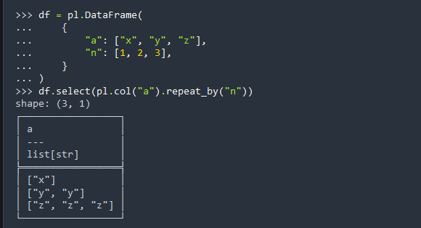

#### DEBUGGING: .inspect()

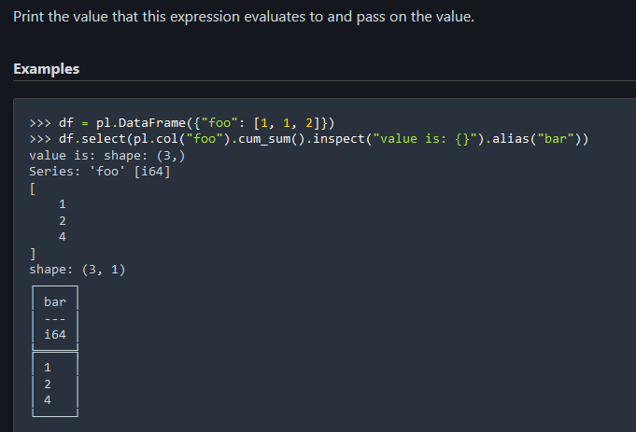

#### .flatten() 🡪 flatten a list/string column

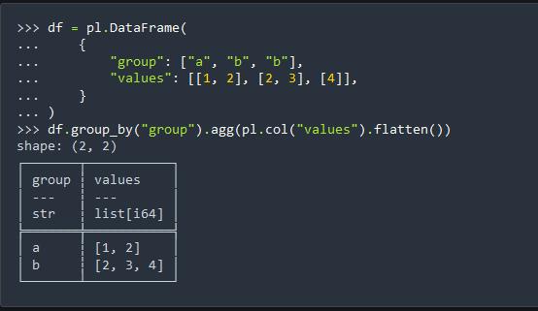

### Manipulation / Selection (shared with Series)

#### Concat, Explode/Implode, Flatten

.append(series2) 🡪 multiple chunks, modifies series in-place

.extend(series2), Series only atm? 🡪 extend memory backed with series2, may cause reallocation. If appending a lot, use pl.concat with a call to .rechunk at the end?

.extend_constant(value, n) 🡪 fast method for appending constant

.explode() (for a list Series)

.implode()

pl.flatten() – flatten a list or string column. <https://docs.pola.rs/api/python/stable/reference/expressions/api/polars.Expr.flatten.html>

#### Conversion, Reshaping, Renaming, Resizing

Conversion 🡪 .cast(dtype, .. )

Renaming 🡪 .rename(str), .alias(str)

Reshape 🡪 .reshape( (rows, length_of_array) )

Resize 🡪 shrink_dtype(..), shrink_to_fit(..)

#### Selection

.top_k(k), .bottom_k(k), top_k_by, bottom_k_by

.first(), .last()

.head(n), .limit(n), .tail(n), .slice(offset, length), .new_from_index(index, length)

* .new_from_index repeats the value at the index ‘length’ times

.filter( … ) 🡪 see Boolean masks or Boolean aggregations section

.item( index = 0)

.gather( indices)

.gather_every(n, offset)

**From Polars namespace:**

select(*exprs, **named_exprs)

* Run polars expressions without a context.

exclude(columns, *more_columns)

* Represent all columns except for the given columns.

struct(*exprs[, schema, eager])

* Collect columns into a struct column.

groups(column)

* Syntactic sugar for pl.col("foo").agg_groups().

nth(*indices)

* Get the nth column(s) of the context.

#### Mapping / Modify / Replace values

**From Polars namespace:**

element()

* Alias for an element being evaluated in an eval expression.
* Often used with pl.list.eval( <pl.element used within this context> )

pipe(func, *args, **kwargs)

* Can operate similar to map_batches?

map_batches(exprs, function[, return_dtype])

* Map a custom function over multiple columns/expressions.
* Agg_list parameter can make it more efficient in a group-by context, see <https://docs.pola.rs/api/python/stable/reference/expressions/api/polars.Expr.map_batches.html> . Aggregates values of expression into a list before apply function. i.e. instead of lambda x: x+2, we can do lambda x: x.list.eval(pl.element() + 2), agg_list=True
* Returns_scalar parameter if it returns a scalar and we want it to stay scalar rather than in a list

.map_elements(func, … ) 🡪 map custom function over elements in Series, SLOW

* 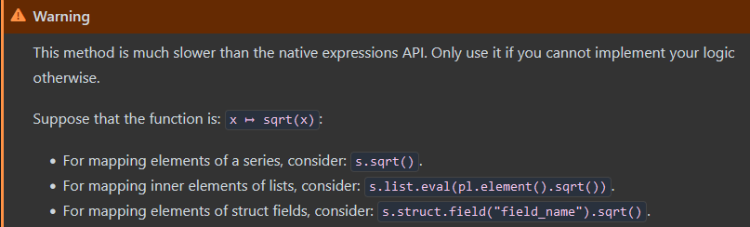

map_groups(exprs, function[, return_dtype, ...])

* Apply a custom/user-defined function (UDF) in a GroupBy context.

format(f_string, *args)

* Format expressions as a string. Uses values from multiple columns per row to generate the new column?

pl.when(..).then(..).when(..).then(..).otherwise(..)

* Better than .scatter / .set in the Series namespace

**Series namespace:**

.replace(old, new) 🡪 old/new can be lists

.replace_strict(old, new, default_val, dtype) 🡪

* + No default param 🡪 error if any values were not replaced. Compare to .replace method

.zip_with(mask, series2) 🡪 True = self, False = series2

.scatter(indices, values)

.set(filter_predicate, value)

NOTE::: the following is better than the above two

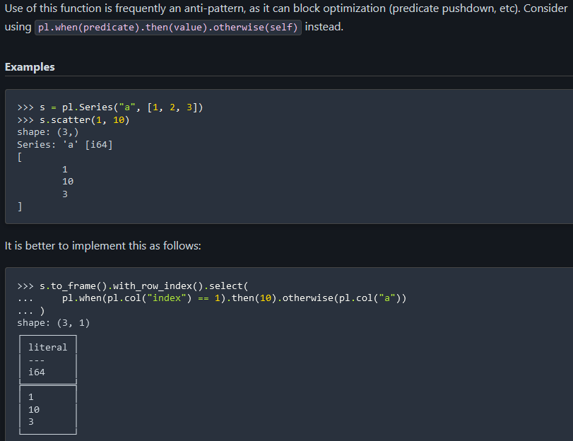

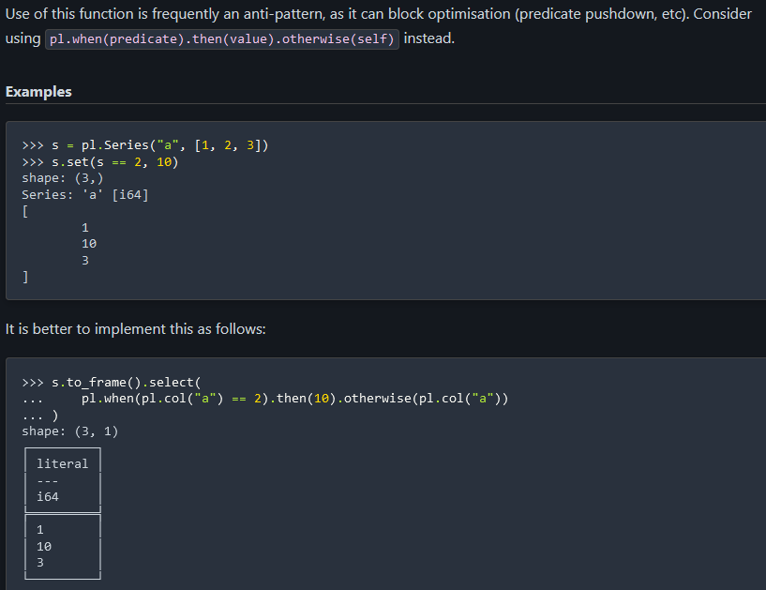

#### Null Manipulation

.drop_nans(), .drop_nulls()

.fill_nans(value), .fill_nulls()

.interpolate(method=), .interpolate_by( series2? )

#### Clear, Clone

.clear(n) 🡪 only for Series atm?

.clone() 🡪 only for Series atm?

#### Binning, Clipping

**Binning**

[**https://docs.pola.rs/api/python/stable/reference/series/api/polars.Series.qcut.html**](https://docs.pola.rs/api/python/stable/reference/series/api/polars.Series.qcut.html)

* UNSTABLE: .cut(list_of_unique_cuts), labels, left_closed, .. )

* UNSTABLE: .qcut(quantiles or bin_num, … )

**Clipping**

.clip(lower_bound, upper_bound) 🡪 set values outside to boundaries.

#### Sampling, Shuffling

.sample(n|fraction)

.shuffle([seed])

#### Get dummies

.to_dummies(separator, drop_first)

#### Shifting up or down

.shift(n, fill_value)

#### Run-length encoding

.rle()

.rle_id() 🡪 new ‘group’ every time there’s been a change throughout the Series

## Arrays / Lists

<https://docs.pola.rs/api/python/stable/reference/expressions/list.html>

one column List and one column not List 🡪 how to do element-wise between these?

<https://github.com/pola-rs/polars/pull/17823>

Diff between Arrays/Lists attribute (.arr and .list)

* Array needs subarrays to be of same length,
* Lists can have subarrays of varying length

.arr and .list methods computes on each subarray, i.e. [[1, 2, 3], [4, 3,6]] 🡪 two sub-arrays of length 3

### Array (top) vs List (Extra at bottom)

**Arrays only:**

polars.Expr.arr.max

polars.Expr.arr.min

polars.Expr.arr.median

polars.Expr.arr.sum

polars.Expr.arr.std

polars.Expr.arr.to_list

polars.Expr.arr.unique

polars.Expr.arr.n_unique

polars.Expr.arr.var

polars.Expr.arr.all

polars.Expr.arr.any

polars.Expr.arr.sort

polars.Expr.arr.reverse

polars.Expr.arr.arg_min

polars.Expr.arr.arg_max

polars.Expr.arr.get

polars.Expr.arr.first

polars.Expr.arr.last

polars.Expr.arr.join

polars.Expr.arr.explode

polars.Expr.arr.contains

polars.Expr.arr.count_matches

polars.Expr.arr.to_struct

polars.Expr.arr.shift

**Extra from list:**

polars.Expr.list.drop_nulls

polars.Expr.list.concat

polars.Expr.list.diff

polars.Expr.list.eval

polars.Expr.list.gather

polars.Expr.list.head

polars.Expr.list.len

polars.Expr.list.mean

polars.Expr.list.sample

polars.Expr.list.set_difference

polars.Expr.list.set_intersection

polars.Expr.list.set_symmetric_difference

polars.Expr.list.set_union

polars.Expr.list.slice

polars.Expr.list.tail

polars.Expr.list.to_array

polars.Expr.list.to_struct

polars.Expr.list.gather_every

Only List methods shown below, but should try .arr version first as may be more efficient?

Below is Expr.list.<method> but all these methods are also part of Series.list.<method>

### .eval

* .eval( any pl expression , ..)

### Aggregate common usages

* .max / .min / .arg_max / .arg_min
* .sum / .mean / .median / .std(ddof) / .var(ddof)
* .all / .any
* .join(sep, ignore_nulls)

### Misc (sampling, drop nulls, exploding)

* .drop_nulls()
* .sample(n|frac, with_replacement, ..)
* .explode( ) 🡪 every element in every sublist gets a new row

### Counting / Unique / Membership

* .len / n_unique
* .count_matches(elem) / .contains(item)
* .unique( .. ) 🡪 unique list of elements per sub-array

### Sort / Reverse

* .sort(desc, null_last, ..)
* .reverse()

### Operation between two lists/arrays:

* .concat(other list/array?) (joins subarray 1 of each list/array into a subarray, join subarray 2 of each … etc.)
* Set_difference(other), set_intersection(other), set_union(other), set_symmetric_difference(other)

### Indexing/Slicing subarrays:

* Return an array for each subarray:
  + .head / .tail / .slice(offset[,length]) / .gather(inds, .. ), .gather_every(every_n[,offset]
* Return scalar for each subarray:
  + .first / .last / .get(ind, .. )

### Lead/Lag/Diff/Shifting

* .diff(n, null_behaviour)
* .shift(n)

### Convert to array / struct

* .to_array( width ) 🡪 convert each subarray to list
* .to_struct( … ) 🡪 convert Series to type Struct from type list
* .to_list() 🡪 convert subarray to list (lists can be of any length)

## String (.str….)

<https://docs.pola.rs/api/python/stable/reference/series/string.html>

### Aggregate or Explode (aggregated to scalar)

* .join(sep, ignore_nulls) 🡪 aggregate to scalar
* .split(str).explode() 🡪 return different # rows

### Slicing each string (return Same length Series)

* .head(n|ve), .tail(n|ve)
* .slice(offset, length)

### Replacing each string (return Same length Series)

* .to_lowercase(), .to_uppercase(), to_titlecase()
  + Title case is Proper case
* .replace(pattern, value_to_replace, literal?, n_number_of_matches_to_replace)
* .replace_all(pattern, value_to_replace, literal?)
* .replace_many(patterns, replace_withs, ascii_case_insensitive)
  + Doesn’t support regex
* .reverse()

### Stripping / Padding each string (return Same length Series)

* .strip_chars( chars_to_remove )
  + Chars_to_remove from start and end of string. Default to whitespace and whitespace like chars like \t
* .strip_chars_start(chars), .strip_chars_end(chars)
* .strip_suffix(suffix), .strip_prefix(prefix) 🡪 remove specific combination compared to .strip_chars_start and .strip_chars_end
* .pad_end(length, fill_char), .pad_start(length, fill_char),
* zfill(length) (for padding START with zeroes, and compatible with negative sign in string)

### Extracting or Finding pattern in each String (return same length Series, each element may be returned as scalar, string or list of values)

* .extract(pattern, group_index (capture group) )
* .extract_all(pattern) 🡪 each element becomes a list of matched strings from orig string
* .extract_many([pattern_list]) 🡪 like .extract_all but with multiple patterns, if a pattern from the pattern_list matches multiple times in the string, it outputs multiple times
* .extract_groups(pattern) 🡪 returns struct, struct fields are either index (if unnamed in regex pattern, where index starts from 1), or named variables within the pattern
* .find(pattern, literal?, .. ) 🡪 maps to index of first match with pattern, or None

### Split each string in Series into list

* .split(by, include_split_char)
* .split_exact(by, n_splits_to_make, inclusive_of_split_char)
  + Struct of n+1 fields with the splitting pattern
* .splitn(by, n_max_item_to_return, inclusive_of_split_char)
  + .splitn( , n+1, …) equivalent to .split_exact(, n, … ) except that .split_exact will chop off the rest of the splitted string if it finds more than n splits, where as .splitn will include the rest of the string (that includes the ‘by’ characters in unsplitted form).

### Count_matches, len for each String in each Series

* .count_matches( pattern, literal? )
* .len_bytes(), .len_chars()

### Convert to different dtype

* .strptime( dtype, format, …) 🡪 convert string to Date/Datetime/Time column
* .to_date( format, … ) 🡪 convert string to Date
* .to_datetime( format, … ) 🡪 convert string to Datetime
* .to_time( format, … ) 🡪 convert string to Time
* .to_decimal( .. ) 🡪 convert string to Decimal
* .to_integer( base=, …) 🡪 convert string to Integer

### Boolean mask (return same length, with mapped to Boolean values)

* .contains(pattern|regex , literal=T|F (i.e. treat pattern as a literal string) , ..)
* .contains_any( [sequenceOfStringsToSearch], ..)
* .starts_with(str), .ends_with(str)

### Other (Json/Decoding)

* .decode(..), .encode(..),
* .json_decode( .. ), json_path_match( .. )

## Categories

### Expr and Series

.cat.get_categories()

### Series only

.cat.is_local / .cat.to_local …

* With pl.StringCache(): 🡪 uses ‘global’ set of strings to define Categories in variable?
* <https://docs.pola.rs/api/python/stable/reference/series/api/polars.Series.cat.is_local.html>

.uses_lexical_ordering …

<https://docs.pola.rs/api/python/stable/reference/series/api/polars.Series.cat.uses_lexical_ordering.html>

## Temporal (time-related) (.dt. … )

### Extract date-related values from Date/Time/Datetime

* .millennium / .century
* .date / .time / .datetime
* .year / .quarter / .month
  + .is_leap_year()
* .week / .day / .weekday / .ordinal_day
* .hour / .minute / .second /.millisecond / .microsecond / .nanosecond
* .timestamp(time_unit), one of ‘us’, ‘ns’, ‘ms
* .epoch(time_unit) : {‘us’, ‘ns’, ‘ms’, ‘s’, ‘d’}
* .iso_year()

### Extract time-related values from Duration type

* .total_<x>, where x is one of
  + days
  + hours
  + seconds, milliseconds, microseconds, nanoseconds

### Roll forward to start/end of period, or Offset date by some duration

* .month_start, .month_end 🡪 roll forward/backward to start/end of month
* .truncate(every) 🡪 truncate and map to start of bucket of ‘every’
* .round(every) 🡪 round up or down based ‘every’. Different to truncate which always rounds down.
* .offset_by(by) 🡪
  + <https://docs.pola.rs/api/python/stable/reference/series/api/polars.Series.dt.offset_by.html>
  + y, q, mo, w, d
  + h, m, s, ms, us, ns
  + e.g. 3d12h4m25s
* .add_business_days(n, .. )
  + <https://docs.pola.rs/api/python/stable/reference/series/api/polars.Series.dt.add_business_days.html>

### Conversion / Replacing time

* .cast_time_unit 🡪 convert to a different time unit basis
* .combine( time literal or Series of same length, time_unit) 🡪 add/replace the time with the given time(s)
* .strftime(format) or .to_string(format) 🡪 convert to String column with given format
* .with_time_unit(..) DEPRECATED 🡪 set time unit of Series of Datetime/Duration type
  + Should first cast to Int64 and then to desired data type
* .convert_time_zone(tz) 🡪 convert to a given time zone for a Datetime type
* .replace_time_zone(tz, ..) 🡪 replace time zone for a Datetime type, and will also modify the underlying timestamp

### Aggregation (ONLY available for Series.dt atm?)

* .max, .min,
* .mean, .median

### Constant offsets (kind of/almost)

* .base_utc_offset()
* .dst_offset()

## Struct

<https://docs.pola.rs/api/python/stable/reference/expressions/struct.html>

### Methods:

.struct.field( “name_of_field” ) 🡪 returns Series based on the name of field

* In Expr version can name multiple fields

.Expr.struct.with_fields( *exprs, **named_exprs):

* Expr version only
* Adds or overwrite fields of this struct – similar to with_columns on DataFrame

.struct.unnest() 🡪 DataFrame with separated fields into columns

* No Expr version

.rename_fields(seq of str)

.json_encode() .. see below

<https://docs.pola.rs/api/python/stable/reference/series/api/polars.Series.struct.json_encode.html>

### Attributes:

.Series.struct.fields

.Series.struct.schema

## Operators

<https://docs.pola.rs/api/python/stable/reference/expressions/operators.html>

**Operators**

Polars supports native Python operators for all common operations; these operators are also available as methods on the Expr class.

**Conjunction**

|  |  |
| --- | --- |
| [Expr.and_](https://docs.pola.rs/api/python/stable/reference/expressions/api/polars.Expr.and_.html#polars.Expr.and_)(*others) | Method equivalent of bitwise "and" operator expr & other & .... |
| [Expr.or_](https://docs.pola.rs/api/python/stable/reference/expressions/api/polars.Expr.or_.html#polars.Expr.or_)(*others) | Method equivalent of bitwise "or" operator expr | other | .... |

**Comparison**

|  |  |
| --- | --- |
| [Expr.eq](https://docs.pola.rs/api/python/stable/reference/expressions/api/polars.Expr.eq.html#polars.Expr.eq)(other) | Method equivalent of equality operator expr == other. |
| [Expr.eq_missing](https://docs.pola.rs/api/python/stable/reference/expressions/api/polars.Expr.eq_missing.html#polars.Expr.eq_missing)(other) | Method equivalent of equality operator expr == other where None == None. |
| [Expr.ge](https://docs.pola.rs/api/python/stable/reference/expressions/api/polars.Expr.ge.html#polars.Expr.ge)(other) | Method equivalent of "greater than or equal" operator expr >= other. |
| [Expr.gt](https://docs.pola.rs/api/python/stable/reference/expressions/api/polars.Expr.gt.html#polars.Expr.gt)(other) | Method equivalent of "greater than" operator expr > other. |
| [Expr.le](https://docs.pola.rs/api/python/stable/reference/expressions/api/polars.Expr.le.html#polars.Expr.le)(other) | Method equivalent of "less than or equal" operator expr <= other. |
| [Expr.lt](https://docs.pola.rs/api/python/stable/reference/expressions/api/polars.Expr.lt.html#polars.Expr.lt)(other) | Method equivalent of "less than" operator expr < other. |
| [Expr.ne](https://docs.pola.rs/api/python/stable/reference/expressions/api/polars.Expr.ne.html#polars.Expr.ne)(other) | Method equivalent of inequality operator expr != other. |
| [Expr.ne_missing](https://docs.pola.rs/api/python/stable/reference/expressions/api/polars.Expr.ne_missing.html#polars.Expr.ne_missing)(other) | Method equivalent of equality operator expr != other where None == None. |

**Numeric**

|  |  |
| --- | --- |
| [Expr.add](https://docs.pola.rs/api/python/stable/reference/expressions/api/polars.Expr.add.html#polars.Expr.add)(other) | Method equivalent of addition operator expr + other. |
| [Expr.floordiv](https://docs.pola.rs/api/python/stable/reference/expressions/api/polars.Expr.floordiv.html#polars.Expr.floordiv)(other) | Method equivalent of integer division operator expr // other. |
| [Expr.mod](https://docs.pola.rs/api/python/stable/reference/expressions/api/polars.Expr.mod.html#polars.Expr.mod)(other) | Method equivalent of modulus operator expr % other. |
| [Expr.mul](https://docs.pola.rs/api/python/stable/reference/expressions/api/polars.Expr.mul.html#polars.Expr.mul)(other) | Method equivalent of multiplication operator expr * other. |
| [Expr.neg](https://docs.pola.rs/api/python/stable/reference/expressions/api/polars.Expr.neg.html#polars.Expr.neg)() | Method equivalent of unary minus operator -expr. |
| [Expr.sub](https://docs.pola.rs/api/python/stable/reference/expressions/api/polars.Expr.sub.html#polars.Expr.sub)(other) | Method equivalent of subtraction operator expr - other. |
| [Expr.truediv](https://docs.pola.rs/api/python/stable/reference/expressions/api/polars.Expr.truediv.html#polars.Expr.truediv)(other) | Method equivalent of float division operator expr / other. |
| [Expr.pow](https://docs.pola.rs/api/python/stable/reference/expressions/api/polars.Expr.pow.html#polars.Expr.pow)(exponent) | Method equivalent of exponentiation operator expr ** exponent. |

**Binary**

|  |  |
| --- | --- |
| [Expr.xor](https://docs.pola.rs/api/python/stable/reference/expressions/api/polars.Expr.xor.html#polars.Expr.xor)(other) | Method equivalent of bitwise exclusive-or operator expr ^ other. |

## Name

The following methods are available under the expr.name attribute.

|  |  |
| --- | --- |
| [Expr.name.keep](https://docs.pola.rs/api/python/stable/reference/expressions/api/polars.Expr.name.keep.html#polars.Expr.name.keep)() | Keep the original root name of the expression. |
| [Expr.name.map](https://docs.pola.rs/api/python/stable/reference/expressions/api/polars.Expr.name.map.html#polars.Expr.name.map)(function) | Rename the output of an expression by mapping a function over the root name. |
| [Expr.name.prefix](https://docs.pola.rs/api/python/stable/reference/expressions/api/polars.Expr.name.prefix.html#polars.Expr.name.prefix)(prefix) | Add a prefix to the root column name of the expression. |
| [Expr.name.suffix](https://docs.pola.rs/api/python/stable/reference/expressions/api/polars.Expr.name.suffix.html#polars.Expr.name.suffix)(suffix) | Add a suffix to the root column name of the expression. |
| [Expr.name.to_lowercase](https://docs.pola.rs/api/python/stable/reference/expressions/api/polars.Expr.name.to_lowercase.html#polars.Expr.name.to_lowercase)() | Make the root column name lowercase. |
| [Expr.name.to_uppercase](https://docs.pola.rs/api/python/stable/reference/expressions/api/polars.Expr.name.to_uppercase.html#polars.Expr.name.to_uppercase)() | Make the root column name uppercase. |
| [Expr.name.map_fields](https://docs.pola.rs/api/python/stable/reference/expressions/api/polars.Expr.name.map_fields.html#polars.Expr.name.map_fields)(function) | Rename fields of a struct by mapping a function over the field name. |
| [Expr.name.prefix_fields](https://docs.pola.rs/api/python/stable/reference/expressions/api/polars.Expr.name.prefix_fields.html#polars.Expr.name.prefix_fields)(prefix) | Add a prefix to all fields name of a struct. |
| [Expr.name.suffix_fields](https://docs.pola.rs/api/python/stable/reference/expressions/api/polars.Expr.name.suffix_fields.html#polars.Expr.name.suffix_fields)(suffix) | Add a suffix to all fields name of a struct. |

## Window

### Over

<https://docs.pola.rs/api/python/stable/reference/expressions/api/polars.Expr.over.html>

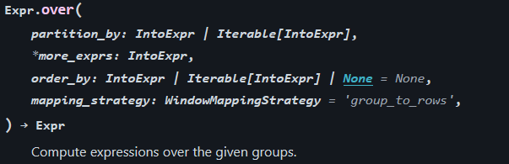

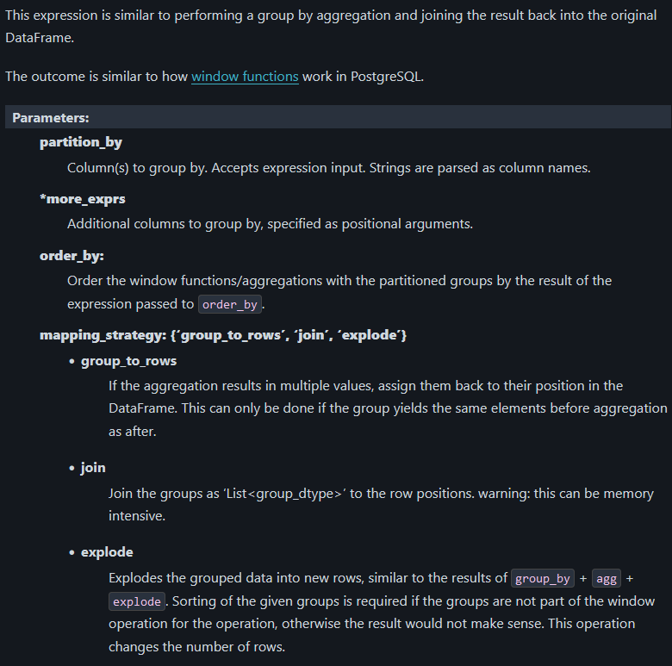

#### Examples

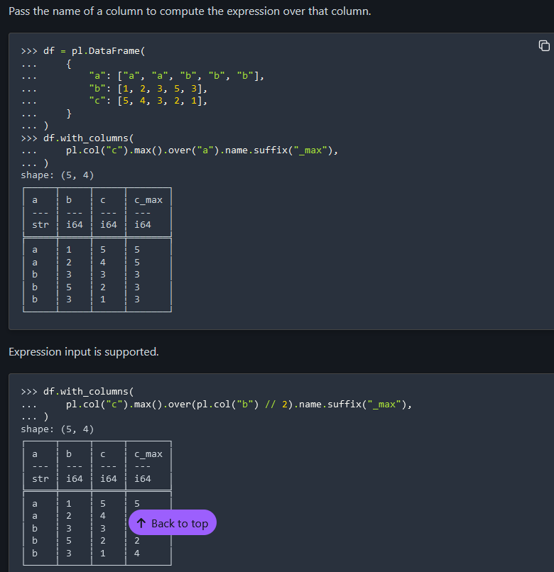

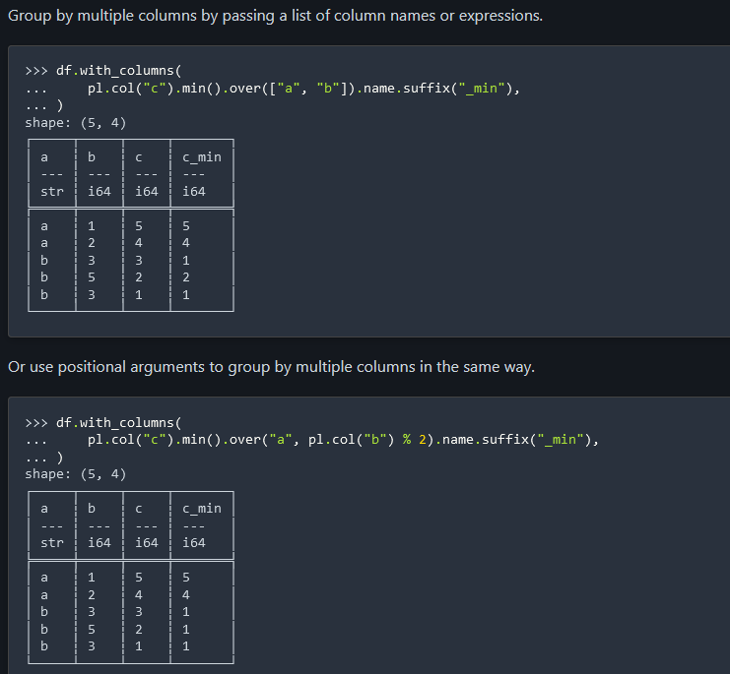

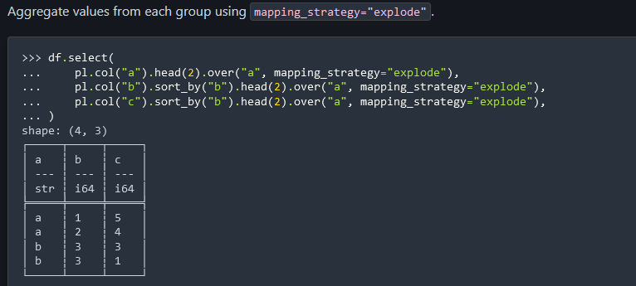

### Rolling

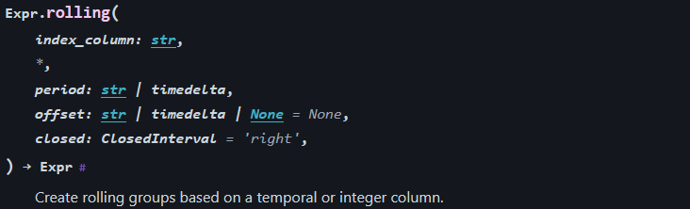

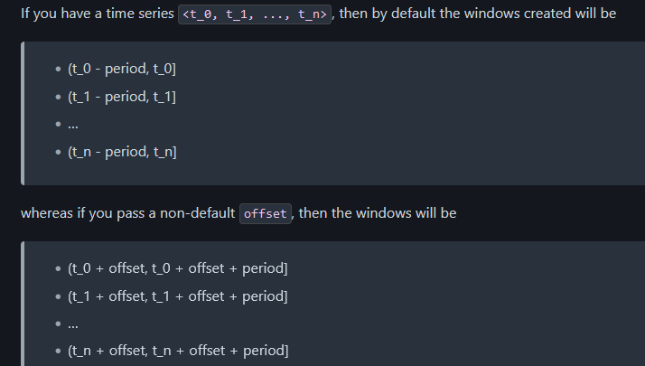

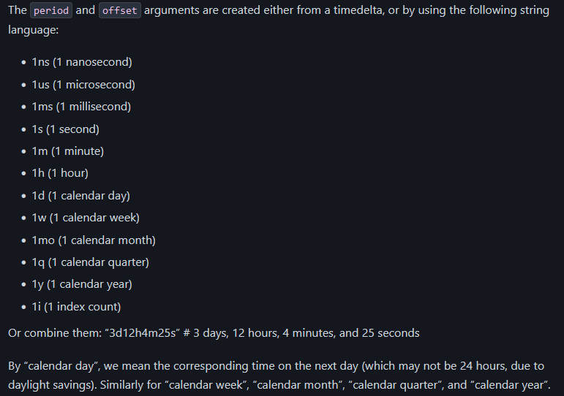

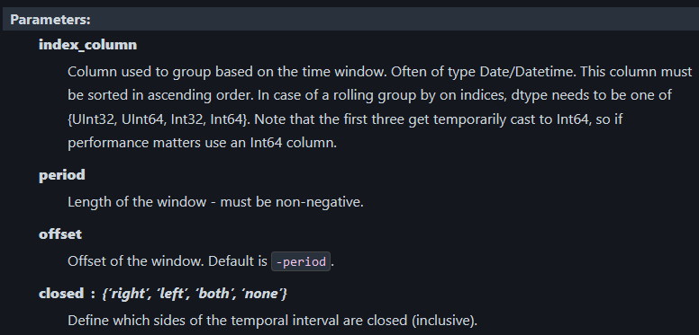

#### Examples

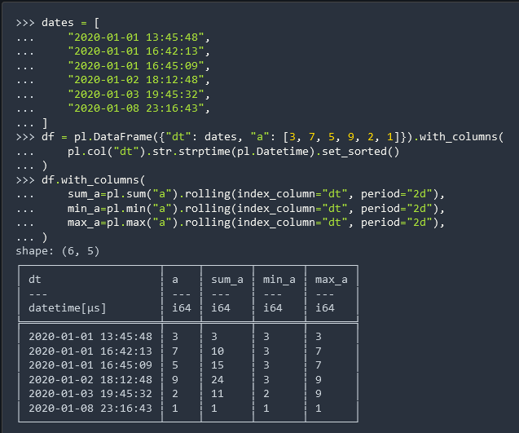

# Selectors

<https://docs.pola.rs/api/python/stable/reference/selectors.html>

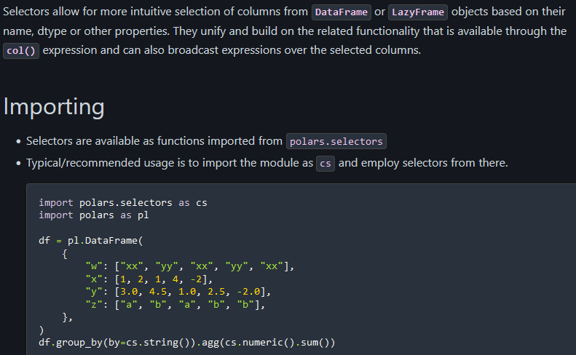

## Set operations

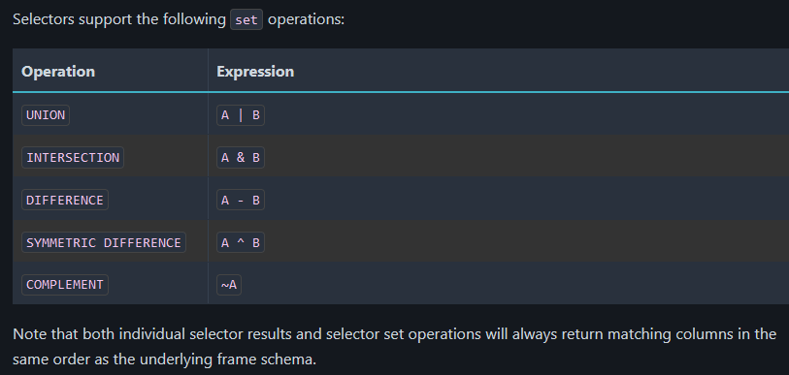

## Examples

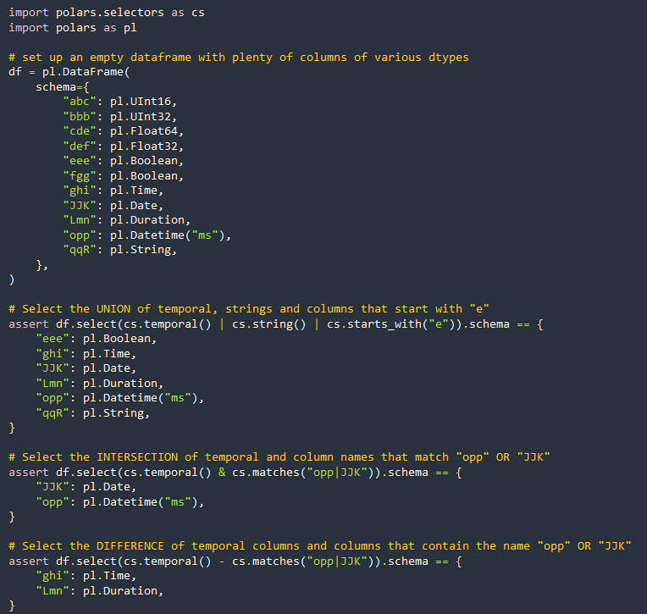

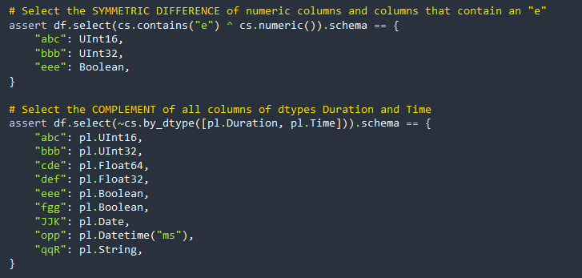

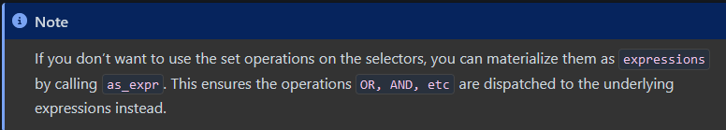

## Functions

### Generic

all()

* Select all columns.

exclude(columns, *more_columns)

* Select all columns except those matching the given columns, datatypes, or selectors.

expand_selector(target, selector, *[, strict])

* Expand selector to column names, with respect to a specific frame or target schema.

is_selector(obj)

* Indicate whether the given object/expression is a selector.

### Type-based

by_dtype(*dtypes)

* Select all columns matching the given dtypes.

#### Numeric

numeric()

* Select all numeric columns.

decimal()

* Select all decimal columns.

float()

* Select all float columns.

integer()

* Select all integer columns.

unsigned_integer()

* Select all unsigned integer columns.

signed_integer()

* Select all signed integer columns.

#### String / Categorical

string(*[, include_categorical])

* Select all String (and, optionally, Categorical) string columns.

categorical()

* Select all categorical columns.

#### Boolean / Binary

binary()

* Select all binary columns.

boolean()

* Select all boolean columns.

#### Temporal

temporal()

* Select all temporal columns.

time()

* Select all time columns.

date()

* Select all date columns.

datetime([time_unit, time_zone])

* Select all datetime columns, optionally filtering by time unit/zone.

duration([time_unit])

* Select all duration columns, optionally filtering by time unit.

### Name-based

by_name(*names[, require_all])

* Select all columns matching the given names.

contains(*substring)

* Select columns whose names contain the given literal substring(s).

starts_with(*prefix)

* Select columns that start with the given substring(s).

ends_with(*suffix)

* Select columns that end with the given substring(s).

matches(pattern)

* Select all columns that match the given regex pattern.

alpha([ascii_only, ignore_spaces])

* Select all columns with alphabetic names (eg: only letters).

digit([ascii_only])

* Select all columns having names consisting only of digits.

alphanumeric([ascii_only, ignore_spaces])

* Select all columns with alphanumeric names (eg: only letters and the digits 0-9).

### Index-based

by_index(*indices)

* Select all columns matching the given indices (or range objects).

first()

* Select the first column in the current scope.

last()

* Select the last column in the current scope.

# Plugins

* [polars-xdt](https://github.com/pola-rs/polars-xdt) Polars plugin with extra datetime-related functionality which isn't quite in-scope for the main library
* [polars-distance](https://github.com/ion-elgreco/polars-distance) Polars plugin for pairwise distance functions
* [polars-ds](https://github.com/abstractqqq/polars_ds_extension) Polars extension aiming to simplify common numerical/string data analysis procedures
* [polars-hash](https://github.com/ion-elgreco/polars-hash) Stable non-cryptographic and cryptographic hashing functions for Polars
* [polars-reverse-geocode](https://github.com/MarcoGorelli/polars-reverse-geocode) Offline reverse geocoder for finding the closest city to a given (latitude, longitude) pair
* [Ritchie Vink - Keynote on Polars Plugins](https://youtu.be/jKW-CBV7NUM)
* [Polars plugins tutorial](https://marcogorelli.github.io/polars-plugins-tutorial/) Learn how to write a plugin by going through some very simple and minimal examples
* [cookiecutter-polars-plugin](https://github.com/MarcoGorelli/cookiecutter-polars-plugins) Project template for Polars Plugins